Development of a feature-rich, Winkel

**A Project Report for Summer Industrial Training**

###### ***Submitted by,***

##### **Susmita Sarkar**

##### **Bekrom Roy**

##### **Swarnali Pradhan**

##### **Amritanshu Kumar Singh**

##### **Azam Azad**

***in partial fulfillment for the award of the degree of***

##### **Bachelor of Computer Applications**

**In**

**Department**

**George College**



At

**Techtree Technologies**



**Techtree Technologies**



**BONAFIDE CERTIFICATE**

Certified that this project work was carried out under my supervision

***“Development* of a feature-rich, practical online Name of the project**“is the bonafide work of

***Name of the student: Susmita Sarkar Signature:***

***Name of the student: Bekrom Roy Signature:***

***Name of the student: Swarnali Pradhan Signature:***

***Name of the student: Amritanshu Kumar Singh Signature:***

***Name of the student: Azam Azad Signature:***

**SIGNATURE**

Name : Saumitra Das

**PROJECT MENTOR**

**Acknowledgement**

I take this opportunity to express my deep gratitude and sincerest thank to my project mentor, **SAUMITRA DAS** for giving most valuable suggestion, helpful guidance and encouragement in the execution of this project work.

I will like to give a special mention to my colleagues. Last but not the least I am grateful to all the faculty members of Techtree Technologies or their support.

|  |  |
| --- | --- |
| **Table of Contents** | **Page No** |
| 1. Abstract |  |
| 1. Introduction and Objectives of the Project |  |
| 1. Project Category (RDBMS/OOPS/Networking/Multimedia/Artificial Intelligence/Expert Systems etc.) |  |
| 1. Tools/Platform, Hardware and Software Requirement specifications |  |
| 1. Goals of Implementation |  |
| 1. SDLC Process Applied |  |
| 1. Functional Requirements (Use Case Diagram) |  |
| 1. Non-functional Requirements |  |
| 1. Feasibility Study |  |
| 1. Project Planning |  |
| 1. Project Scheduling |  |
| 1. Testing |  |
| 1. System Security measures (Implementation of security for the project developed) |  |
| 1. Cost Estimation of the Project along with Cost Estimation Model |  |
| 1. Screenshots & Coding. |  |
| 1. Future scope and further enhancement of the Project |  |
| 1. Conclusion |  |
| 1. Bibliography |  |

**1.  Abstract:**

The main aim of the application is to build a Home Shop website. The website has to provide different kinds of facilities to the users like Car, Real estate, Mobile, facility. Another important reason for the popularity of Internet Users is the advent of Matrimonial and Rental. Now the people are able to do search without wasting their precious time. This make searching flexible. As online Car is a popular way for getting easily, we are implementing it. This project report includes Resume posting, searching of jobs, Posting of jobs and searching of Resumes. As Online matrimonial is a popular way for searching suitable bride and bridegroom and posting your bio-data. As Online rental is a popular way of searching for the apartments and rooms available for monthly rental. This module gives you brief idea about rooms available and area where it is located.

**2. Introduction and Objectives of the Project**

**Introduction:**

Home Shop is being launched because a need for a destination where the local community could come together and help each other is seen. Community members within a city can come here to find an apartment to live-in, sell their old car, or music system, promote their small business, find a life partner, join a salsa class, find people who share their interests, get an audience for a local event, trade any item that they might want or have to offer and make new friends while doing all of the above.

This is a website based on classified – OLX and Quikr. In this project we can easily post any type of ads free by either logging in or not. We also update our classified ads if we register on this website and if the post has been approved by the admin. In this website we also create an admin panel that handles our user, create and update categories and manage classified post and much more. Index page of this classified:

Here are some features of classified project:

1. Home Page
2. About Us Page
3. Contact Us Page
4. FAQ Page
5. Buy & Sell Page
   1. Apple Page
   2. Motorola Page
   3. Vivo Page
   4. Realme Page
   5. Samsung Page

6) Phone Description Page

* 1. Apple
     1. iPhone5 Page
     2. iPhone8 Page
     3. iPhoneX Page
     4. iPhone11 Page
     5. iPhone12 Page
  2. Motorola
     1. Moto C Plus Page
     2. Moto Z2 Force Page
     3. Moto X Force Page
     4. Moto Edge Plus Page
     5. Moto E7 Plus Page
  3. Vivo
     1. Vivo V17 Page
     2. Vivo V19 Page
     3. Vivo V20 Page
     4. Vivo S1 Pro Page
     5. Vivo X50 Pro Page
  4. Realme
     1. Realme 7 Page
     2. Realme C15 Page
     3. Realme Narzo20 Pro Page
     4. Realme U1 Page
     5. Realme X3 Super Zoom Page
  5. Samsung
     1. Samsung M31s Page
     2. Samsung A51 Page
     3. Samsung S10 Plus Page
     4. Samsung Note 20 Page
     5. Samsung Z Flod2 Page

**Objective:**

The summary of the objective of this software is to completely automate the process of:

• Provide better understanding between ad posters and its viewers.

• Provide a user friendly environment so that the ad posters can post their ads easily and free of cost.

• To maintain and store ad details, response details, ad viewer’s details, ad posters details.

• Provide excellent and easy to access means of communication medium between ad posters and its viewers.

• Provide value to its contributors by making available to them its vast global audience reach.

• Provide Classifieds as a service to enable its users to connect with one another.

• Provide local commerce site, uniquely integrating Classifieds and Yellow Pages. The system offers unmatched values such as Real Estate, Travels, jobs/Training, Movies/Entertainment, buy/sale, Matrimonial and more.

**3. Project Category**

-> Web Application

**4. Tools/Platform, Hardware and Software Requirement specifications.**

**Tool**

* Dreamweaver CS6
* Sublime text 3

**Platform**

Microsoft Windows 7/8/10

**Hardware Requirement Specification:**

|  |  |  |  |
| --- | --- | --- | --- |
| **Client Machine** | | **Server Machine** | |
| **HDD** | 200 MB | **HDD** | 320 GB |
| **Processor** | Pentium 4 or newer processor that supports SSE2 | **Processor** | Dual Core or newer processor |
| **Memory** | 512 MB | **Memory** | 2 GB |

**Software Requirement Specification:**

|  |  |  |  |
| --- | --- | --- | --- |
| **Client Machine** | | **Server Machine** | |
| **Browser** | Any standard browser with JavaScript interpreter | **Software** | Apache |
| **Client side mark up / scripting languages** | HTML, JavaScript |  |  |

**5. Goals of Implementation**

The implementation aims at seamless document sharing across the institution.

**6. SDLC Process Applied**



Often, a customer defines a set of general objectives for software but does not identify detailed input, processing, or output requirements. In other cases, the developer may be unsure of the efficiency of an algorithm, the adaptability of an operating system, or the form that human/machine interaction should take. In these, and many other situations, a prototyping paradigm may offer the best approach.

The prototyping paradigm begins with **requirements gathering**. Developer and customer meet and define the overall objectives for the software, identify whatever requirements are known, and outline areas where further definition is mandatory. A **"quick design"** then occurs. The quick design focuses on a representation of those aspects of the software that will be visible to the customer/user (e.g., input approaches and output formats). The quick design leads to the construction of a prototype. The prototype is evaluated by the customer/user and used to refine requirements for the software to be developed. Iteration occurs as the prototype is tuned to satisfy the needs of the customer, while at the same time enabling the developer to better understand what needs to be done.

Ideally, the prototype serves as a mechanism for identifying software requirements. If a working prototype is built, the developer attempts to use existing program fragments or applies tools (e.g., report generators, window managers) that enable working programs to be generated quickly.

**7. Functional Requirements**

Functional Requirements are those that refer to the functionality of the system, i.e., what services it will provide to the user. Nonfunctional (supplementary) requirements pertain to other information needed to produce the correct system and are detailed separately.

**Use Case Diagram**

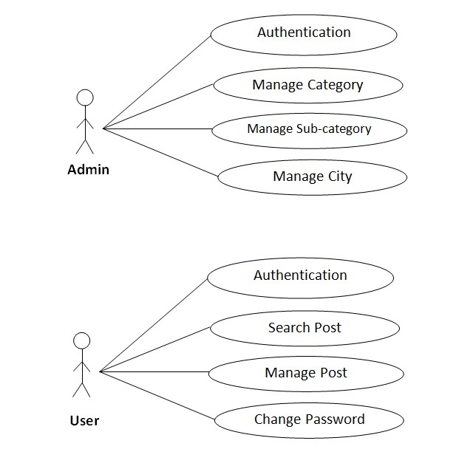

**Use Case Descriptions (User)**

|  |  |
| --- | --- |
| **Use Case Name:** | Authentication |
| **Priority** | Essential |
| **Trigger** | Menu selection |
| **Precondition** | User is connected to the Internet and on the user’s main page |
| **Basic Path** | 1. User enters user email and password. 2. User email and password is matched with the record in the database. 3. If the authentication parameters are correct the User is directed to the User main page, otherwise an error message is displayed. |
| **Alternate Path** | NA |
| **Post Condition** | The User is on the User home page. |
| **Exception Path** | If there is a connection failure the server returns to the wait state |

|  |  |
| --- | --- |
| **Use Case Name:** | Search post |
| **Priority** | Essential |
| **Trigger** | Menu selection |
| **Precondition** | User is connected to the Internet and on the User’s main page |
| **Basic Path** | 1. User Selects a search post.  2. User clicks on the search post details button.  3. The server side program receives the user’s details and saves  it in the server system’s file system. |
| **Alternate Path** | NA |
| **Post Condition** | The users search the post details. |
| **Exception Path** | If there is a connection failure the server returns to the wait state |

|  |  |
| --- | --- |
| **Use Case Name:** | Manage post |
| **Priority** | Essential |
| **Trigger** | Menu selection |
| **Precondition** | User is connected to the Internet and on the user’s main page |
| **Basic Path** | 1. User selects a post add.  2. User clicks on the post add details button.  3. The server side program receives the User details and saves it in the server system’s file system. |
| **Alternate Path** | NA |
| **Post Condition** | The user adds the post. |
| **Exception Path** | If there is a connection failure the server returns to the wait state |

|  |  |
| --- | --- |
| **Use Case Name:** | Change password |
| **Priority** | Essential |
| **Trigger** | Menu selection |
| **Precondition** | User is connected to the Internet and on the user’s main page |
| **Basic Path** | 1. User selects a my account.  2. User clicks on the chance password button.  3. The server side program receives the User details and saves it in the server system’s file system. |
| **Alternate Path** | NA |
| **Post Condition** | The user can change password. |
| **Exception Path** | If there is a connection failure the server returns to the wait state |

**8. Non Functional Requirements**

In addition to the obvious features and functions that you will provide in your system, there are other requirements that don't actually DO anything, but are important characteristics nevertheless. These are called "non-functional requirements" or sometimes "Quality Attributes." For example, attributes such as performance, security, usability, compatibility. Isn’t a "feature" of the system, but are a required characteristic. You can't write a specific line of code to implement them; rather they are "emergent" properties that arise from the entire solution. The specification needs to describe any such attributes the customer requires. You must decide the kind of requirements that apply to your project and include those that are appropriate.

Each requirement is simply stated in English. Each requirement must be objective and quantifiable; there must be some measurable way to assess whether the requirement has been met.

Often deciding on quality attributes requires making tradeoffs, e.g., between performance and maintainability. In the APPENDIX you must include an engineering analysis of any significant decisions regarding tradeoffs between competing attributes.

Here are some examples of non-functional requirements:

**Performance requirements**

Requirements about resources required, response time, transaction rates, throughput, benchmark specifications or anything else having to do with performance. For better performance the application will restrict the document size to 5 MB.

**Operating constraints**

List any run-time constraints. This could include system resources, people, needed software,

The application must run without any manual intervention.

**Platform constraints**

Discuss the target platform. Be as specific or general as the user requires. If the user doesn't care, there are still platform constraints. Since the application will be developed in JEE it is platform independent.

**Accuracy and Precision**

Requirements about the accuracy and precision of the data. (Do you know the difference?) Beware of 100% requirements; they often cost too much.

**Modifiability**

Requirements about the effort required to make changes in the software. Often, the measurement is personnel effort (person- months).

**Portability**

The effort required to move the software to a different target platform. The measurement is most commonly person-months or % of modules that need changing.

**Reliability**

Requirements about how often the software fails. The measurement is often expressed in MTBF (mean time between failures). The definition of a failure must be clear. Also, don't confuse reliability with availability which is quite a different kind of requirement. Be sure to specify the consequences of software failure, how to protect from failure, a strategy for error detection, and a strategy for correction.

**Security**

One or more requirements about protection of your system and its data. The measurement can be expressed in a variety of ways (effort, skill level, and time,) to break into the system. Do not discuss solutions (e.g. passwords) in a requirements document.

Only secured users can access the application.

No one can go to any independent page without logging in.

**Usability**

Requirements about how difficult it will be to learn and operate the system. The requirements are often expressed in learning time or similar metrics.

**Legal**

There may be legal issues involving privacy of information, intellectual property rights, export of restricted technologies, etc.

**9. Feasibility Study**

You should provide a feasibility report in the following format:

* **Product:** A general statement of the product; give a brief description of what the proposed system will do, highlighting where the proposed system meets the specified business requirements of the organization.
* **Technical Feasibility:** Will the proposed system perform to the required specification? Outline technical systems options you propose to use, which will give a technical solution satisfying the requirements and constraints of the system, as outlined in the terms of reference.
* **Social Feasibility:** Consideration of whether the proposed system would prove acceptable to the people who would be affected by its introduction. Describe the effect on users from the introduction of the new system; consider whether there will be a need for retraining the workforce. Will there be a need for relocation of some of the workforce? Will some jobs become deskilled? Will the current workforce be able to perform effectively any new tasks introduced by the proposed system? Describe how you propose to ensure user co-operation before changes are introduced.
* **Economic Feasibility:** Consider the cost/benefits of the proposed system. Detail the costs that will be incurred by the organization adopting the new system; consider development costs and running costs. Detail benefits that the new system will bring, direct economic benefits such as reduced costs, and indirect benefits, such as improved management information and better customer service. Illustrate the cost/benefit of the new system by applying a suitable cost/benefit analysis method such as the payback method.
* **Market Research:** A comprehensive market research identifying a need for the product. Detail all market research you carried out, listing sources of information. Justify any conclusions you have drawn from your research. Identify the potential customer base for your product, together with evidence of customer need for the product. Describe how you propose to compete with similar products on the market.
* **Alternative Solution:** Consideration of alternative solutions should be documented. At least two alternative business or technical systems options should be considered. Detail the differences between these options and the proposed system. Justify your choice of the proposed system and the reasons for rejecting the alternative options.

At this point, all of the planning for the project has been done and if the feasibility study has shown that the project is likely to succeed within its constraints, then it only remains for us to start the requirements analysis and thus proceed with the project.

|  |  |
| --- | --- |
| **Feasibility Study** | |
| System: WINKEL | Date: |
| Author: Bekrom Roy | Page: 1 |
| **Product** | |
| The project requires a web application to be developed that will allow online treading/document/paper sharing. | |
| **Technical Feasibility** | |
| The web application will be developed using HTML, CSS & JS. The team is competent in that. | |
| **Social Feasibility** | |
| Some training for the users is required but all users are IT literate. | |
| **Market Research** | |
| Market research says that this application would be useful for the users as it could seamlessly help them to share documents. | |
| **Economic Feasibility** | |
| The application can be developed within budget. | |
| **Alternate Solution** | |
| Could be a desktop system but that would not allow documents to be shared online. | |

**10. Project Planning**

Project planning is concerned with identifying the following for every project:

* Activities
* Milestones
* Deliverables.

A plan must be drawn up to guide the development towards the project goal. A plan is drawn up at the start of a project. This plan should be used as the driver for the project. The initial plan is not static, and must be modified as the project progresses.

Planning is required for development activities from specification through to delivery of the system.

**11. Project Scheduling:**

**Grant Chart**

|  |  |  |  |  |  |  |  |
| --- | --- | --- | --- | --- | --- | --- | --- |
| **Task** | **Person(s) Responsible** | **Week 1** | **Week 2** | **Week 3** | **Week 4** | **Week**  **5** | **Week**  **6** |
| **Communication** |  |  |  |  |  |  |  |
| **Quick Plan** |  |  |  |  |  |  |  |
| **Modeling Quick Design** |  |  |  |  |  |  |  |
| **Construction of Prototype** |  |  |  |  |  |  |  |
| **Deployment, Delivery and Feedback** |  |  |  |  |  |  |  |

**12. Testing**

## Team Interaction

The following describes the level of team interaction necessary to have a successful product.

* The Test Team will work closely with the Development Team to achieve a high quality design and user interface specifications based on customer requirements. The Test Team is responsible for visualizing test cases and raising quality issues and concerns during meetings to address issues early enough in the development cycle.
* The Test Team will work closely with Development Team to determine whether or not the application meets standards for completeness. If an area is not acceptable for testing, the code complete date will be pushed out, giving the developers additional time to stabilize the area.
* Since the application interacts with a back-end system component, the Test Team will need to include a plan for integration testing. Integration testing must be executed successfully prior to system testing.

# Test Objective

The objective our test plan is to find and report as many bugs as possible to improve the integrity of our program. Although exhaustive testing is not possible, we will exercise a broad range of tests to achieve our goal. We will be testing a Binary Search Tree Application utilizing a pre-order traversal format. There will be eight key functions used to manage our application: load, store, clear, search, insert, delete, list in ascending order, and list in descending order. Our user interface to utilize these functions is designed to be user-friendly and provide easy manipulation of the tree. The application will only be used as a demonstration tool, but we would like to ensure that it could be run from a variety of platforms with little impact on performance or usability.

# Process Overview

# The following represents the overall flow of the testing process:

1. Identify the requirements to be tested. All test cases shall be derived using the current Program Specification.
2. Identify which particular test(s) will be used to test each module.
3. Review the test data and test cases to ensure that the unit has been thoroughly verified and that the test data and test cases are adequate to verify proper operation of the unit.
4. Identify the expected results for each test.
5. Document the test case configuration, test data, and expected results.
6. Perform the test(s).
7. Document the test data, test cases, and test configuration used during the testing process. This information shall be submitted via the Unit/System Test Report (STR).
8. Successful unit testing is required before the unit is eligible for component integration/system testing.
9. Unsuccessful testing requires a Bug Report Form to be generated. This document shall describe the test case, the problem encountered, it’s possible cause, and the sequence of events that led to the problem. It shall be used as a basis for later technical analysis.
10. Test documents and reports shall be submitted. Any specifications to be reviewed, revised, or updated shall be handled immediately.

# Testing Process

**b.** Design System Test

**e.** Design/Build Test Proc.

**f.** Signoff

**c.** Design/Build Test Proc.

**a.** Organize Project

**d.** Organize Project

The diagram above outlines the Test Process approach that will be followed.

**a. Organize Project** involves creating a System Test Plan, Schedule & Test Approach, and assigning responsibilities.

**b.** **Design/Build System Test** involves identifying Test Cycles, Test Cases, Entrance & Exit Criteria, Expected Results, etc. In general, test conditions/expected results will be identified by the Test Team in conjunction with the Development Team. The Test Team will then identify Test Cases and the Data required. The Test conditions are derived from the Program Specifications Document.

**c.** **Design/Build Test Procedures** includes setting up procedures such as Error Management systems and Status reporting.

**d.** **Build Test Environment** includes requesting/building hardware, software and data set-ups.

**e. Execute System Tests –** The tests identified in the Design/Build Test Procedures will be executed. All results will be documented and Bug Report Forms filled out and given to the Development Team as necessary.

**f.** **Signoff** - Signoff happens when all pre-defined exit criteria have been achieved.

# Testing Strategy

The following outlines the types of testing that will be done for unit, integration, and system testing. While it includes what will be tested, the specific use cases that determine how the testing is done will be detailed in the Test Design Document. The test cases that will be used for designing use cases is shown in Figure 2.1 and onwards.

**Test Cases**

|  |  |  |
| --- | --- | --- |
| **Tested By:** | | Susmita Sarkar |
| **Test Type** | | Unit Testing |
| **Test Case Number** | | 1 |
| **Test Case Name** | | Some Page despising |
| **Test Case Description** | |  |
| **Item(s) to be tested** | | |
| 1 | Checking the pages are working and links are working. | |

## Unit Testing

Unit Testing is done at the source or code level for language-specific programming errors such as bad syntax, logic errors, or to test particular functions or code modules. The unit test cases shall be designed to test the validity of the programs correctness.

### White Box Testing

In white box testing, the UI is bypassed. Inputs and outputs are tested directly at the code level and the results are compared against specifications. This form of testing ignores the function of the program under test and will focus only on its code and the structure of that code. Test case designers shall generate cases that not only cause each condition to take on all possible values at least once, but that cause each such condition to be executed at least once. To ensure this happens, we will be applying Branch Testing. Because the functionality of the program is relatively simple, this method will be feasible to apply.

Each function of the binary tree repository is executed independently; therefore, a program flow for each function has been derived from the code.

**Black Box Testing**

Black box testing typically involves running through every possible input to verify that it results in the right outputs using the software as an end-user would. We have decided to perform Equivalence Partitioning and Boundary Value Analysis testing on our application.

**13. System Security measures (Implementation of security for the project developed)**

* All users are allowed.
* Anyone can access our website. If there is any problem then user can take help of FAQ page or, user can contact us by contact us page.

**14. Cost Estimation of the Project along with Cost Estimation Model**

**Analogous estimate of effort or cost**

Used for Early Estimate or Individual Activity Estimate

Sample example shown below is for two major deliverables of a software project. You use a previous project as a benchmark for analogous estimation. Using your experience you will estimate a multiplier.

Multipliers:

1. Prototyping: 0.5.
2. Testing: 0.25
3. Deployment: 0.5

Finally, if you want to convert to cost, you would use current rates for the resource.

|  |  |  |  |  |  |  |
| --- | --- | --- | --- | --- | --- | --- |
| **WBS ID** | **Previous**  **Similar Project**  **Activity** | **Previous**  **Effort** | **Current**  **Project**  **Estimate** | **Multiplier** | **Effort**  **(Previous Effort * 0.75)** | **Cost**  **(Rs. 500/hr.)** |
| 1 | Prototyping | 40 Work-Hours | Prototyping | 0.5 | 30 Work-hours | Rs. 7500/- |
| 2 | Testing | 20 Work-Hours | Testing | 0.25 | 10 Work-Hours | Rs. 1250/- |
| **Total** |  |  |  |  | **40 Work- Hours** | **Rs. 8750/-** |

**15. Interface Design**

**15.1 Home page**

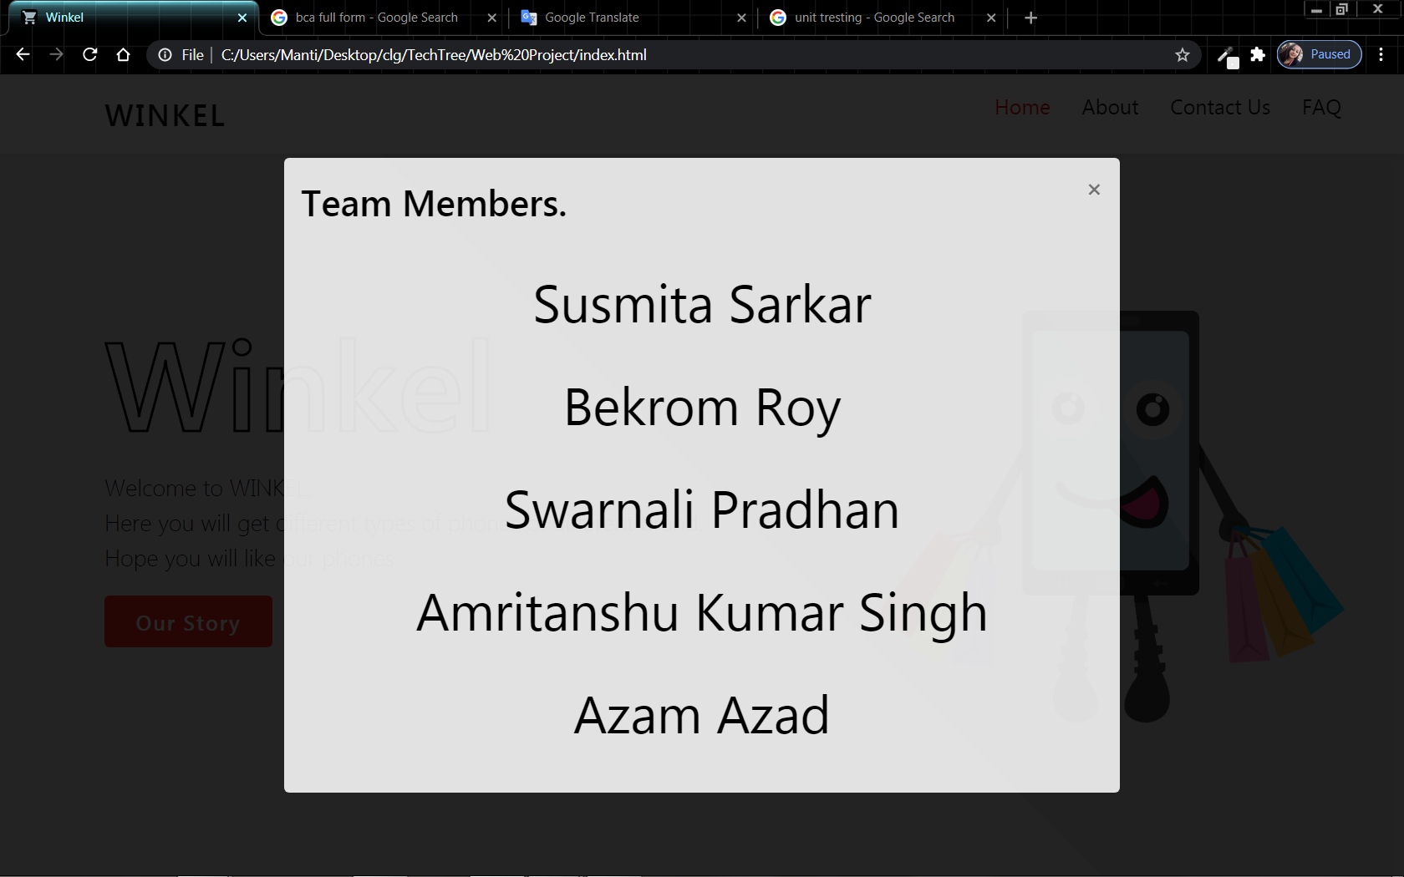

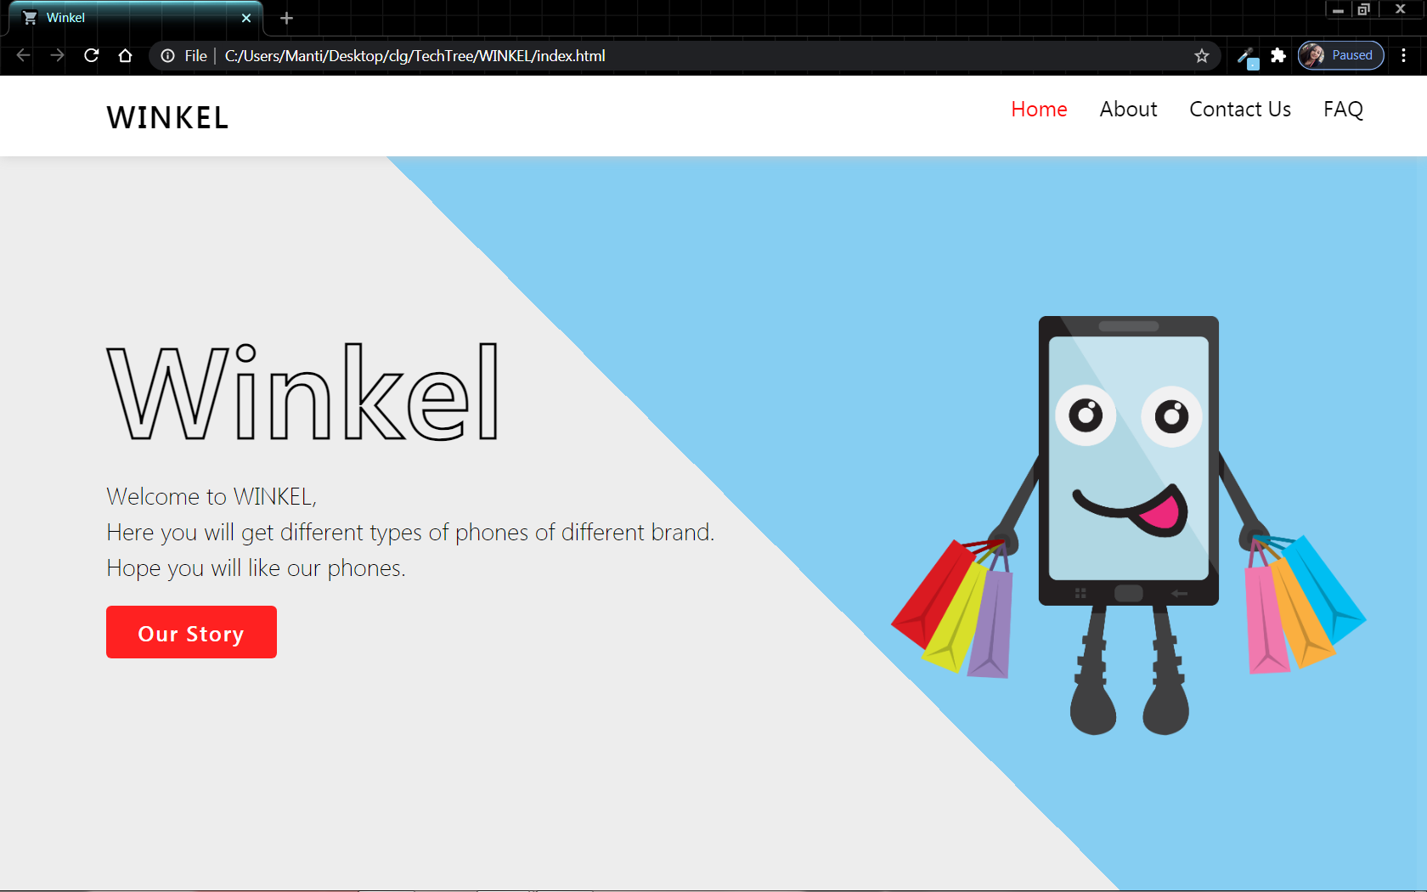

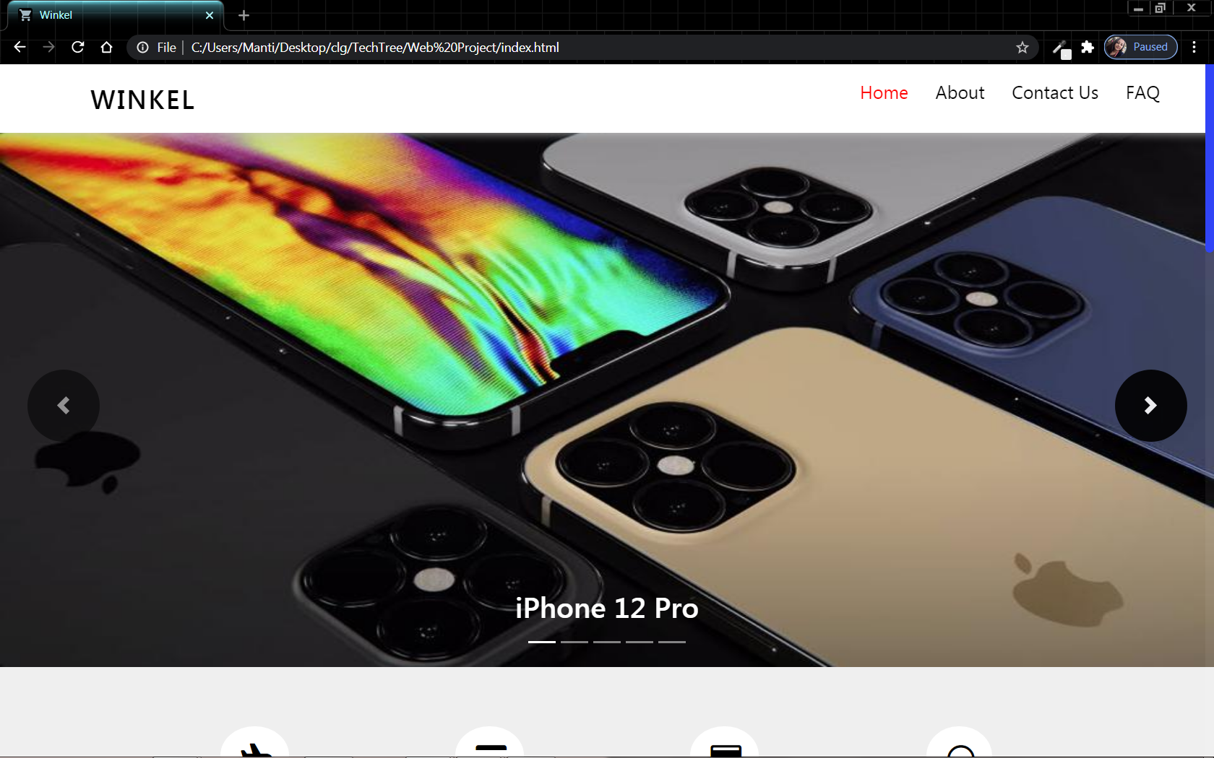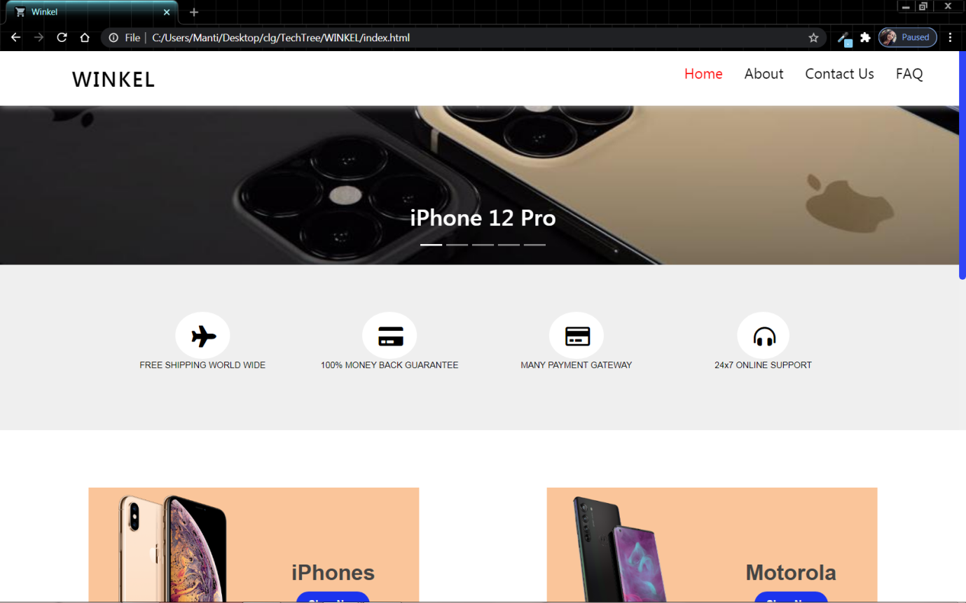

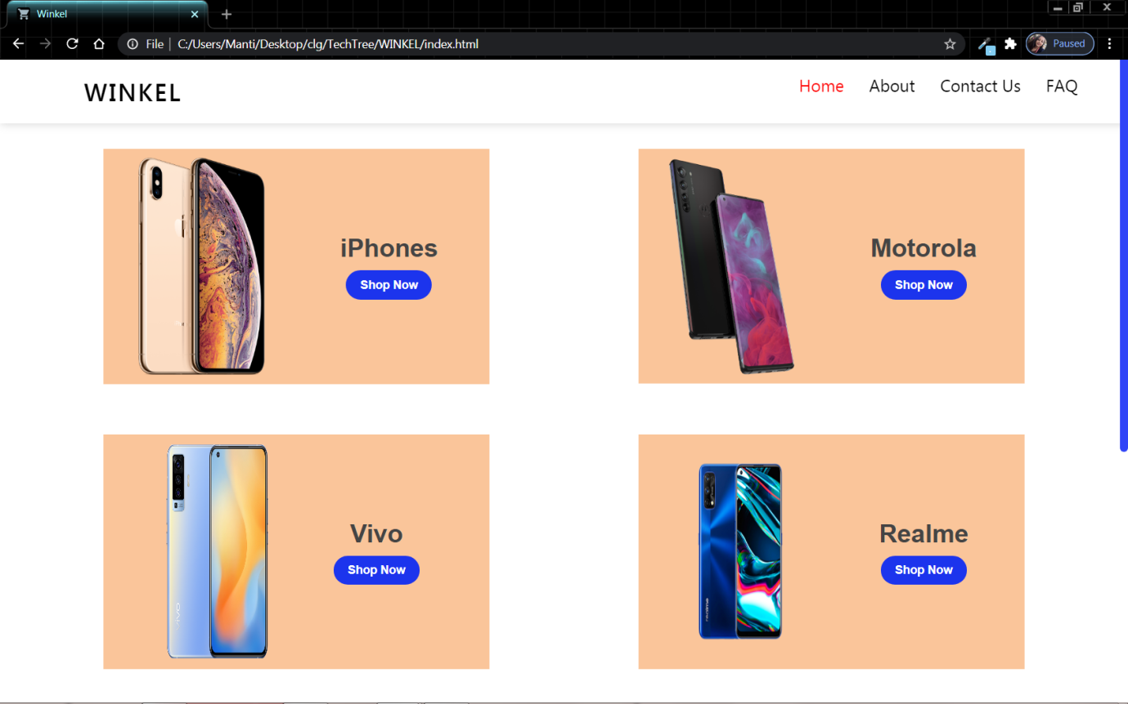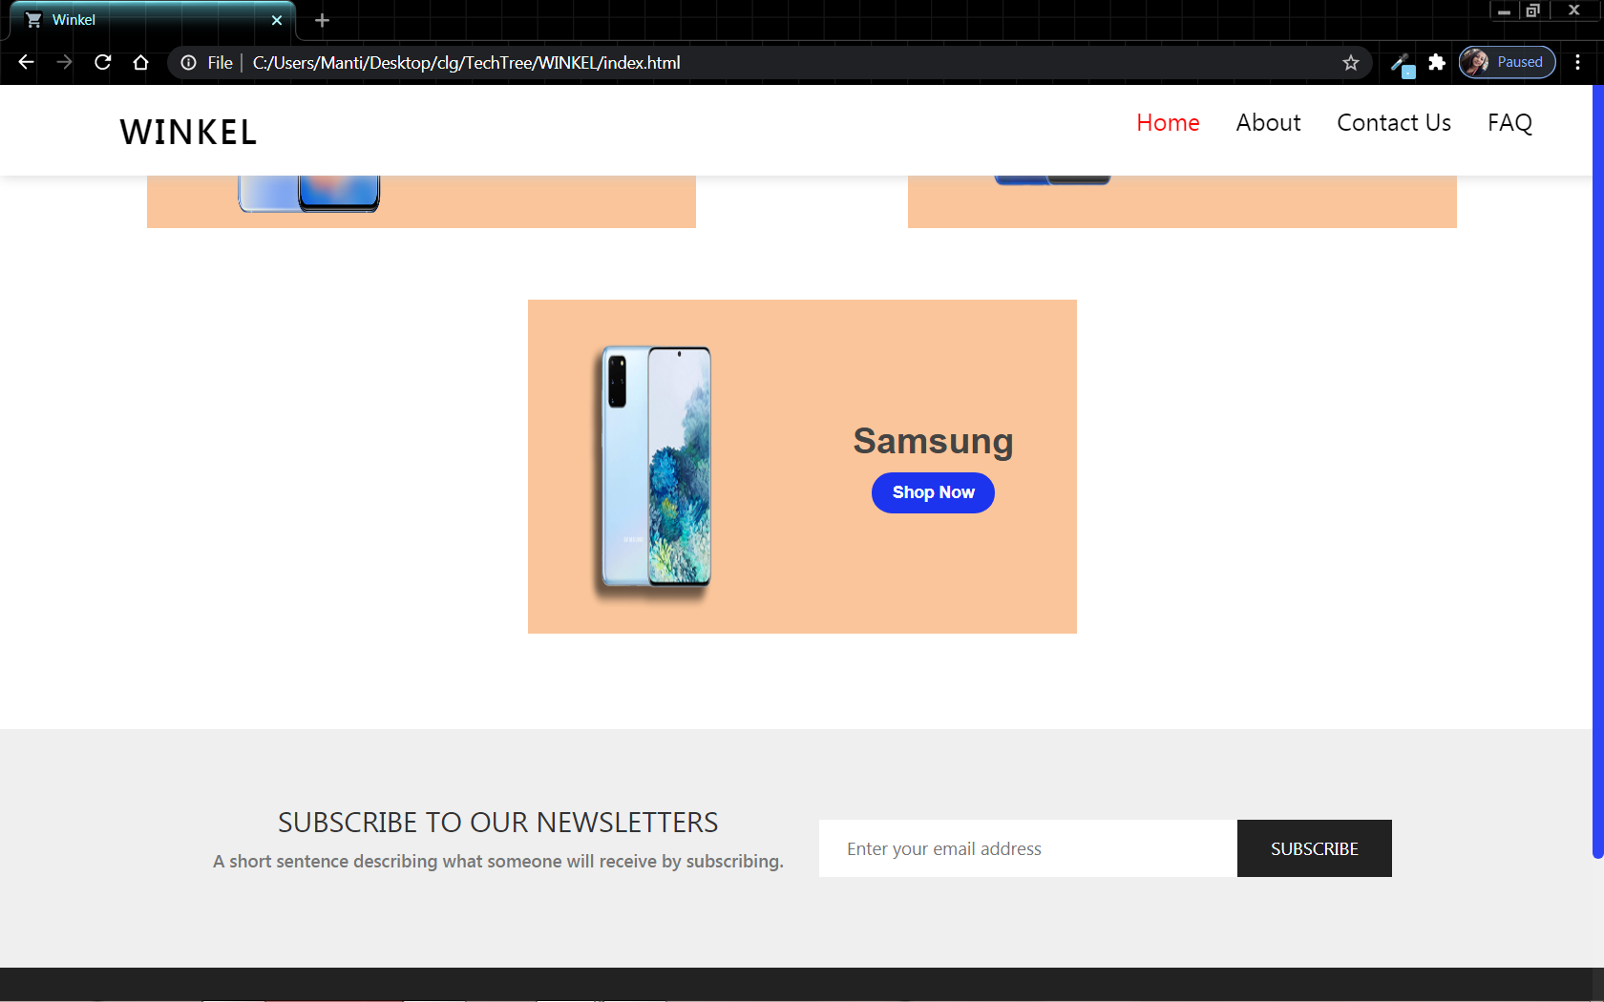

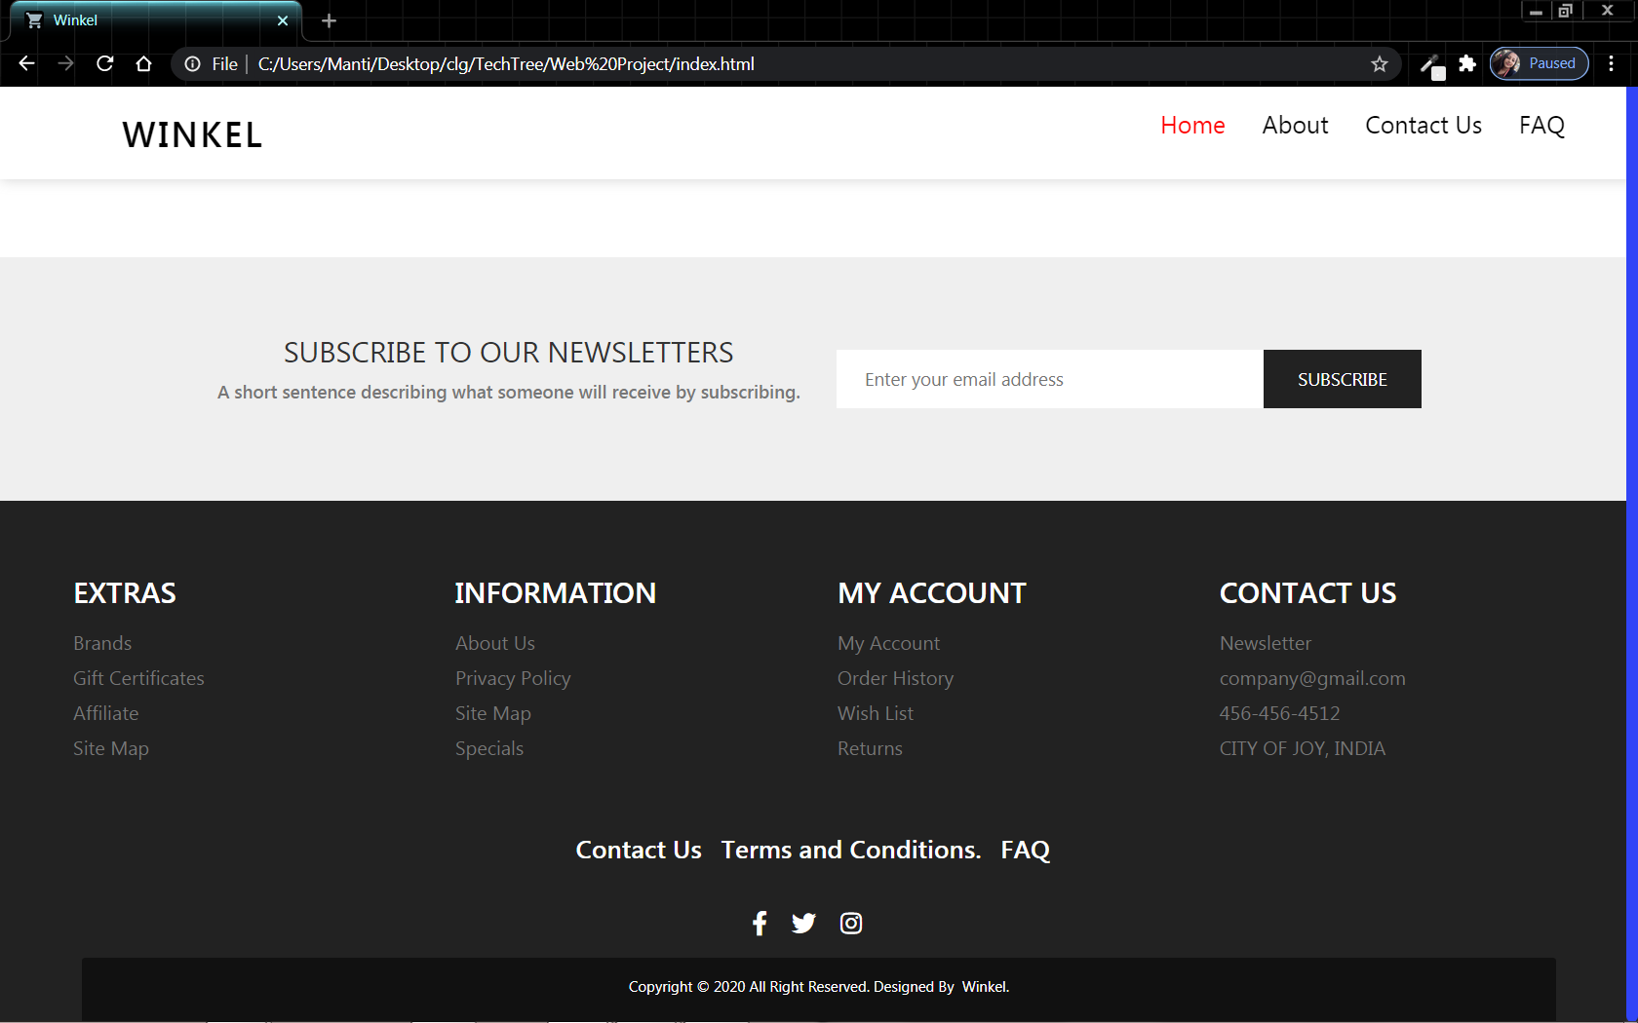

**15.2.About Us Page:**

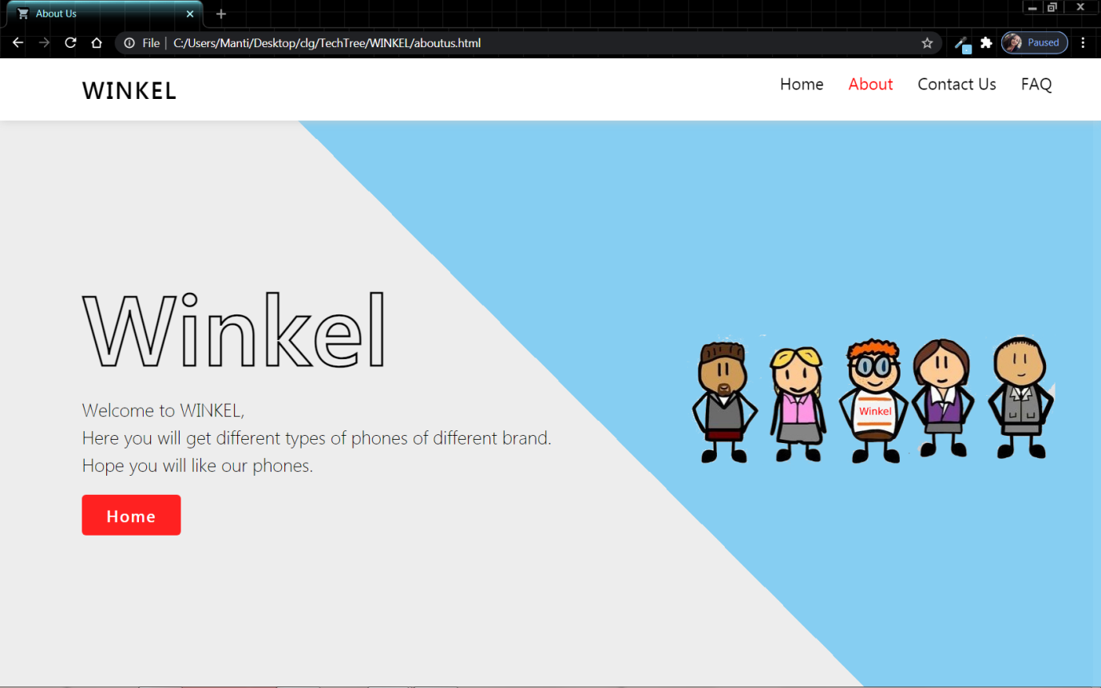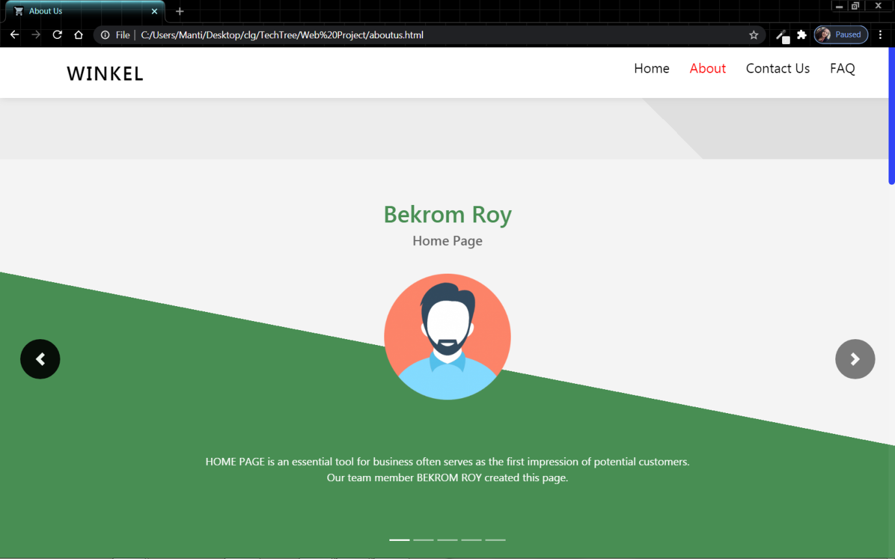

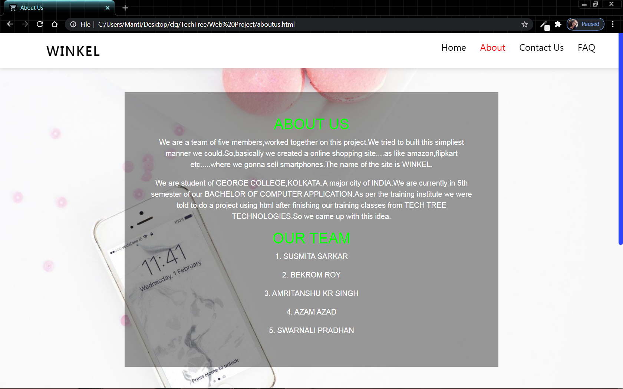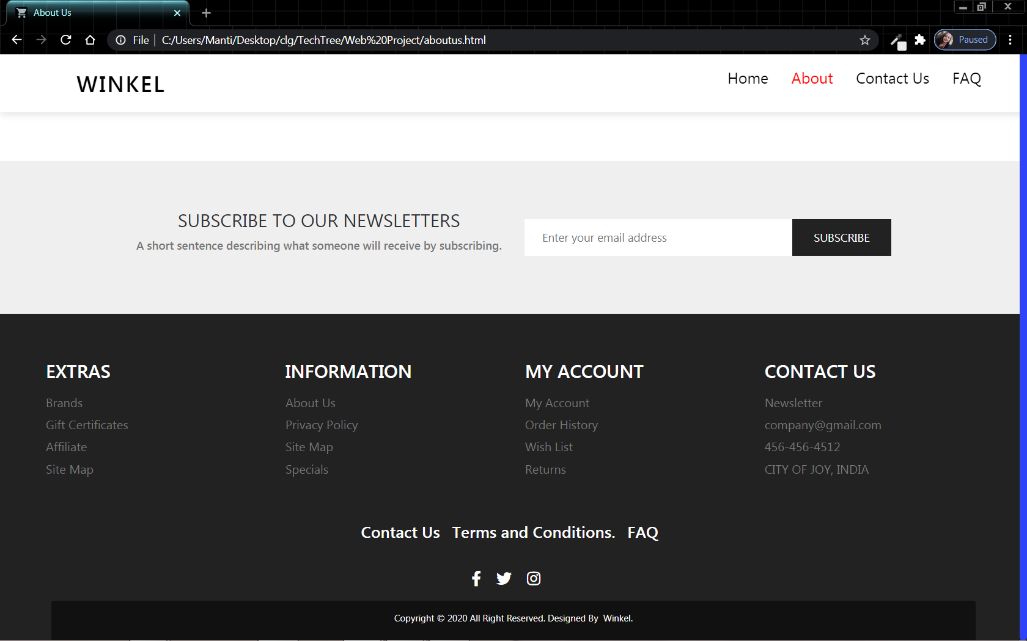

**15.3. Contact Us Page:**

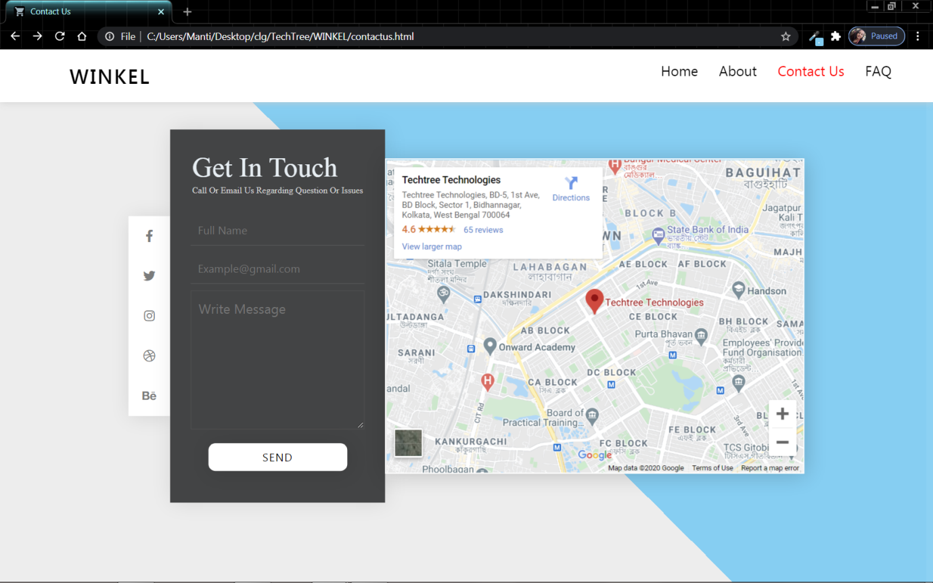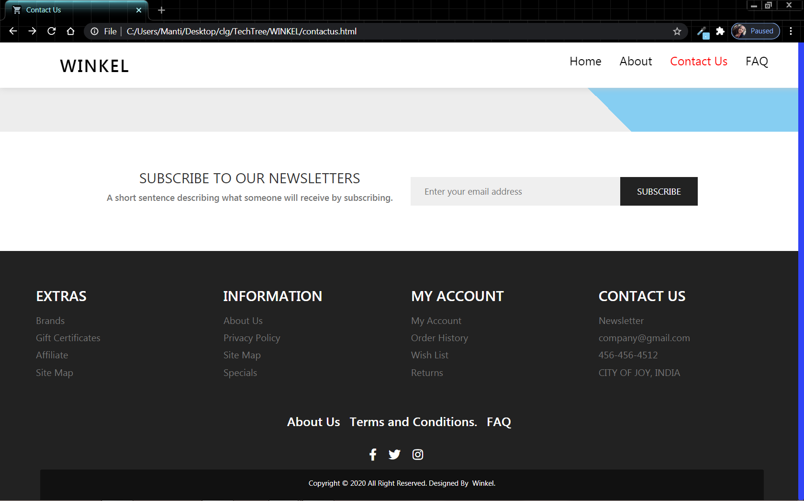

**15.4.FAQ Page:**

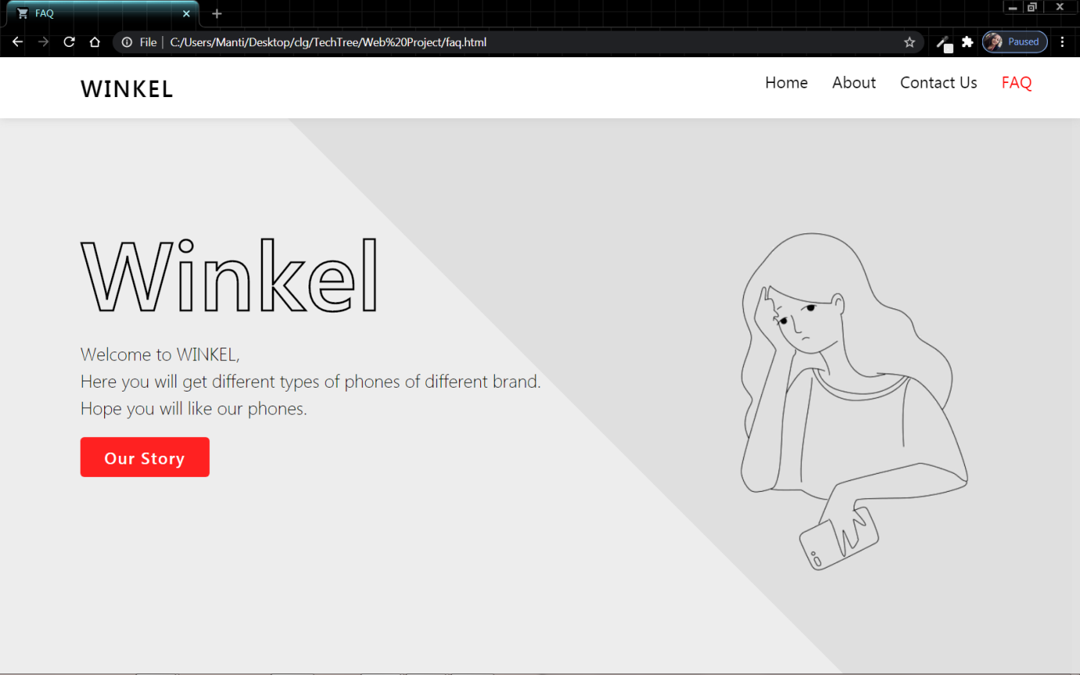

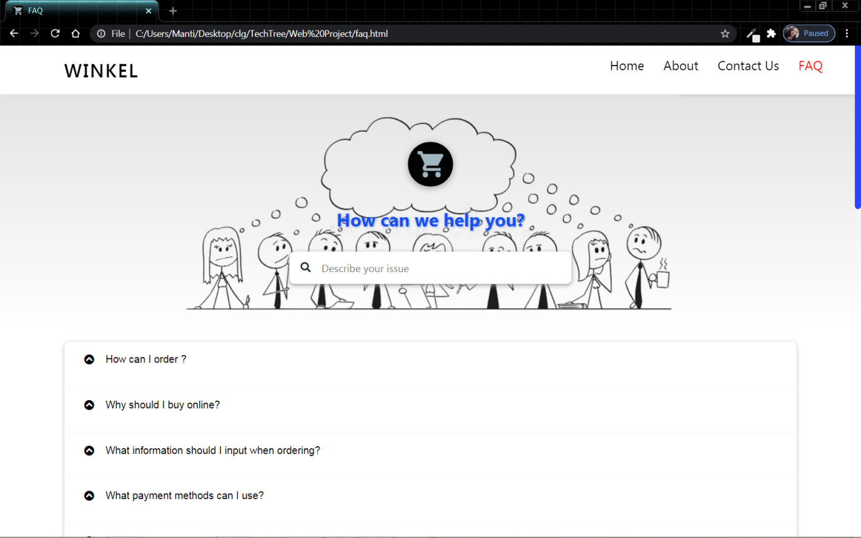

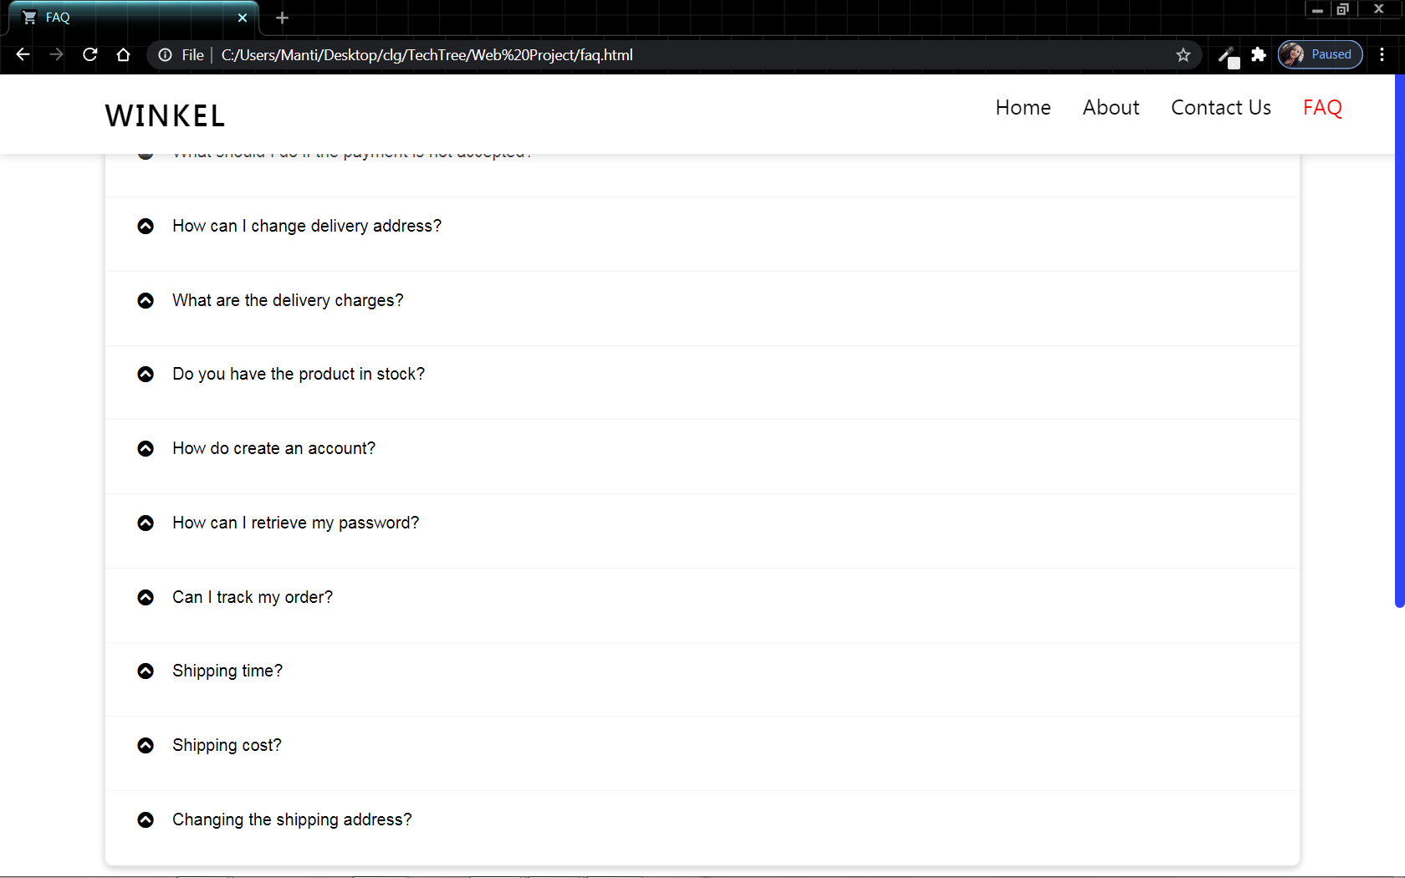

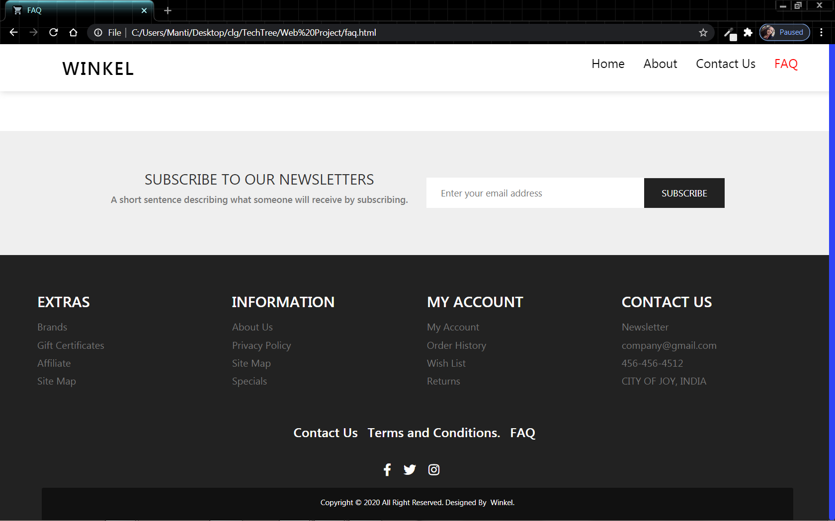

**15.5.1.Buy & Sell Page:**

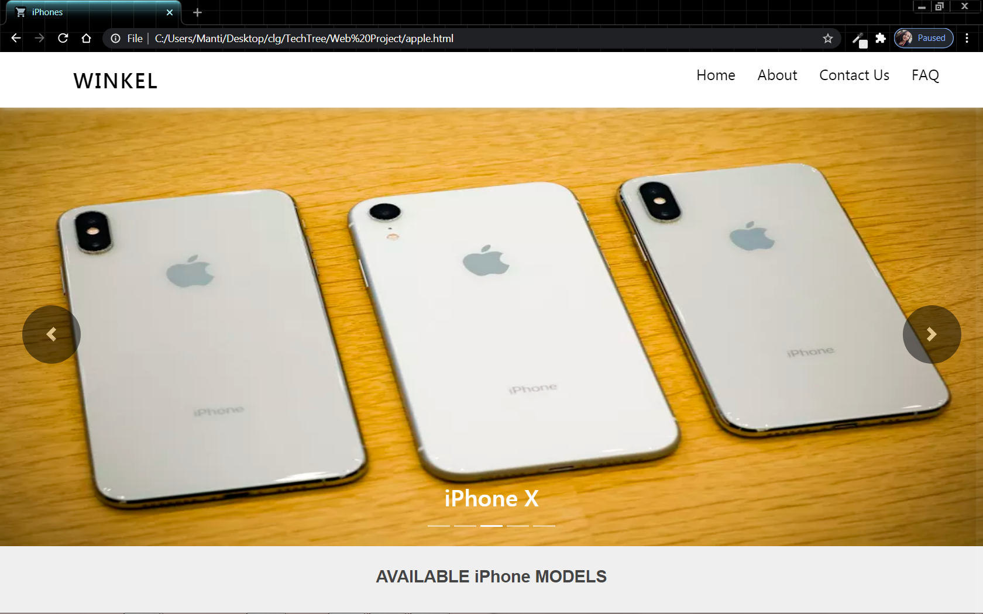

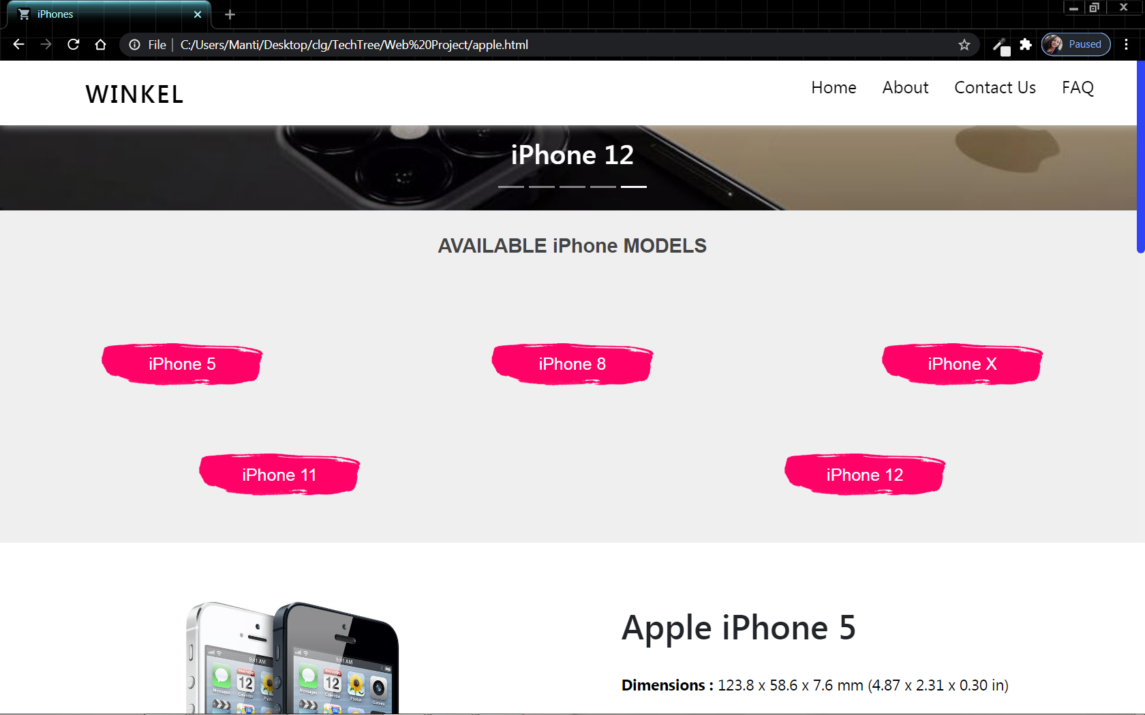

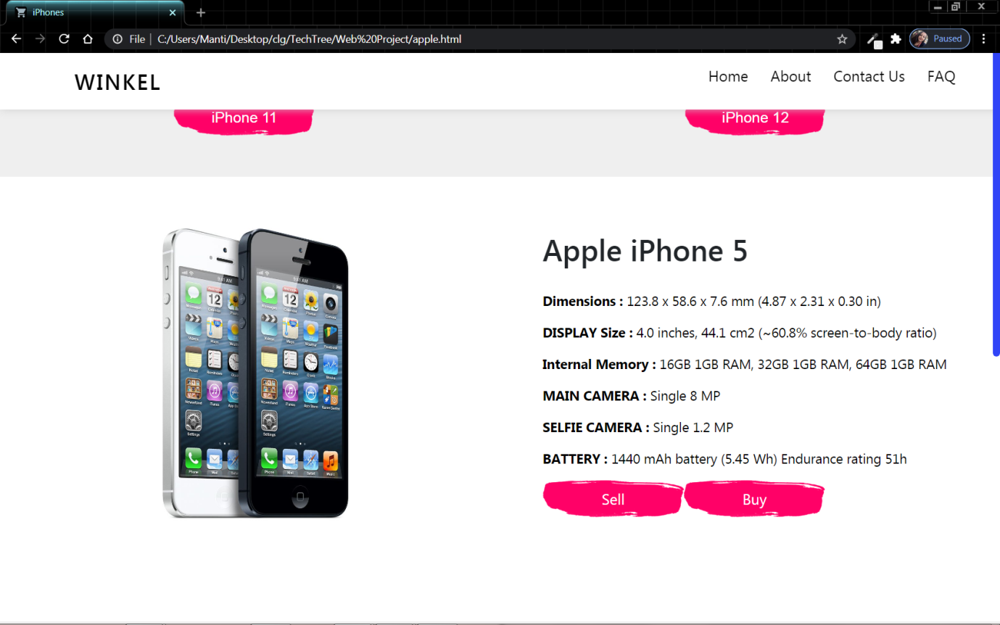

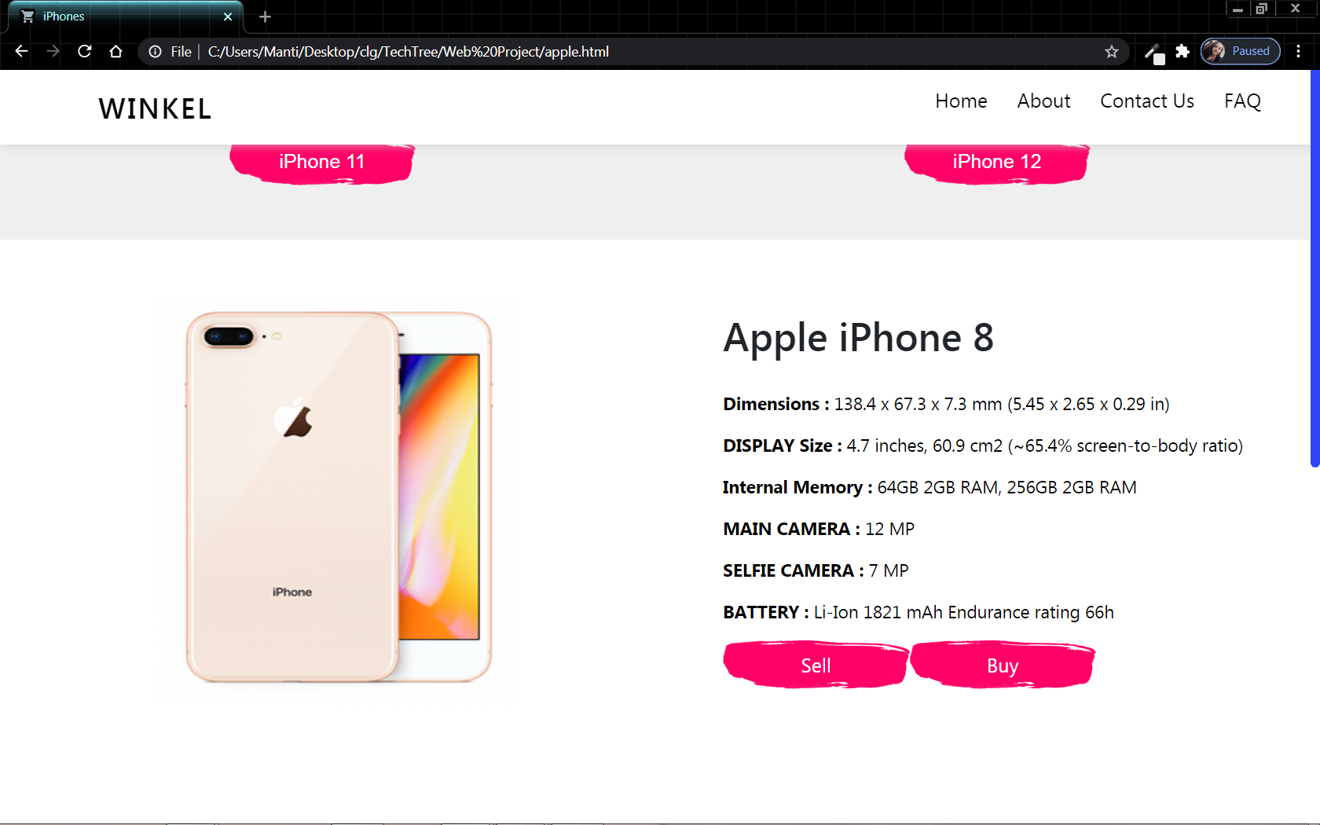

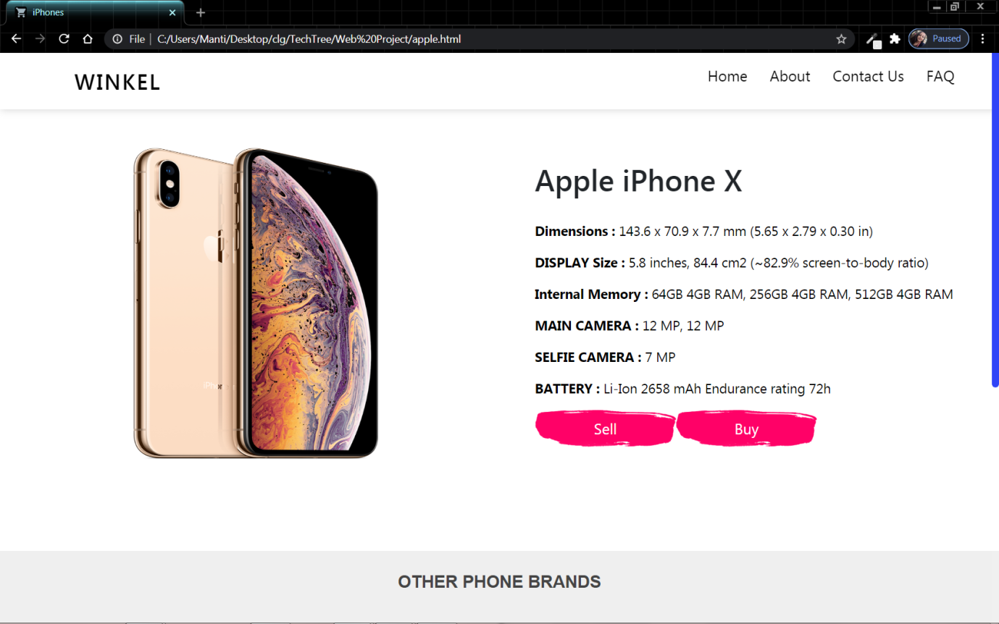

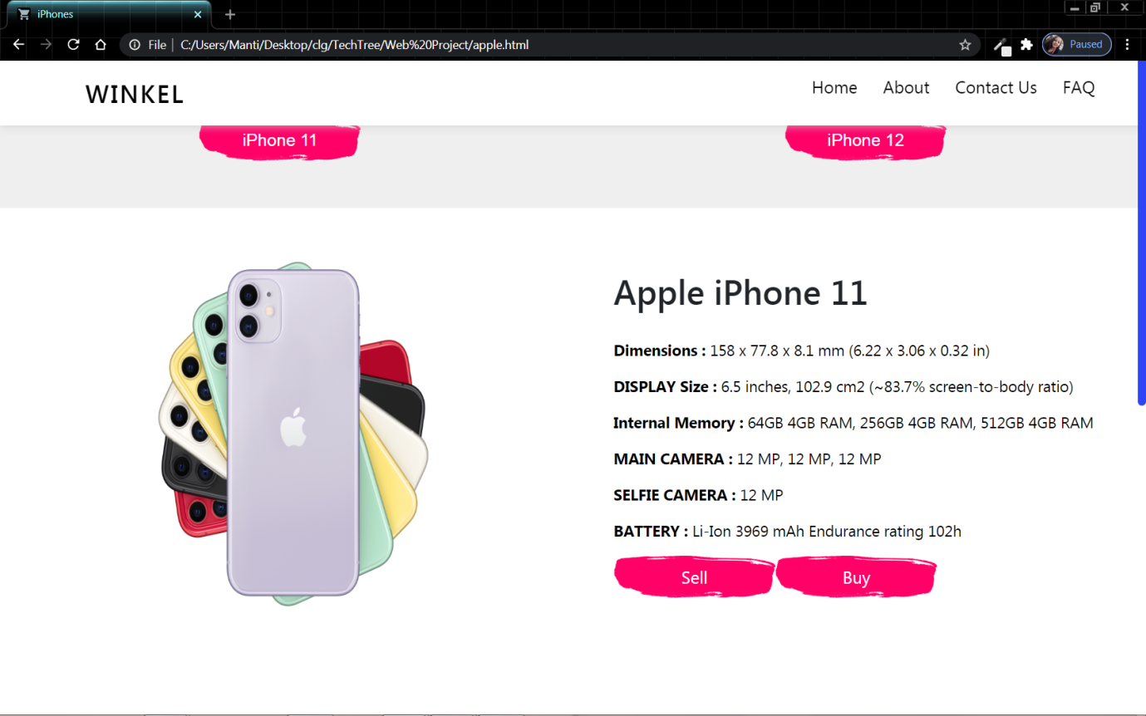

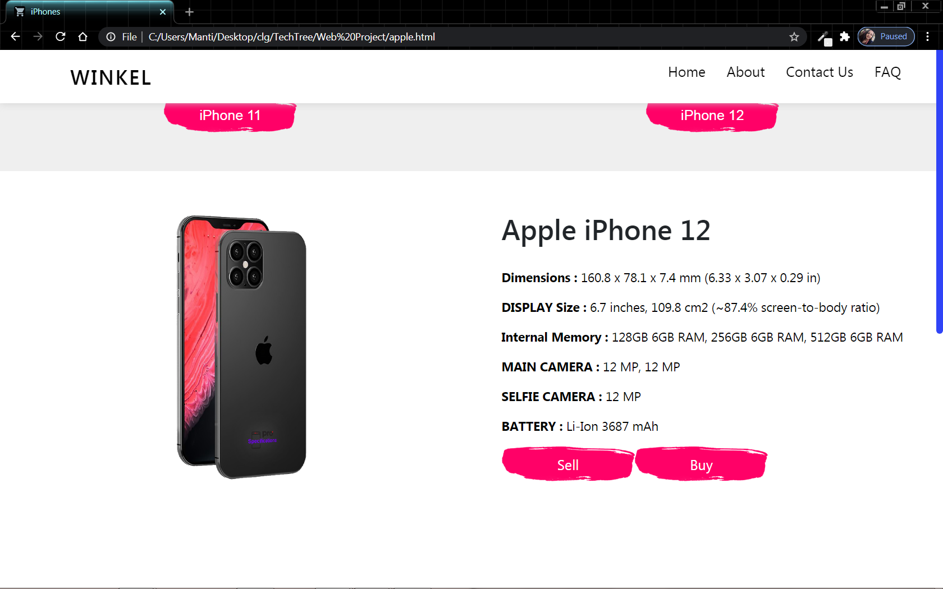

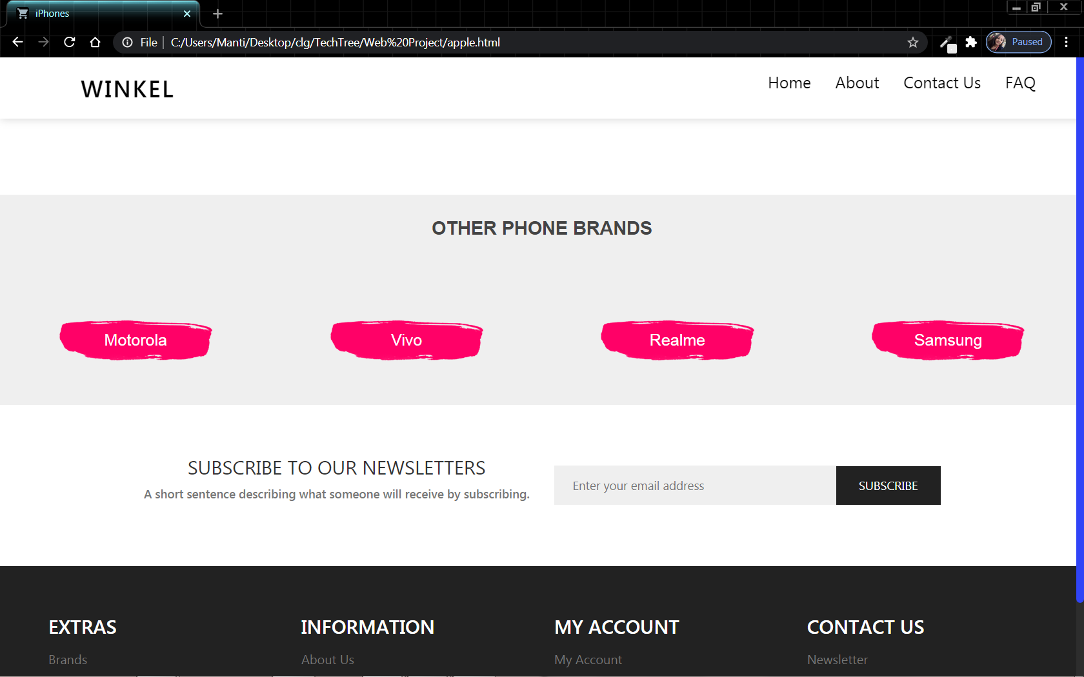

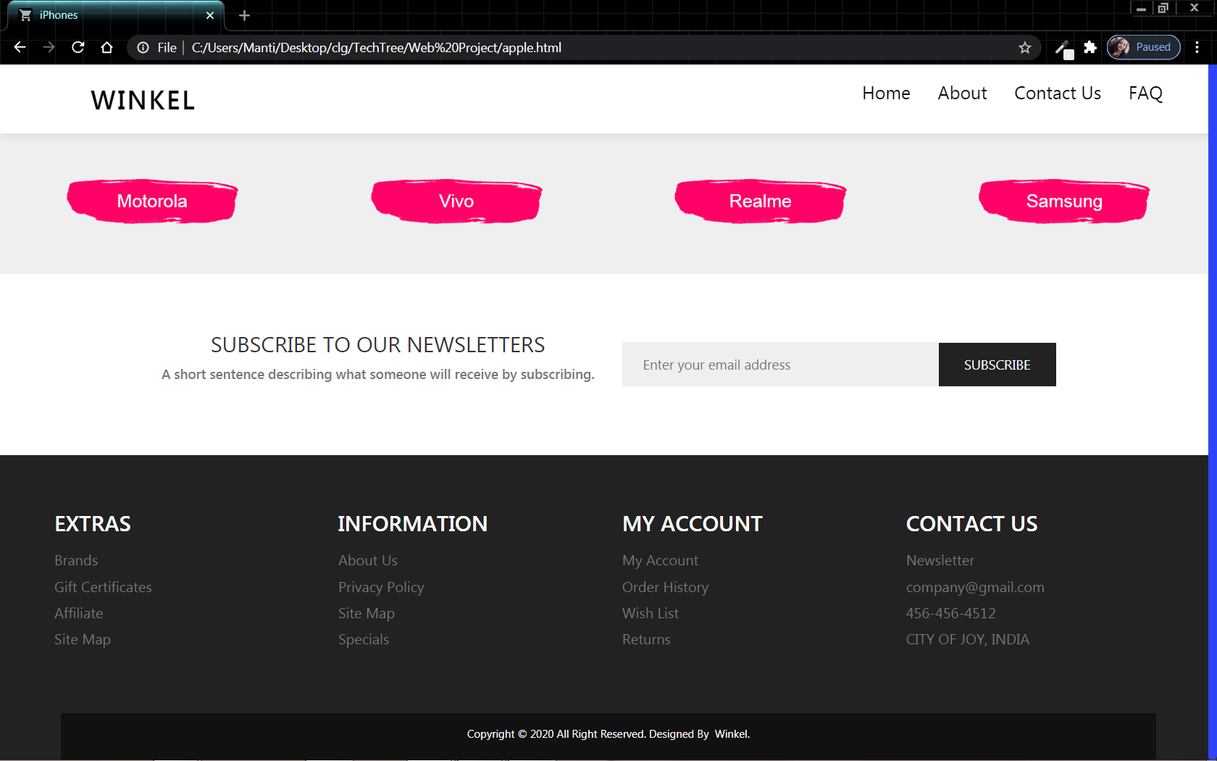

**15.5.2.Buy & Sell Page:**

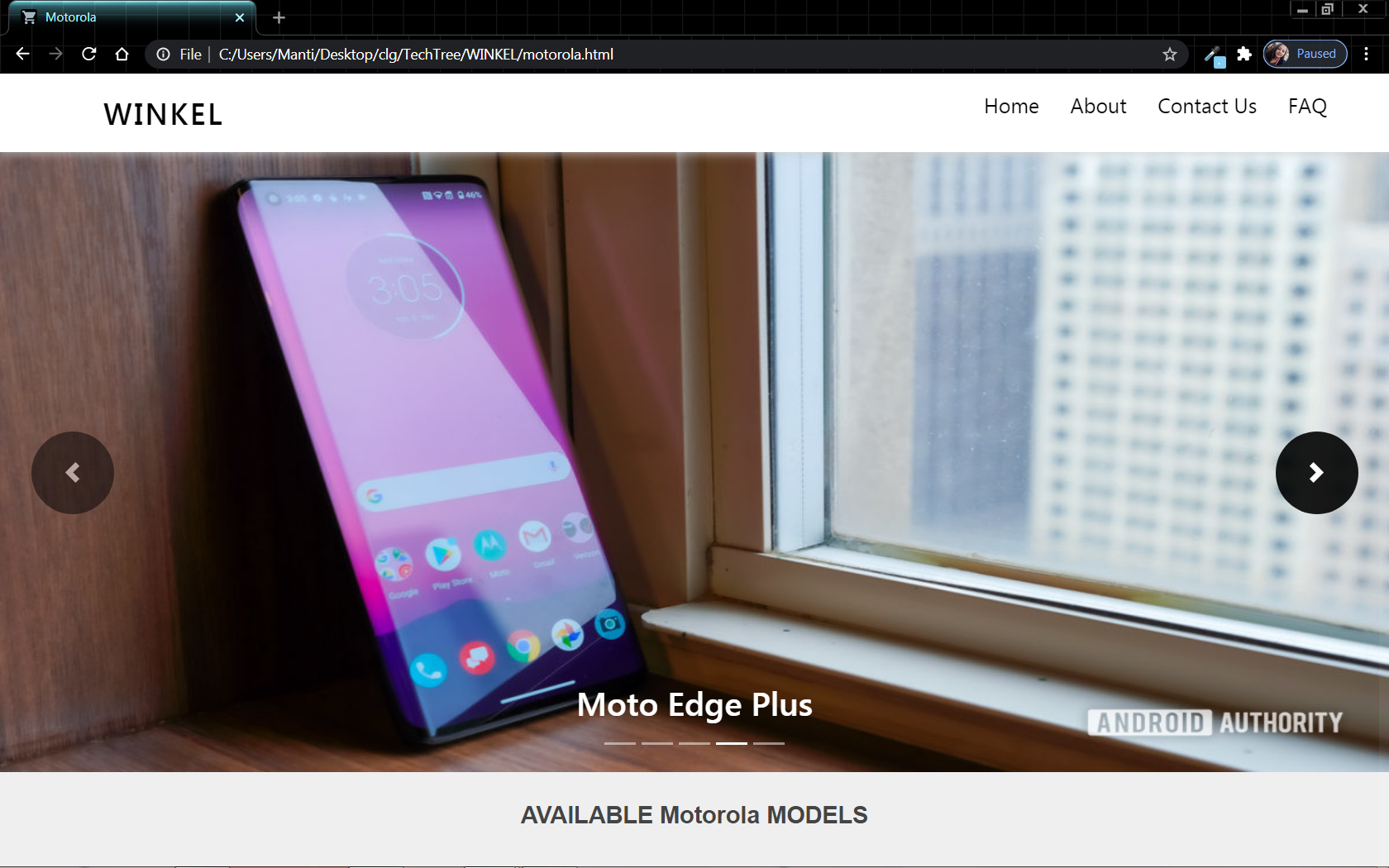

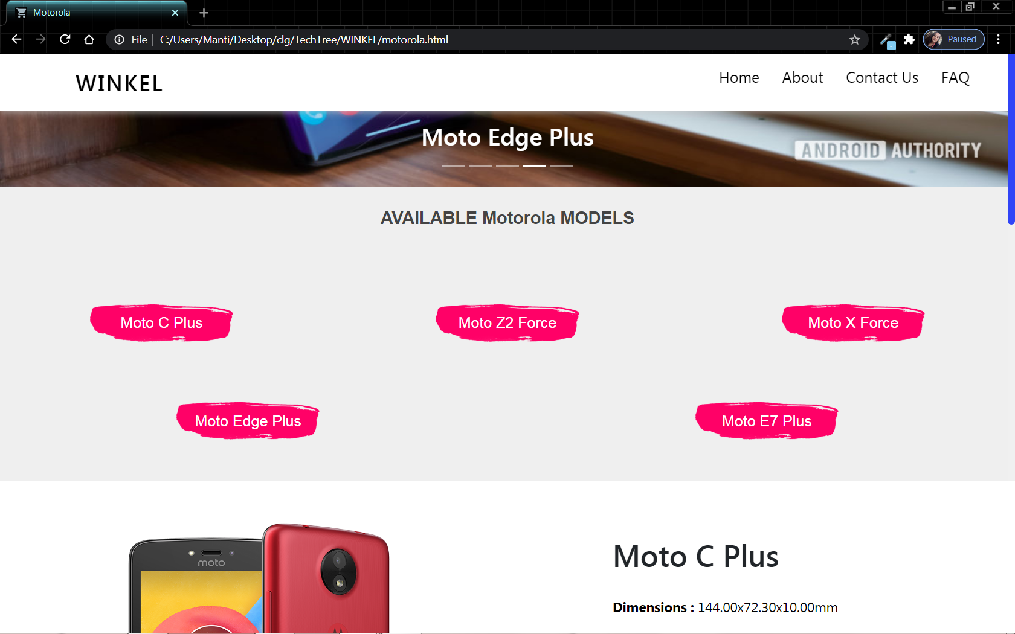

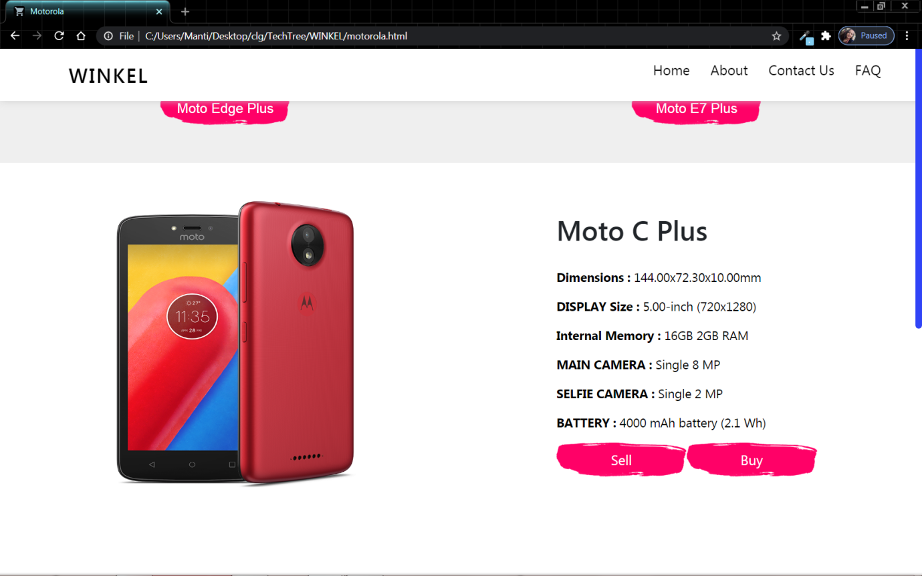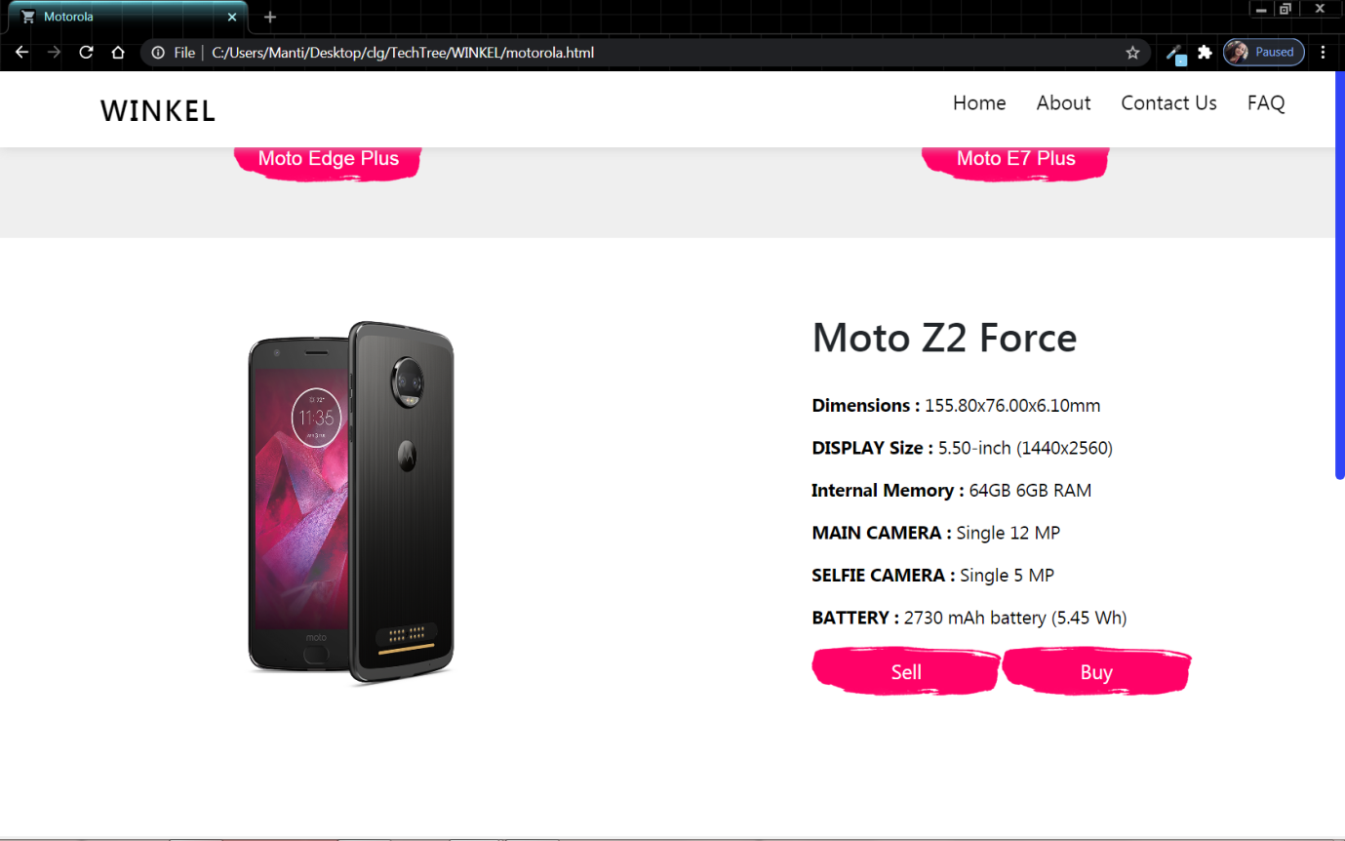

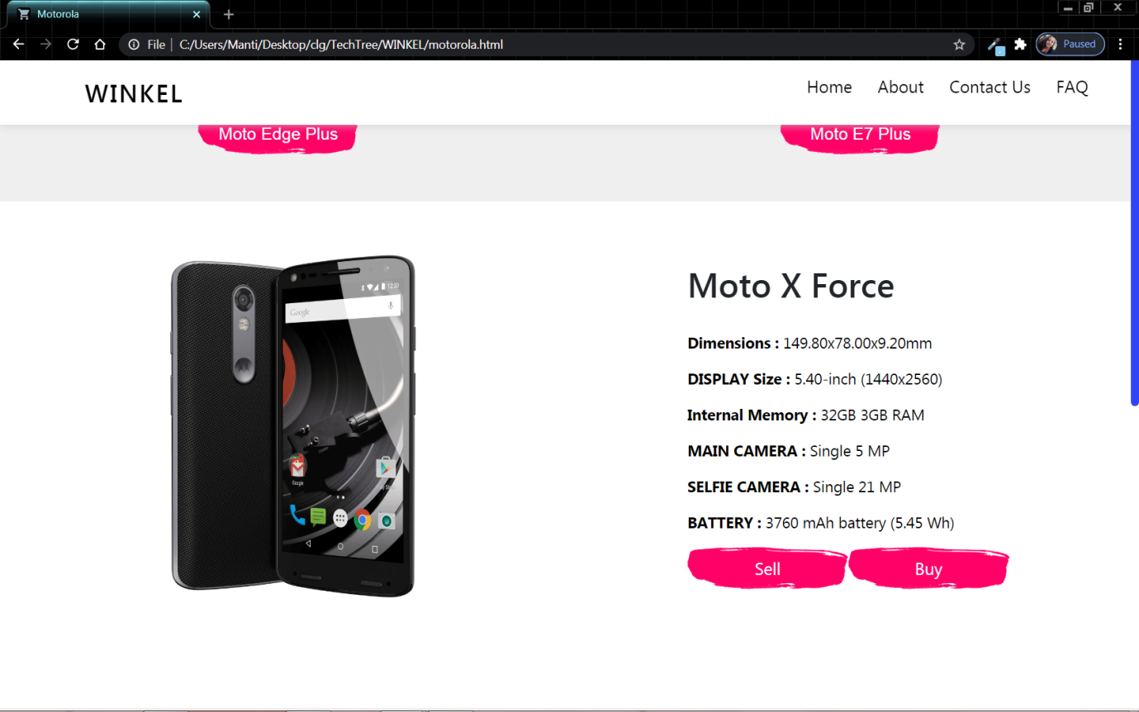

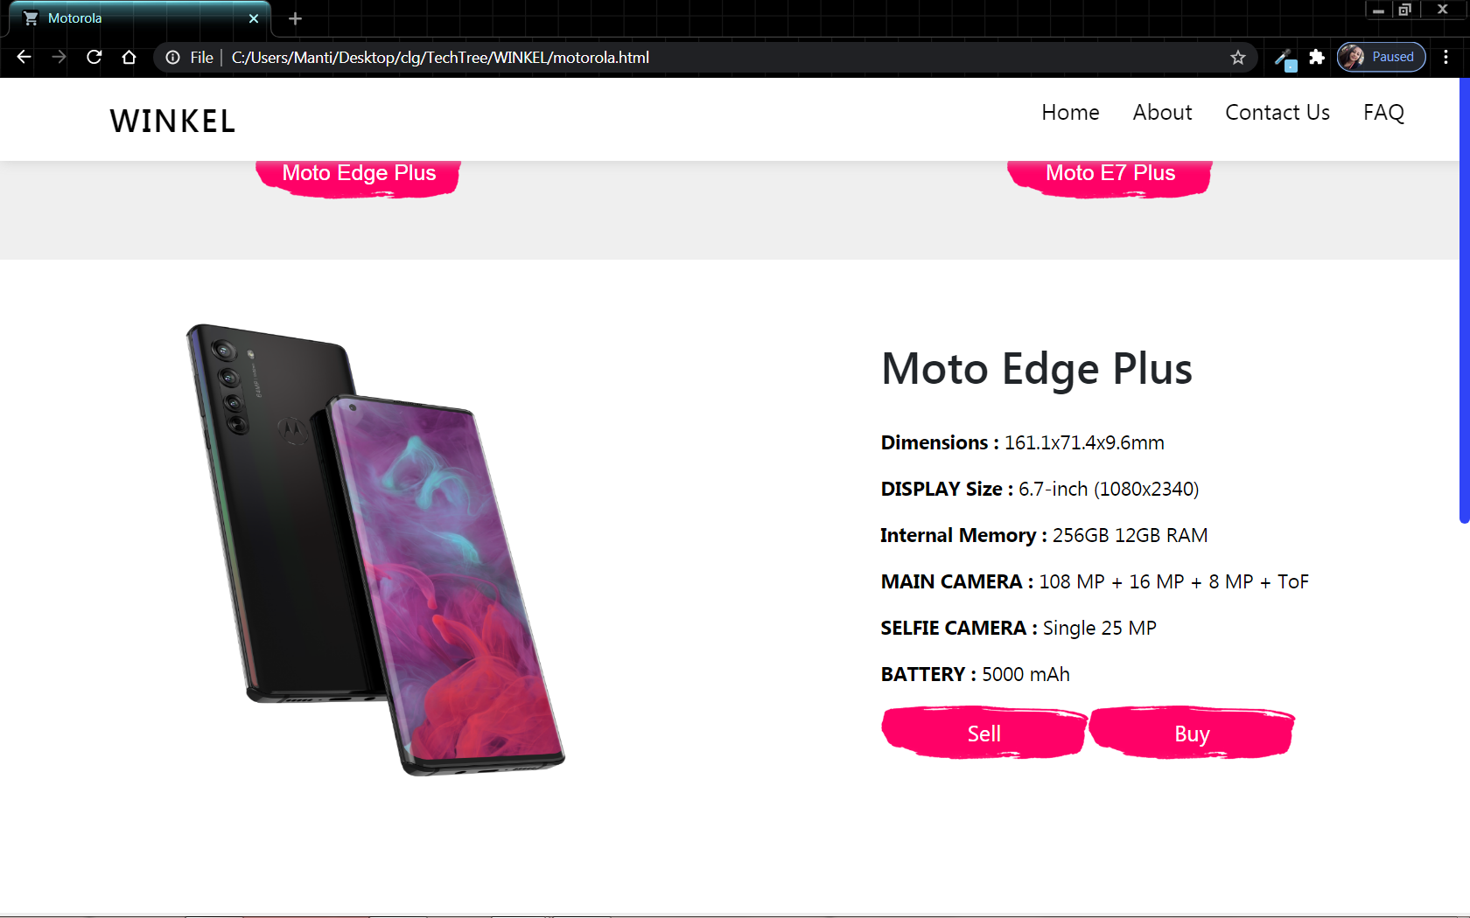

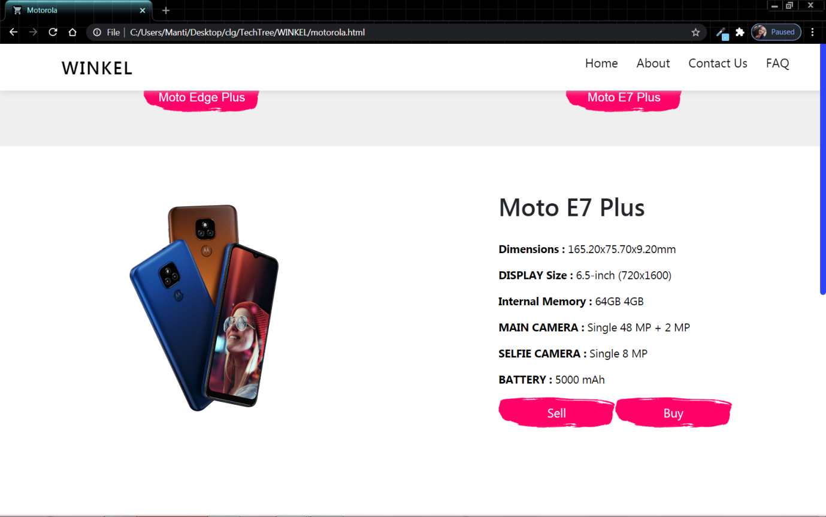

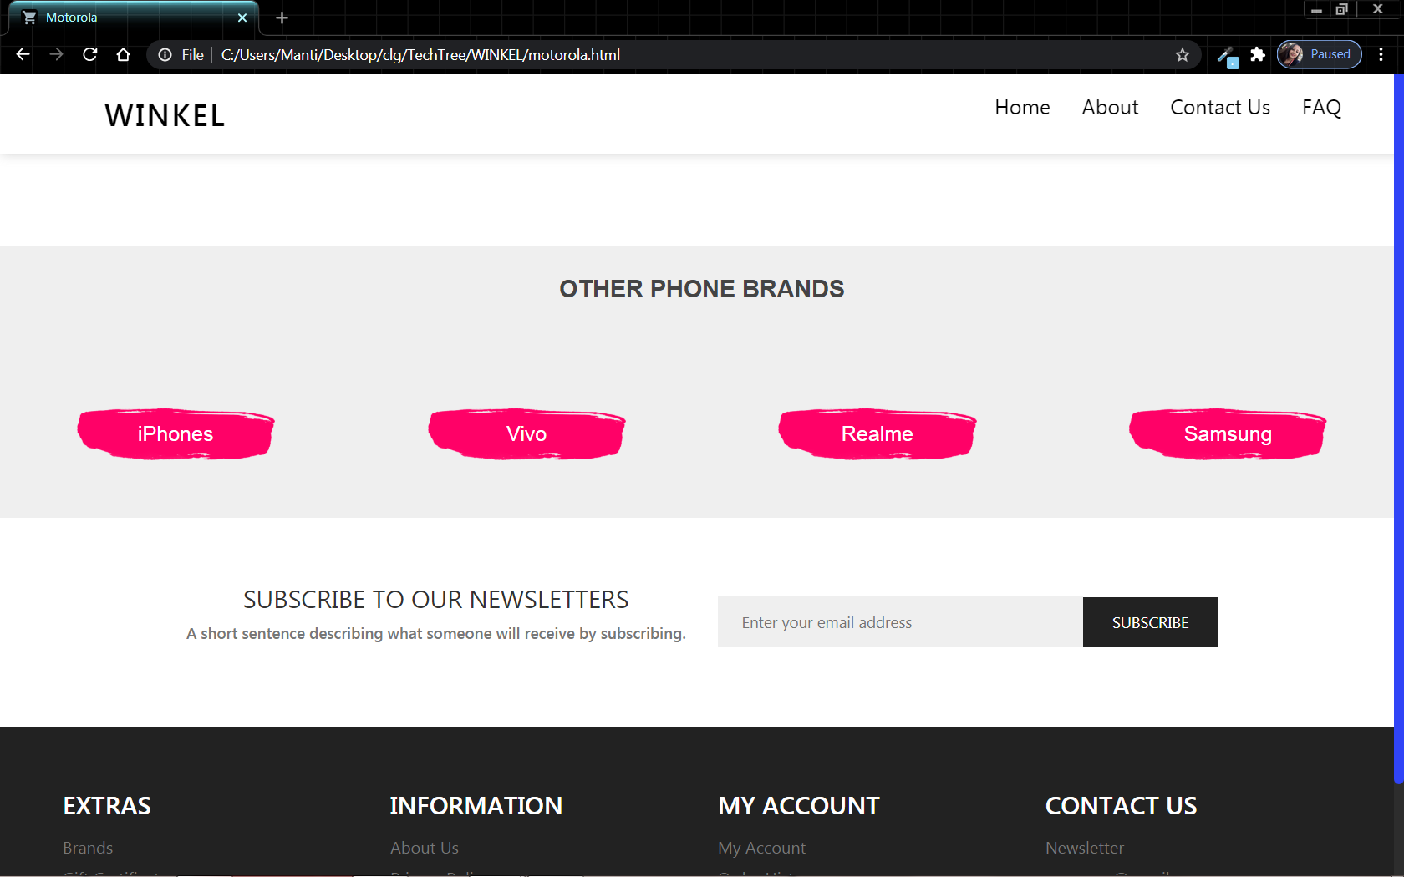



**15.5.3.Buy & Sell Page:**

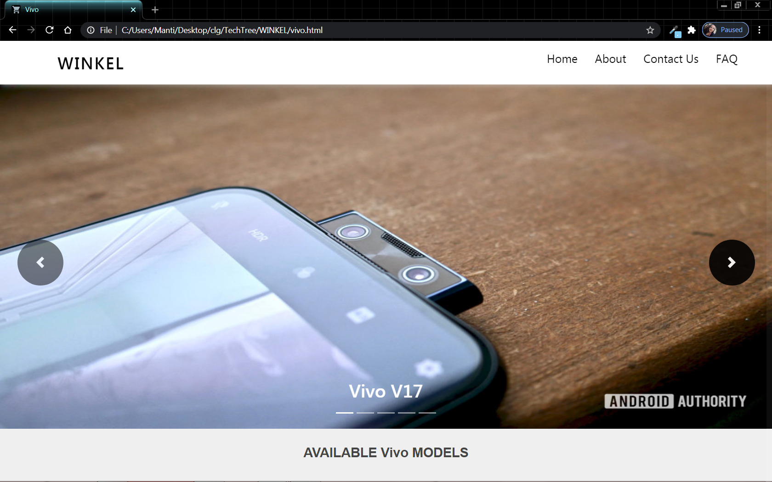

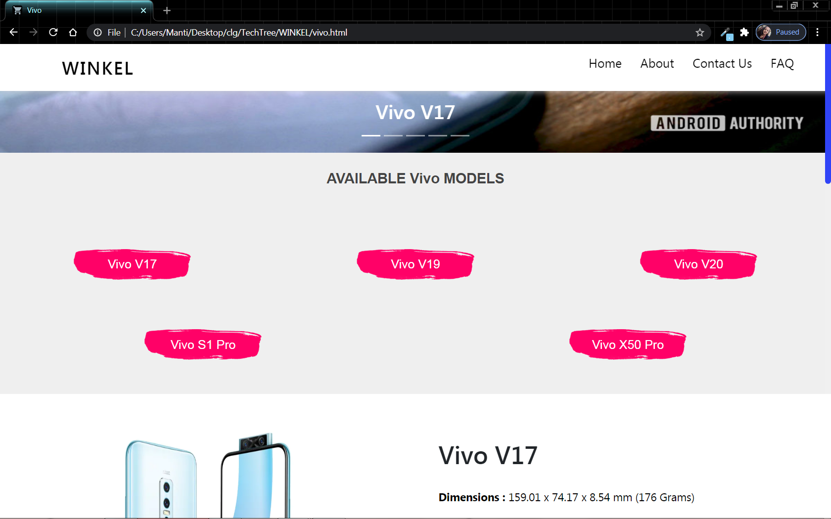

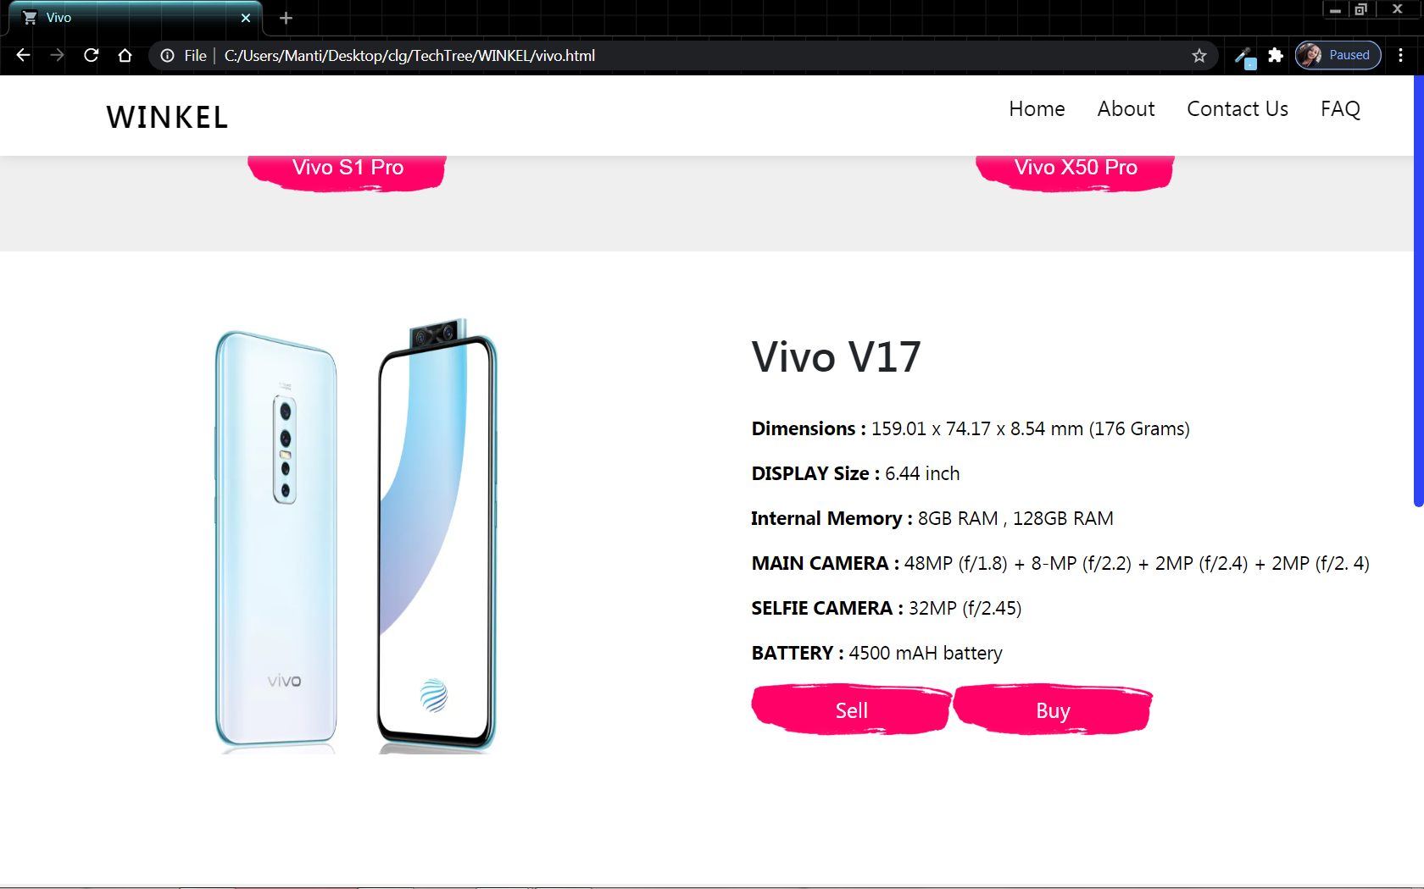

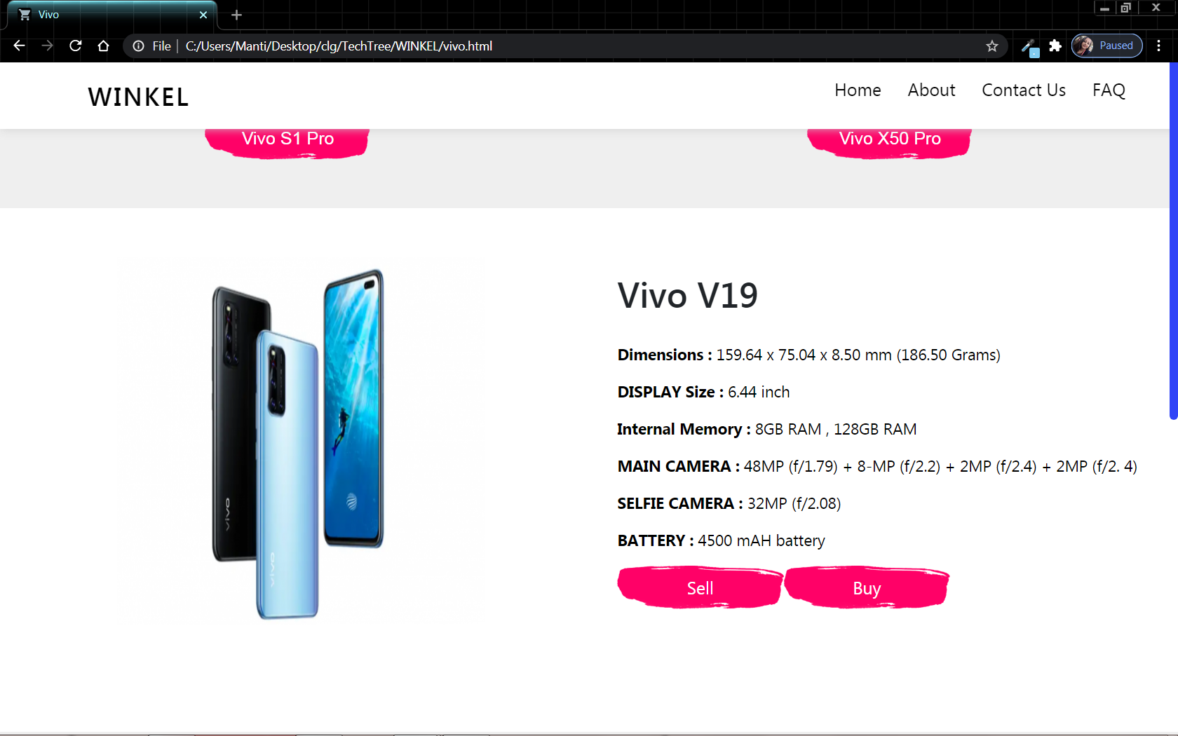

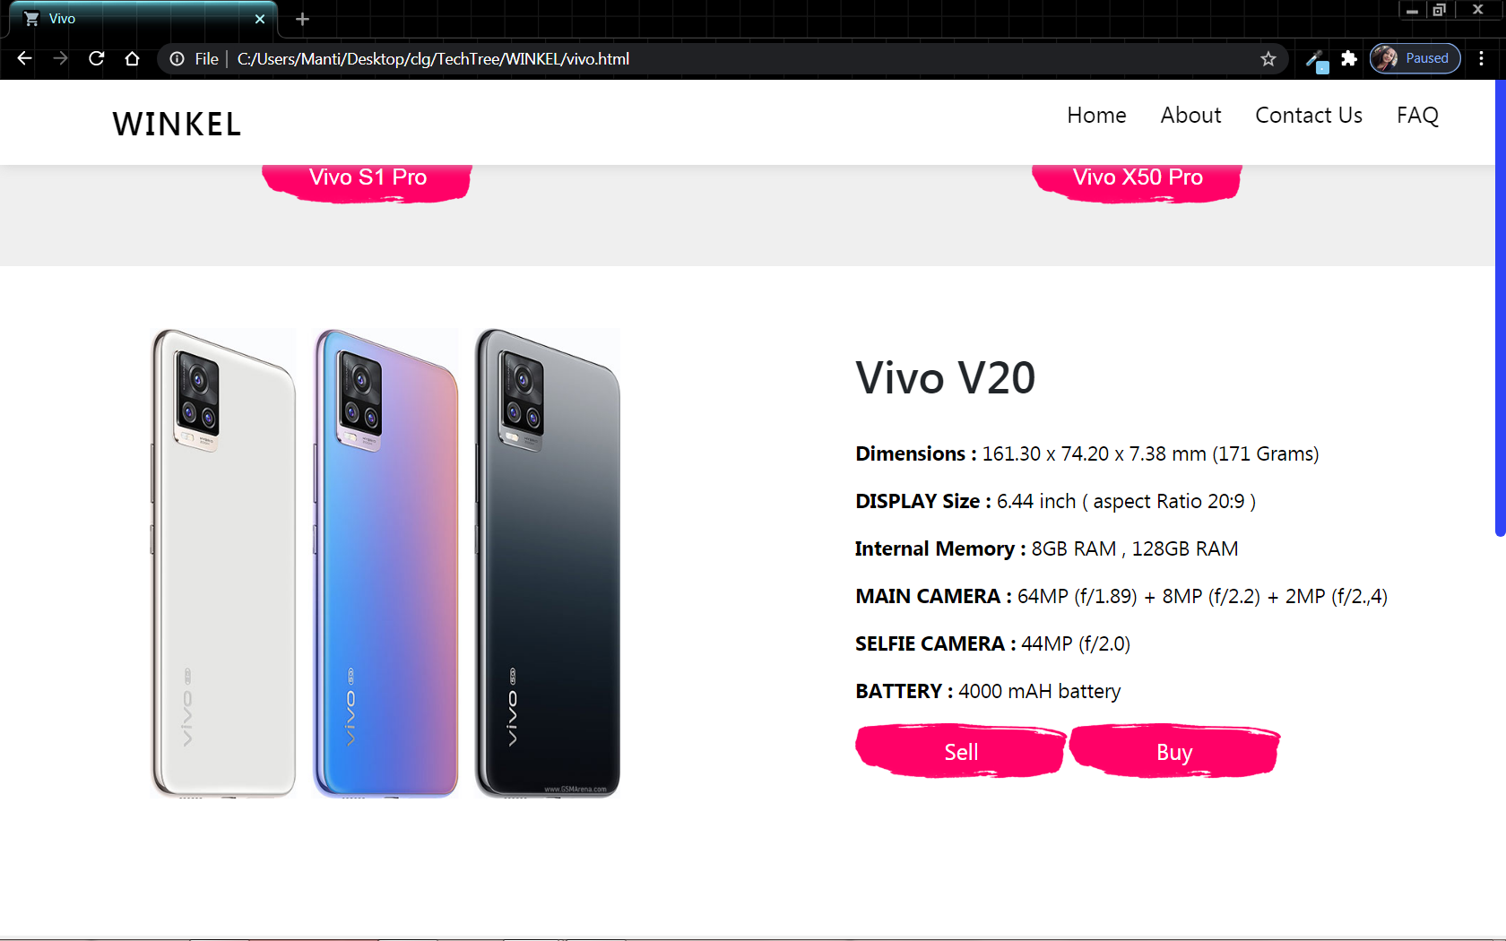

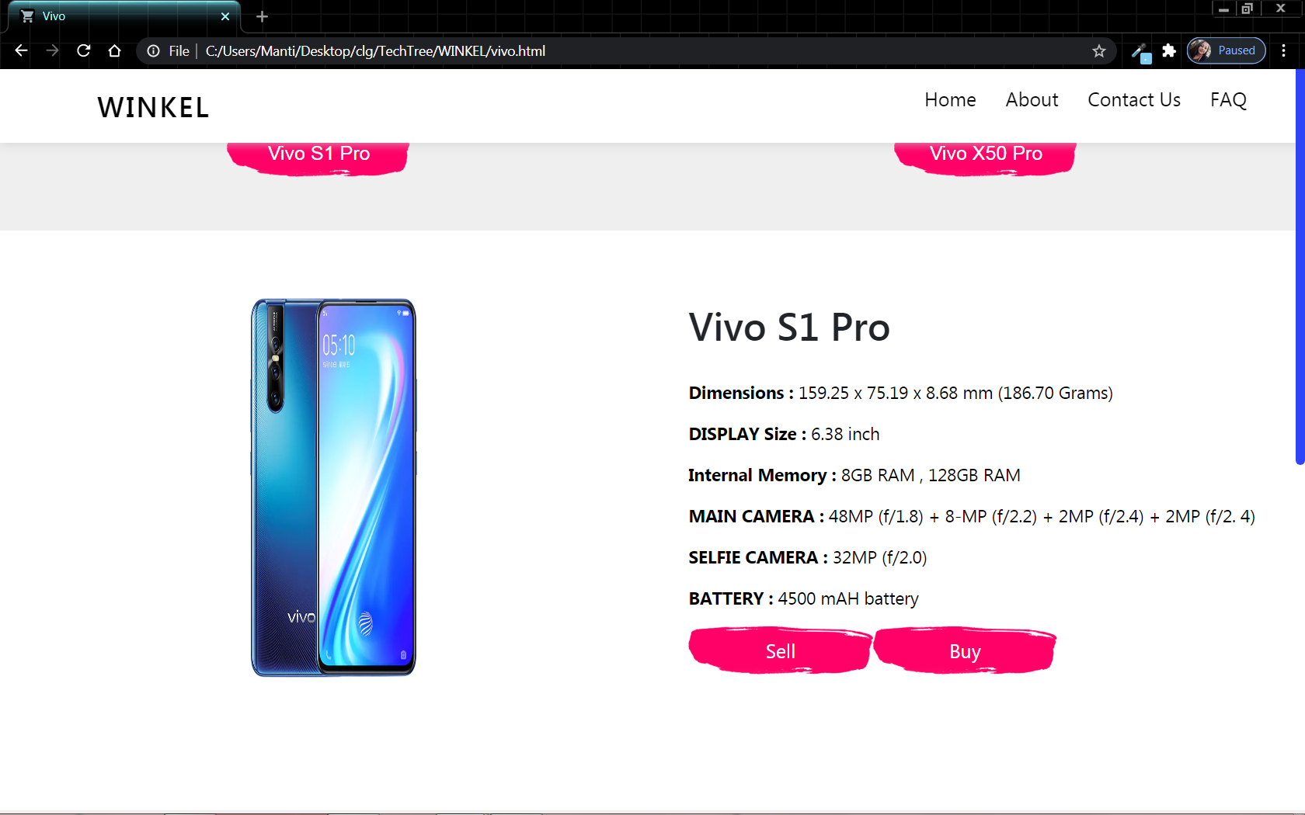

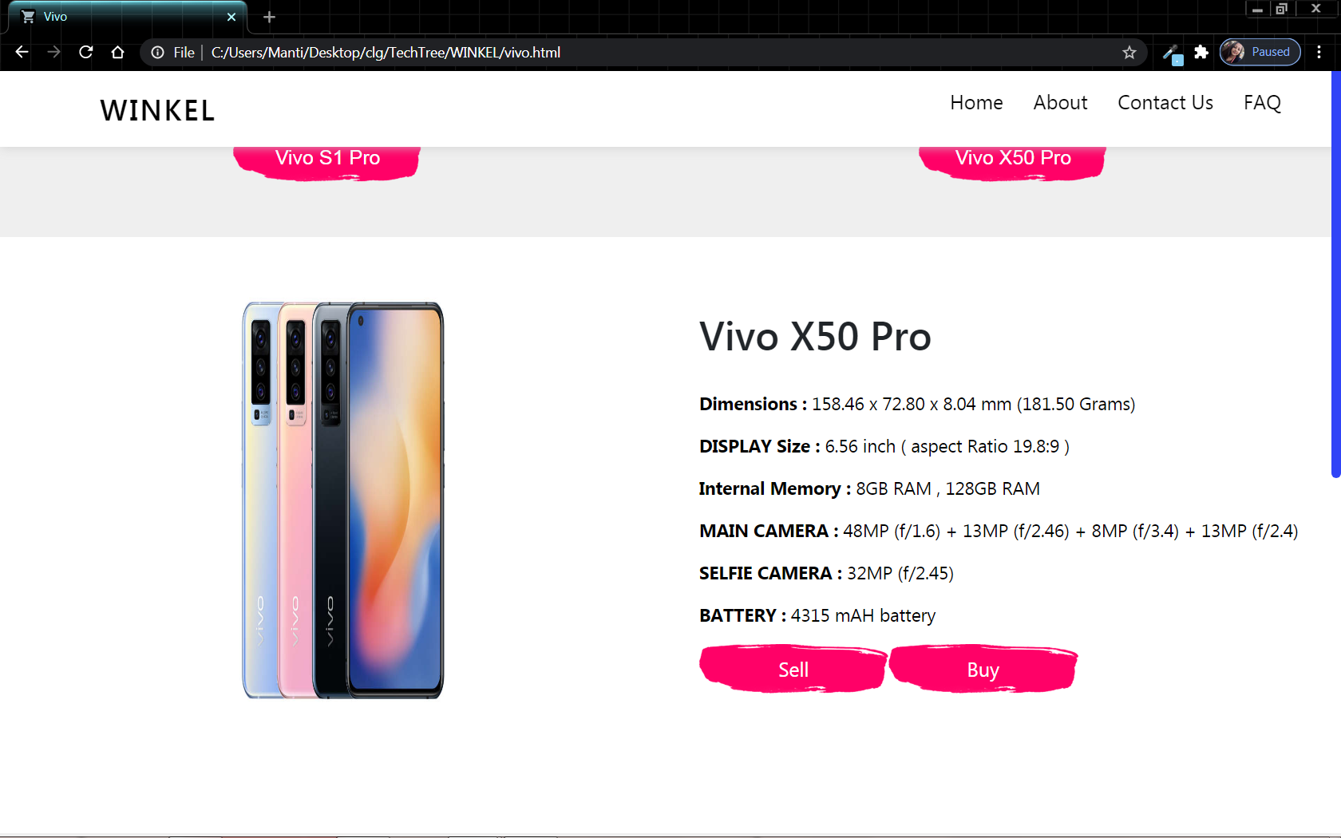

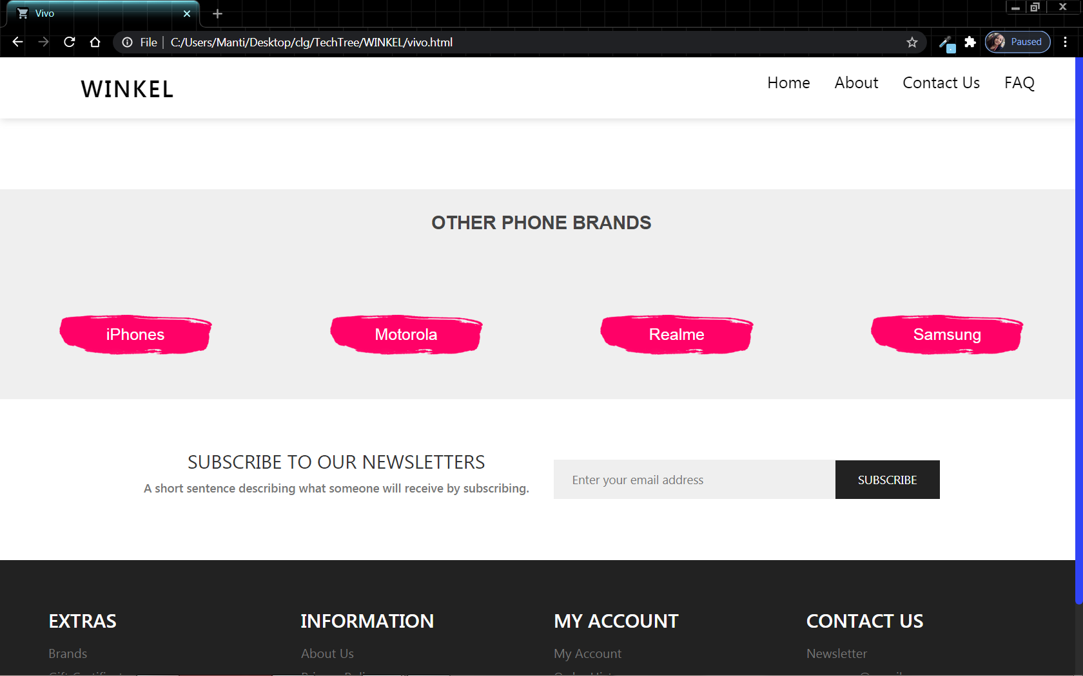



**15.5.4.Buy & Sell Page:**

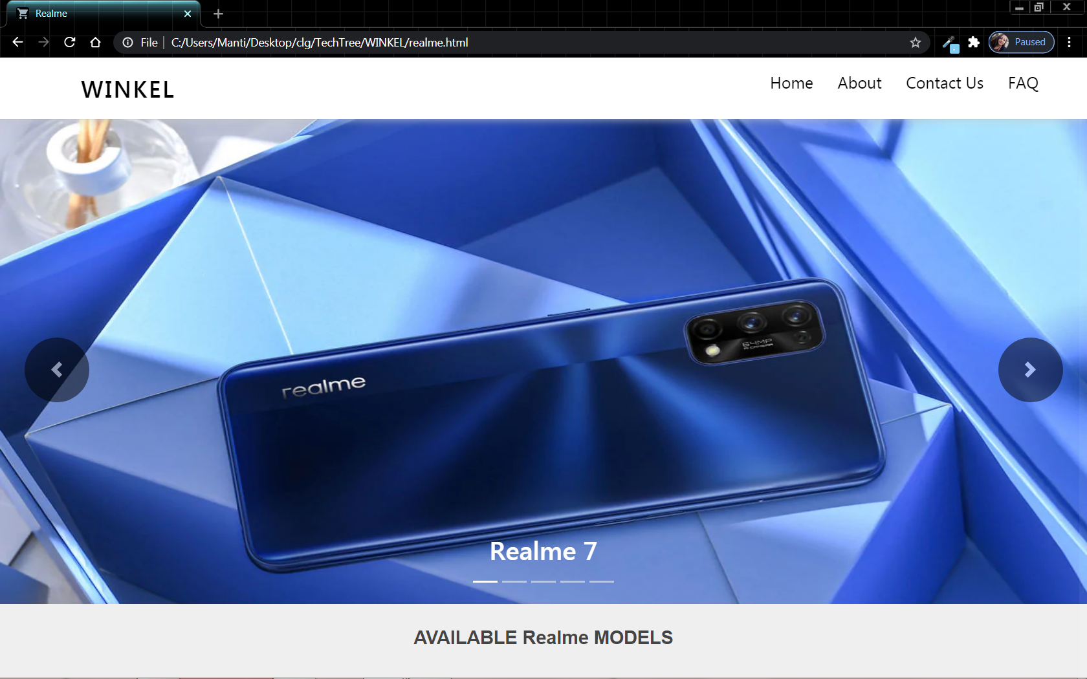

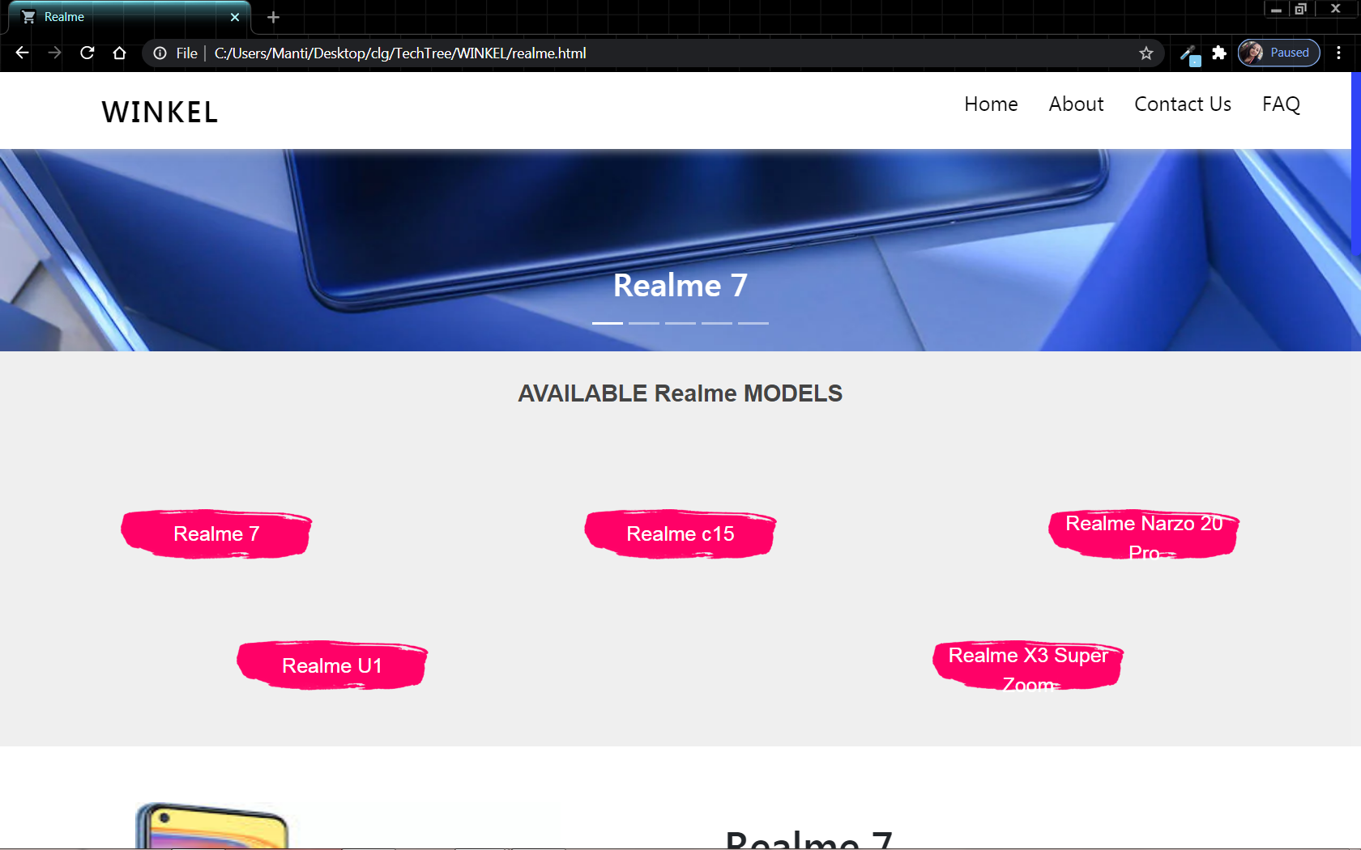

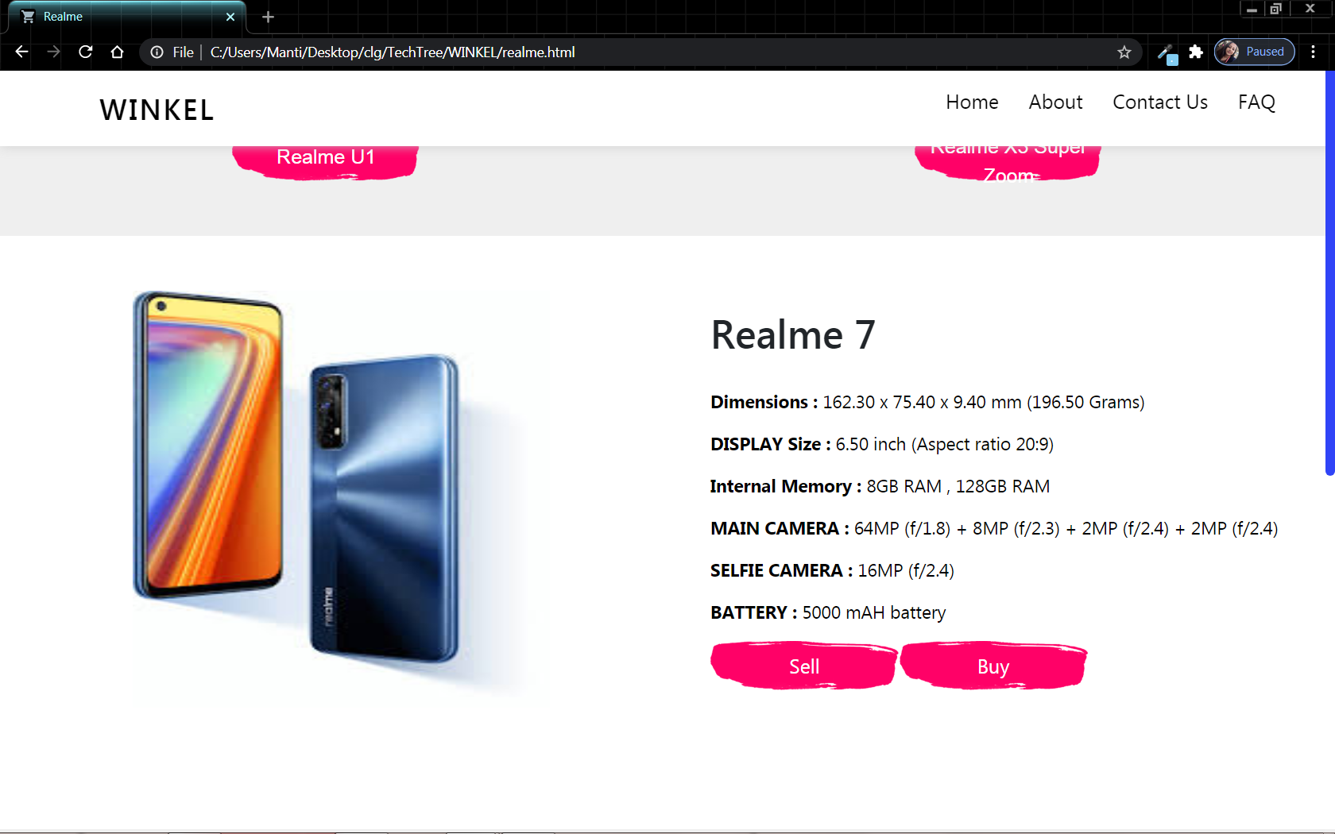

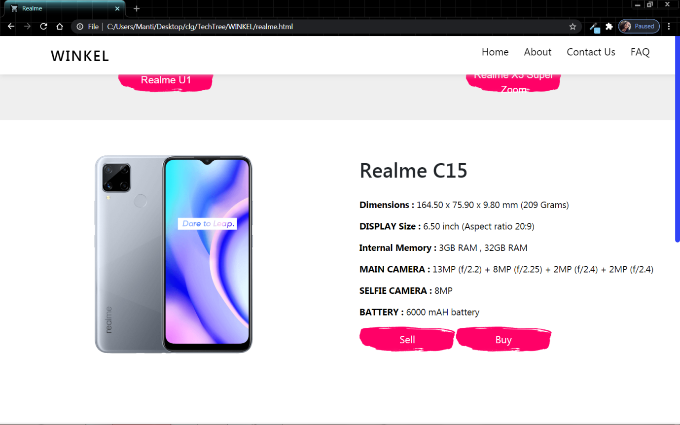

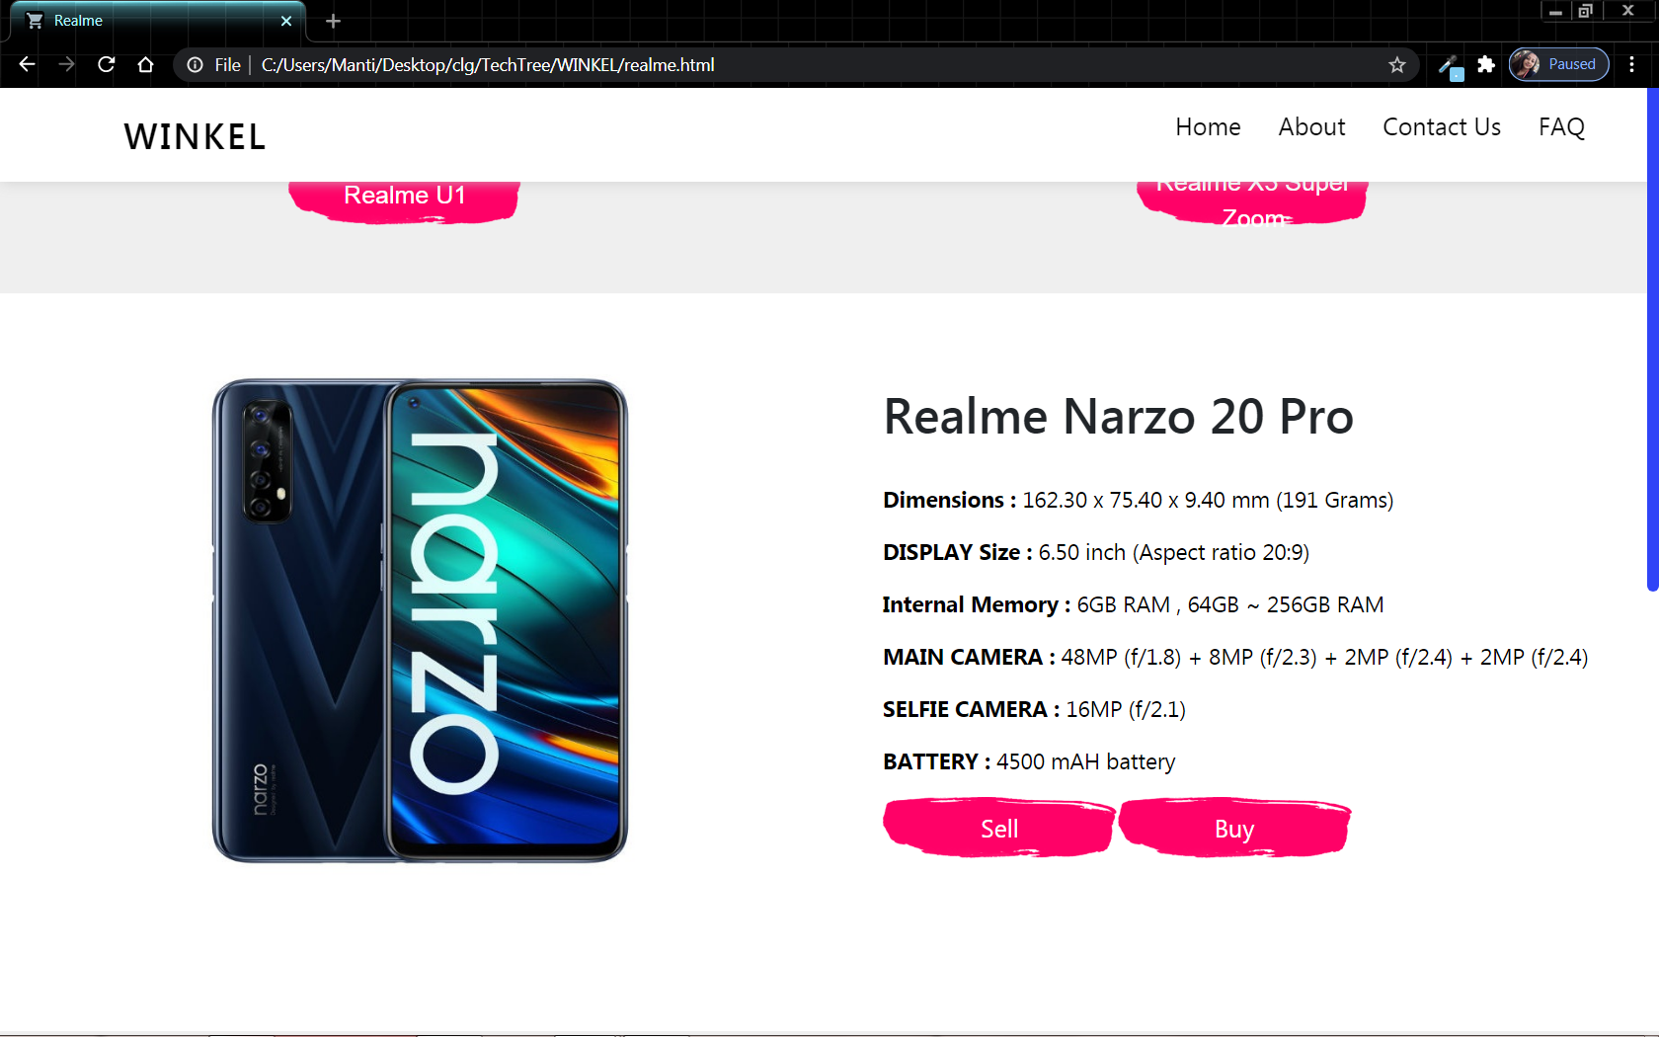

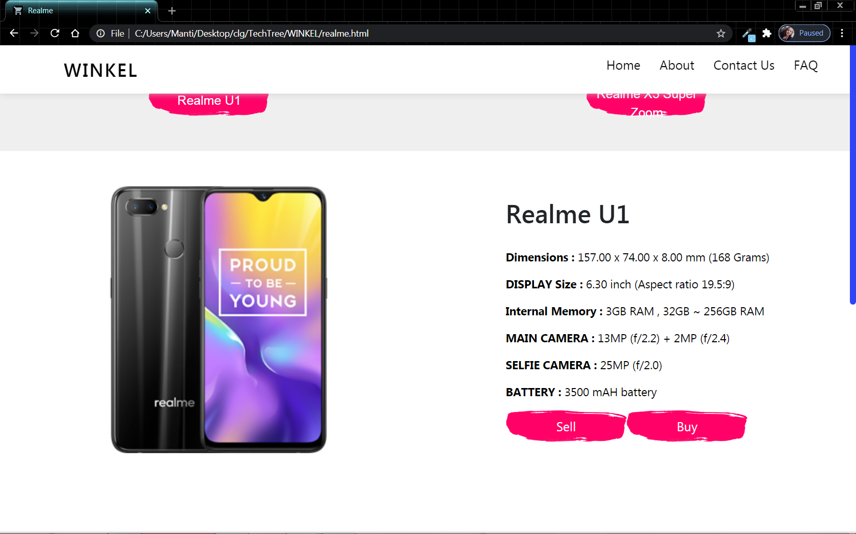

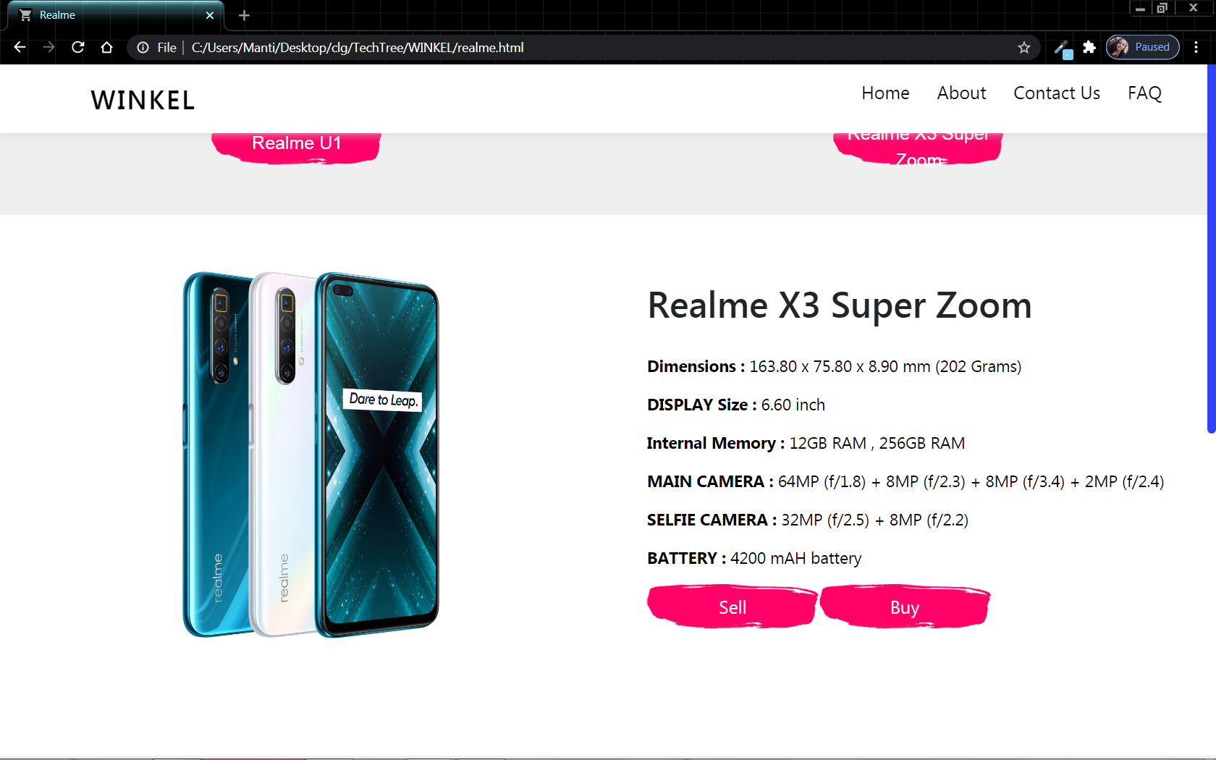

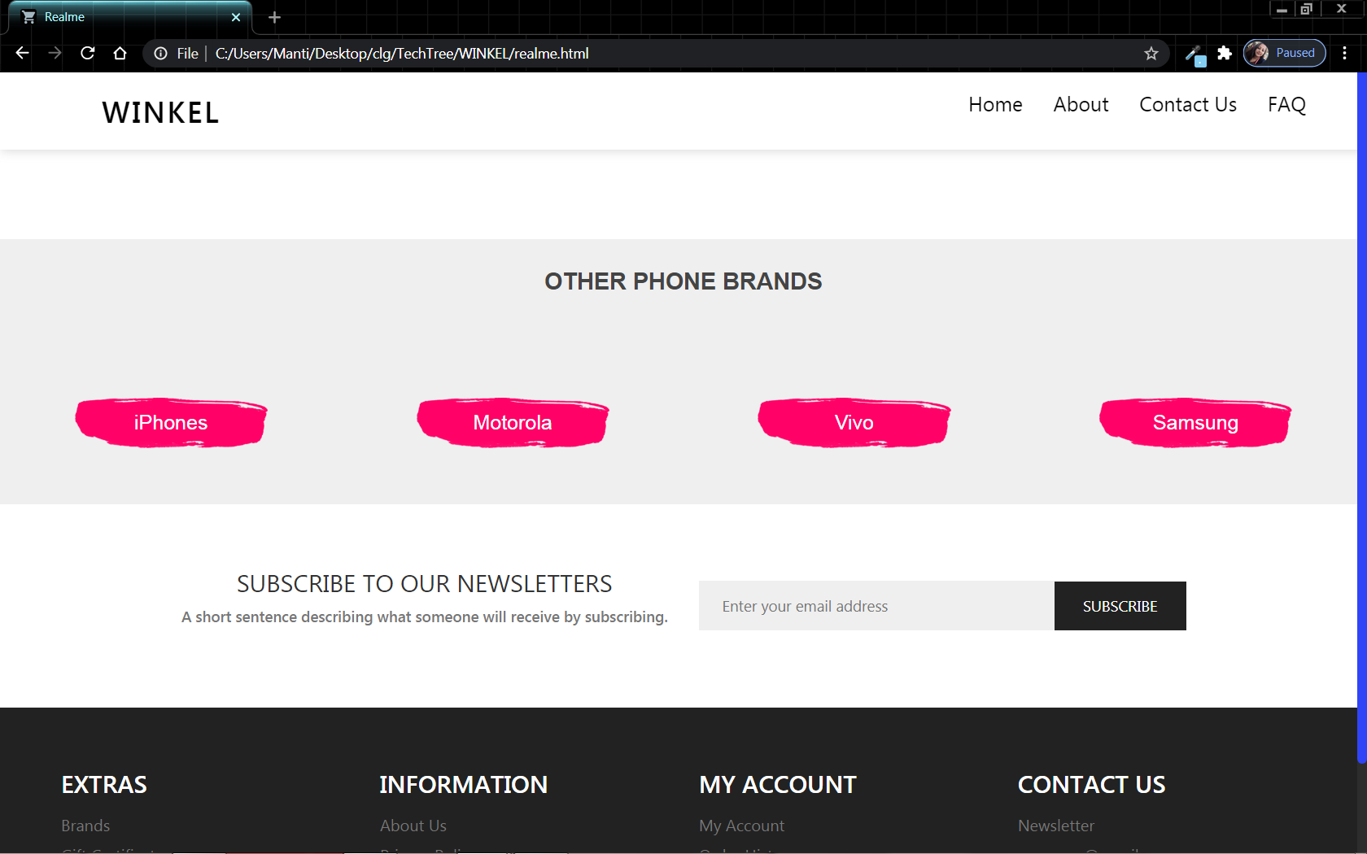



**15.5.5.Buy & Sell Page:**

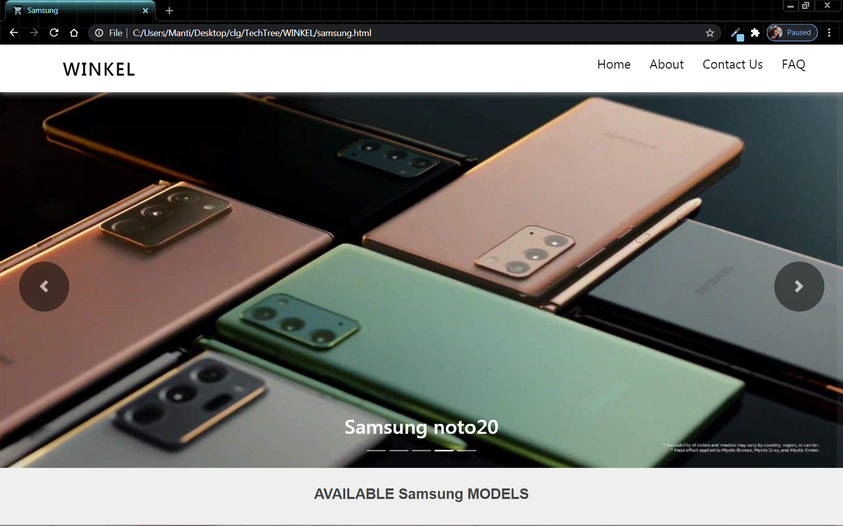

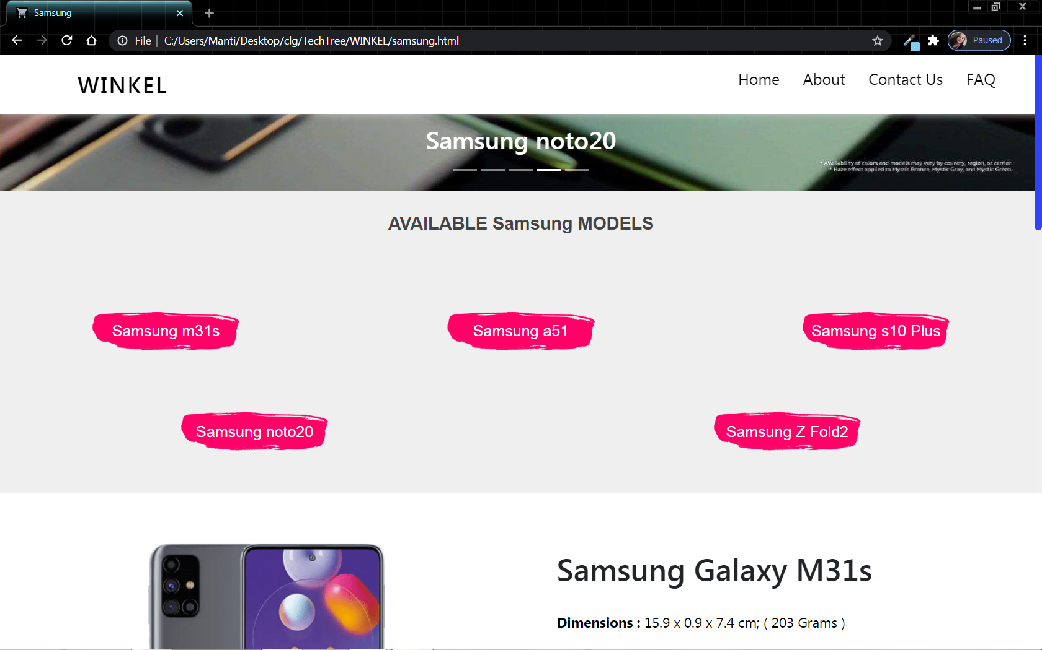

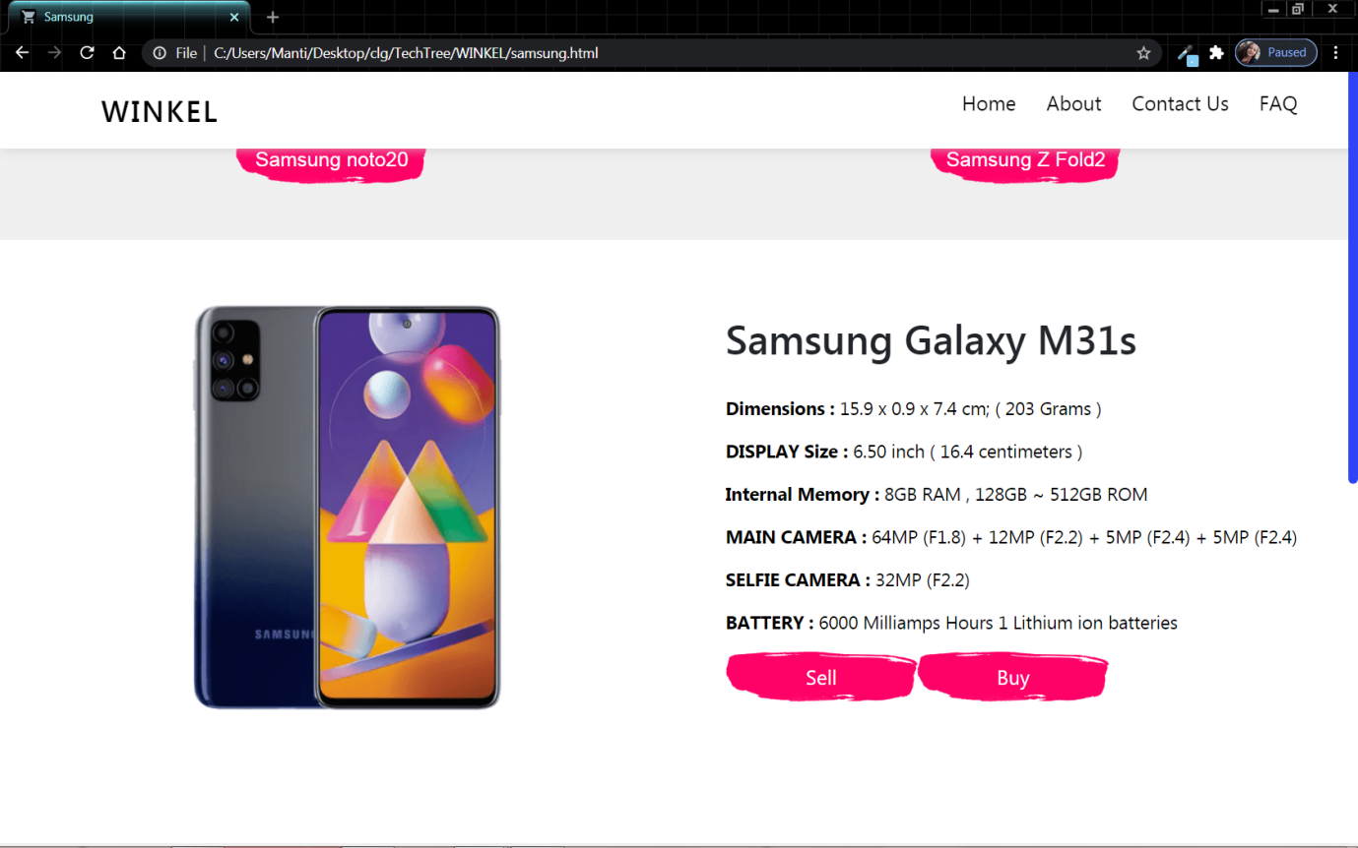

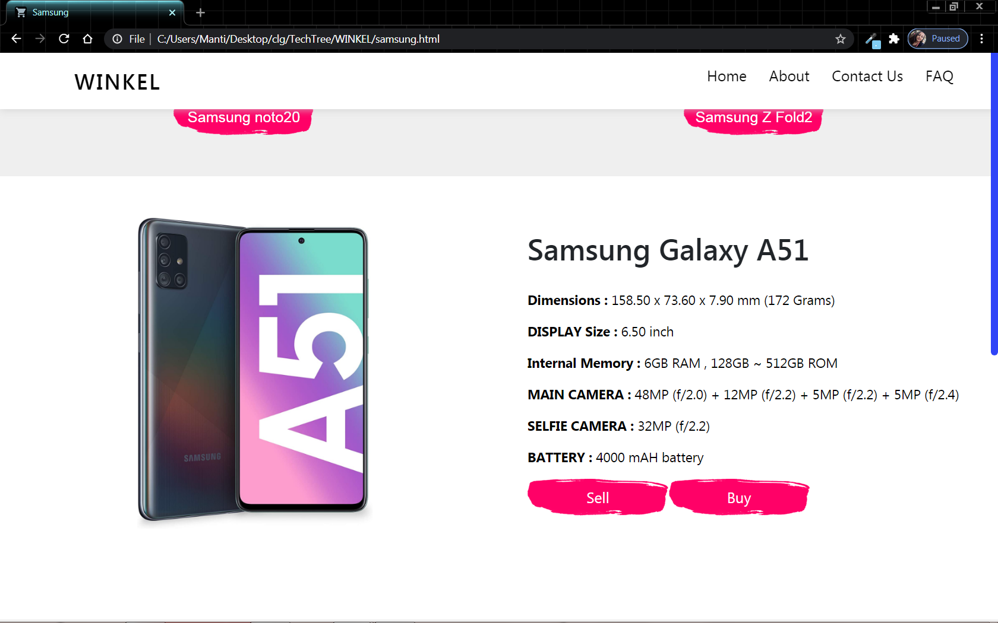

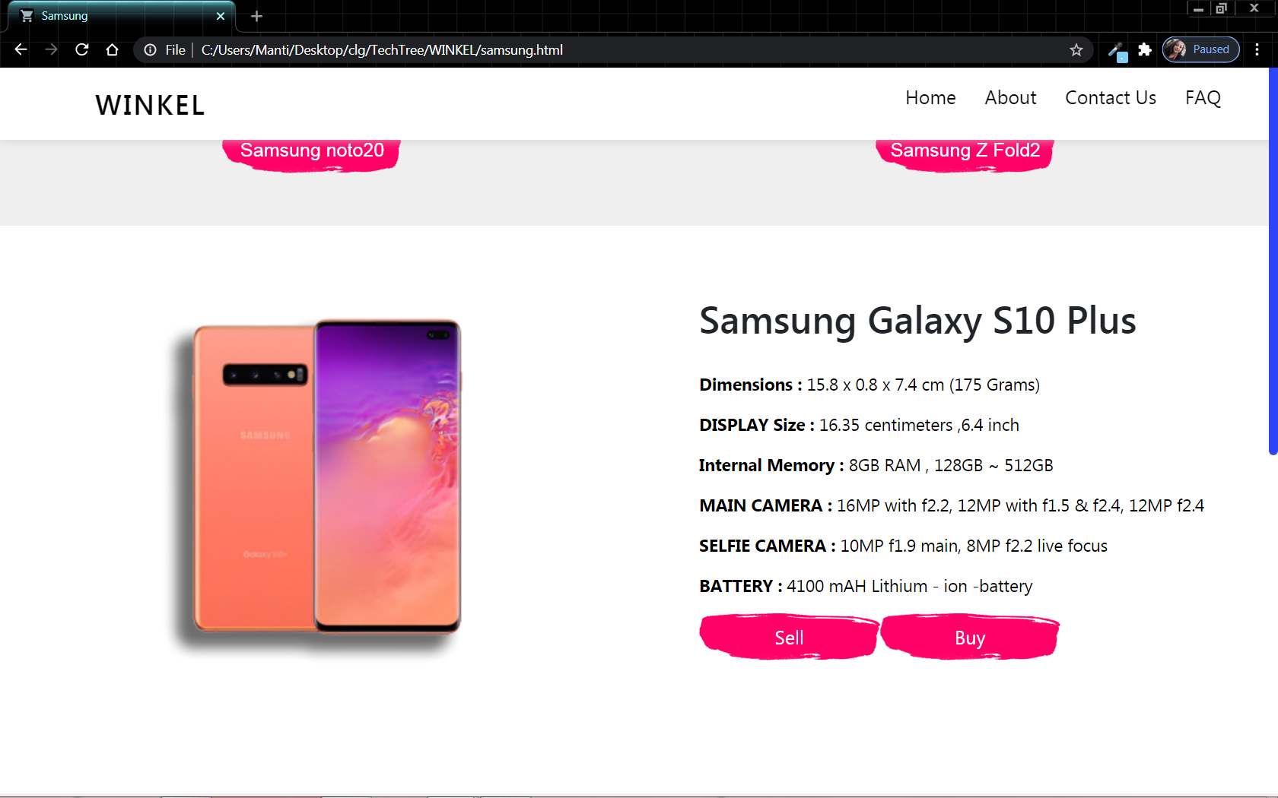

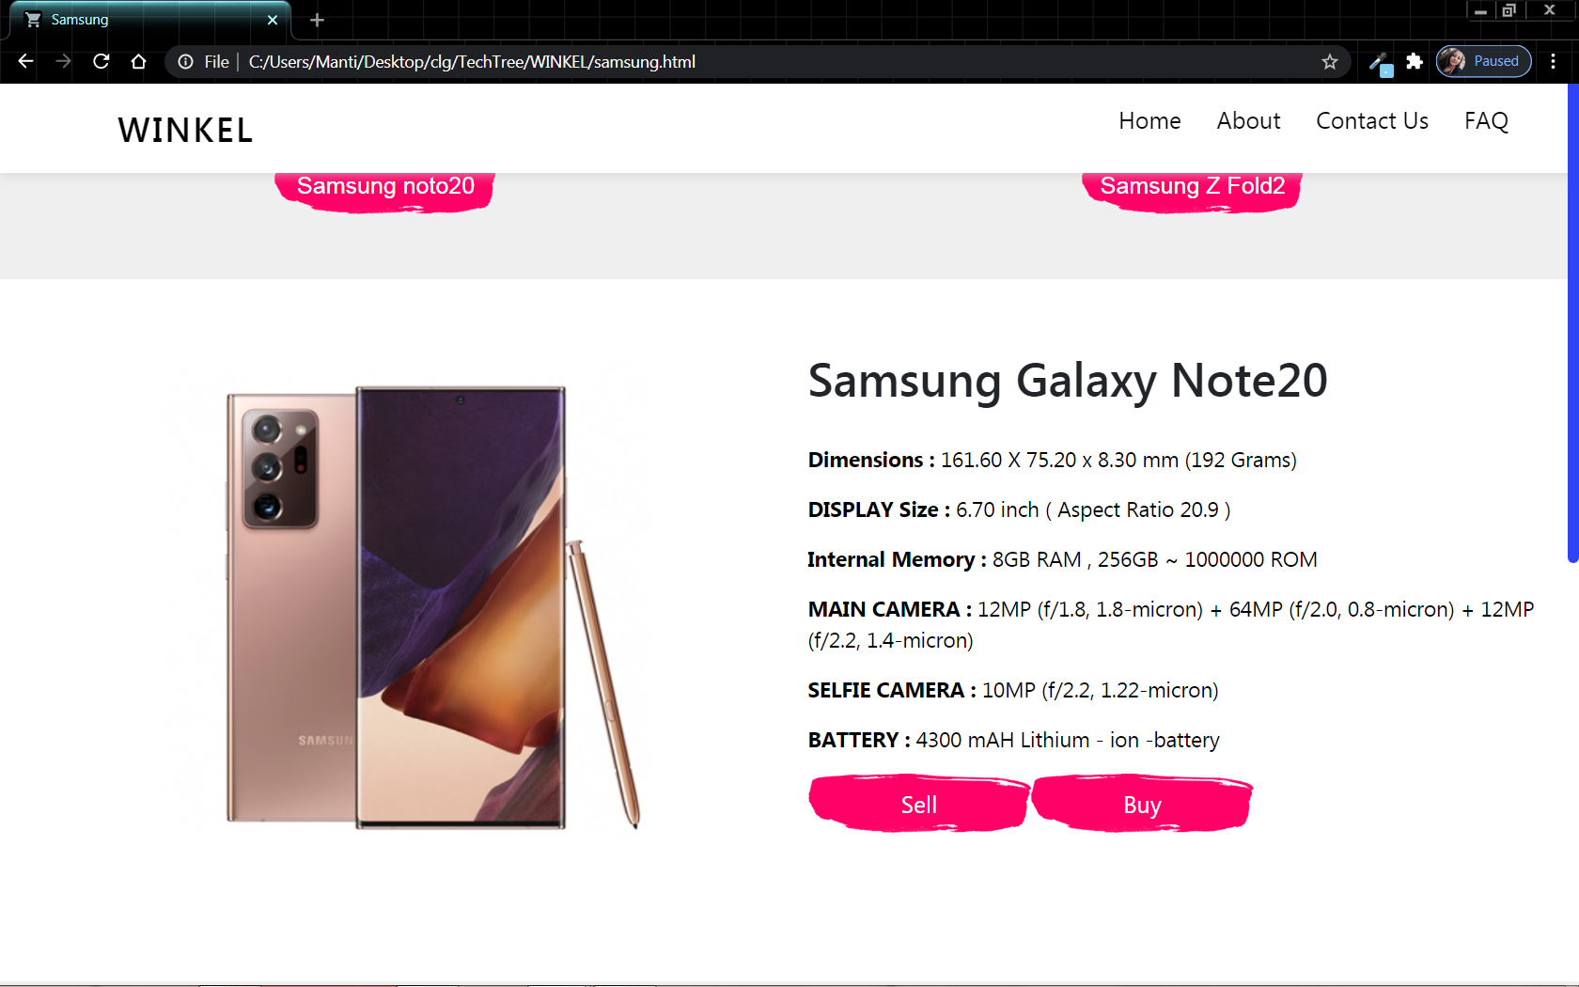

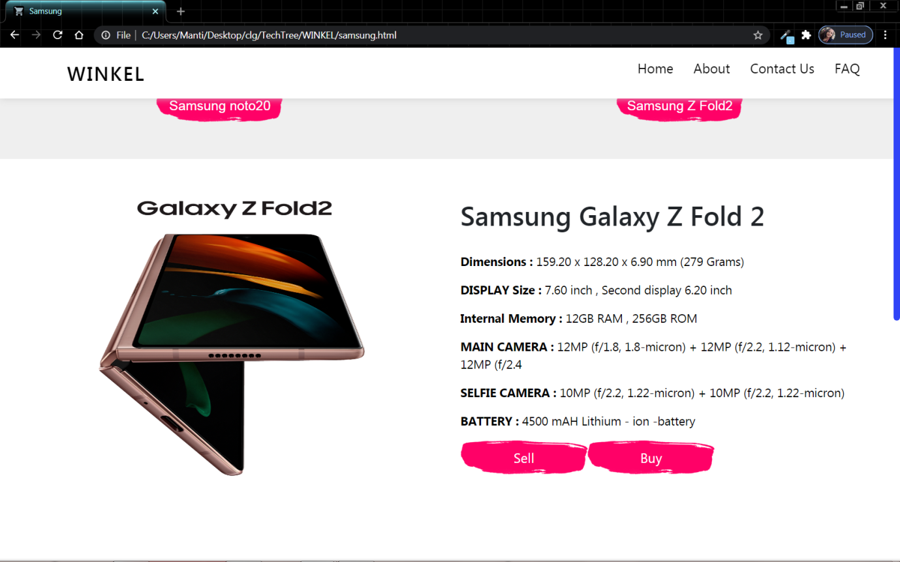

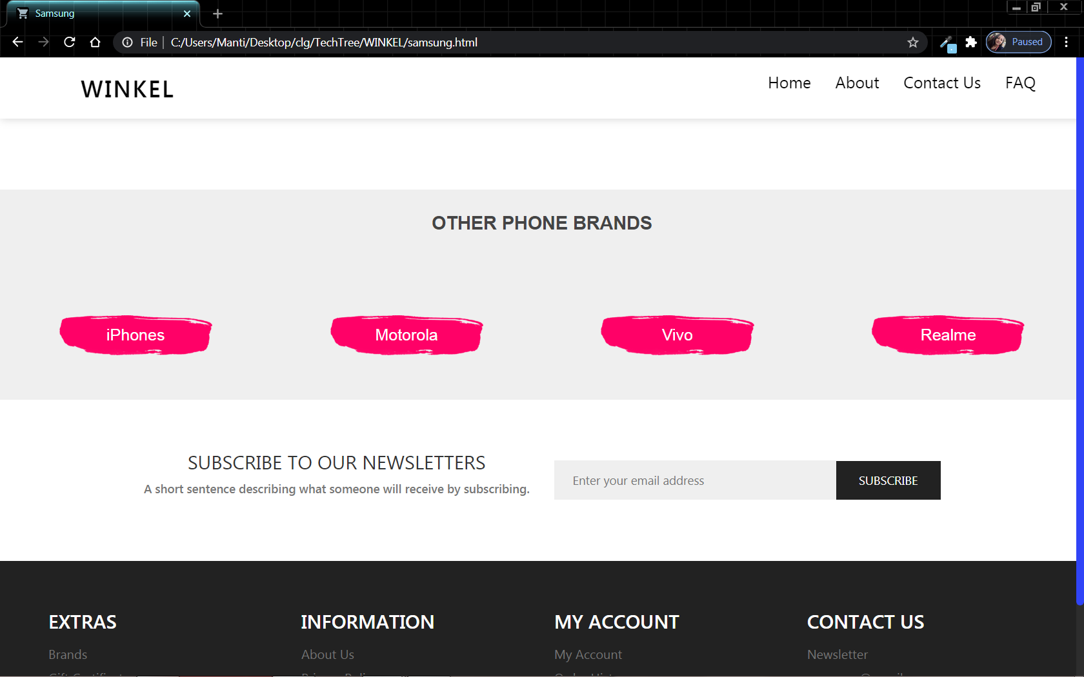



**Coding**

**Home Page**

<!DOCTYPE html>

<html>

<head>

<meta charset="utf-8">

<meta name="viewport" content="width=device-width, initial-scale=1.0, shrink-to-fit=no">

<link rel="stylesheet" href="https://stackpath.bootstrapcdn.com/bootstrap/4.5.2/css/bootstrap.min.css" integrity="sha384-JcKb8q3iqJ61gNV9KGb8thSsNjpSL0n8PARn9HuZOnIxN0hoP+VmmDGMN5t9UJ0Z" crossorigin="anonymous">

<link rel="stylesheet" href="https://pro.fontawesome.com/releases/v5.10.0/css/all.css" integrity="sha384-AYmEC3Yw5cVb3ZcuHtOA93w35dYTsvhLPVnYs9eStHfGJvOvKxVfELGroGkvsg+p" crossorigin="anonymous"/>

<link rel="stylesheet" href="https://unpkg.com/swiper/swiper-bundle.min.css">

<title>Winkel</title>

<link rel="icon" type="image/ico" href="image/logo.ico">

<link rel="stylesheet" type="text/css" href="css/index_style.css">

<script src="https://unpkg.com/sweetalert/dist/sweetalert.min.js"></script>

</head>

<body>

<!-- scroll bar -->

<div id="progressbar"></div>

<div id="scrollpath"></div>

<!-- <div id="percent"></div> -->

<!-- end of scroll bar -->

<!-- 1st section -->

<section class="b-section1">

<header class="b-header">

<a href="index.html" class="b-logo">Winkel</a>

<ul class="b-nav">

<li class="b-li d-none d-lg-block"><a class="b-menu" href="index.html"><span class="active">Home</span></a></li>

<li class="b-li d-none d-lg-block"><a class="b-menu" href="aboutus.html"><span>About</span></a></li>

<li class="b-li d-none d-lg-block"><a class="b-menu" href="contactus.html"><span>Contact Us</span></a></li>

<li class="b-li d-none d-lg-block"><a class="b-menu" style="margin-right: 0;" href="faq.html"><span>FAQ</span></a></li>

<li class="d-block d-lg-none"><img src="image/menu.png" class="b-menu-img" onclick="openNav()"></li>

</ul>

<div id="myNav" class="overlay d-block d-lg-none">

<a href="javascript:void(0)" class="closebtn" onclick="closeNav()">&times;</a>

<div class="overlay-content">

<a href="index.html"><span class="active">Home</span></a>

<a href="aboutus.html"><span>About</span></a>

<a href="contactus.html"><span>Contact US</span></a>

<a href="faq.html"><span>FAQ</span></a>

</div>

</div>

</header>

<div class="b-content-out">

<div class="row">

<div class="col-lg-8" style="padding-top: 80px;z-index: 2;">

<div class="b-content-in">

<h2><span class="span1">Winkel</span></h2>

<p>Welcome to WINKEL,<br>Here you will get different types of phones of different brand. Hope you will like our phones.</p>

<a href="aboutus.html">Our Story</a>

</div>

</div>

<div class="col-lg-4" style="align-items: center;justify-content: center;display: flex;padding-top: 80px;"><img src="image/img1.png" width="450"></div>

</div>

</div>

</section>

<!-- end of 1st section -->

<!-- 2nd section -->

<section class="b-section2">

<div id="carouselExampleFade" class="carousel slide carousel-fade" data-ride="carousel">

<ol class="carousel-indicators">

<li data-target="#carouselExampleFade" data-slide-to="0" class="active"></li>

<li data-target="#carouselExampleFade" data-slide-to="1"></li>

<li data-target="#carouselExampleFade" data-slide-to="2"></li>

<li data-target="#carouselExampleFade" data-slide-to="3"></li>

<li data-target="#carouselExampleFade" data-slide-to="4"></li>

</ol>

<div class="carousel-inner">

<div class="carousel-item active">

<img src="image/apple1.jpg" style="width: 100%;height: 600px;" class="d-block w-100" alt="iPhone 12 Pro">

<div class="carousel-caption d-none d-md-block">

<h2>iPhone 12 Pro</h2>

</div>

</div>

<div class="carousel-item">

<img src="image/moto1.jpg" style="width: 100%;height: 600px;" class="d-block w-100" alt="">

<div class="carousel-caption d-none d-md-block">

<h2>Moto Edge+</h2>

</div>

</div>

<div class="carousel-item">

<img src="image/vivo1.jpg" style="width: 100%;height: 600px;" class="d-block w-100" alt="Vivo x50">

<div class="carousel-caption d-none d-md-block">

<h2>Vivo x50</h2>

</div>

</div>

<div class="carousel-item">

<img src="image/realme1.jpg" style="width: 100%;height: 600px;" class="d-block w-100" alt="realme7 Pro">

<div class="carousel-caption d-none d-md-block">

<h2>realme7 Pro</h2>

</div>

</div>

<div class="carousel-item">

<img src="image/samsung1.jpg" style="width: 100%;height: 600px;" class="d-block w-100" alt="Samsung s20">

<div class="carousel-caption d-none d-md-block">

<h2>Samsung s20</h2>

</div>

</div>

</div>

<a class="carousel-control-prev" href="#carouselExampleFade" role="button" data-slide="prev" style="background: #000;height: 80px;width: 80px;border-radius: 50%;position: absolute;left: 30px;top: 45%;">

<span class="carousel-control-prev-icon" aria-hidden="true"></span>

<span class="sr-only">Previous</span>

</a>

<a class="carousel-control-next" href="#carouselExampleFade" role="button" data-slide="next" style="background: #000;height: 80px;width: 80px;border-radius: 50%;position: absolute;right: 30px;top: 45%;">

<span class="carousel-control-next-icon" aria-hidden="true"></span>

<span class="sr-only">Next</span>

</a>

</div>

</section>

<!-- end of 2nd section -->

<!-- 3rd section -->

<section class="b-section3">

<!-- 4 grid card and shipping -->

<div class="row">

<div class="col-md-3" style="text-align: center;align-items: center;justify-content: center;display: flex;flex-direction: column;">

<div class="b-phone-card">

<span><i class="fas fa-plane"></i></span>

<p>FREE SHIPPING WORLD WIDE</p>

</div>

</div>

<div class="col-md-3" style="text-align: center;align-items: center;justify-content: center;display: flex;flex-direction: column;">

<div class="b-phone-card">

<span><i class="fas fa-credit-card"></i></span>

<p>100% MONEY BACK GUARANTEE</p>

</div>

</div>

<div class="col-md-3" style="text-align: center;align-items: center;justify-content: center;display: flex;flex-direction: column;">

<div class="b-phone-card">

<span><i class="far fa-credit-card"></i></span>

<p>MANY PAYMENT GATEWAY</p>

</div>

</div>

<div class="col-md-3" style="text-align: center;align-items: center;justify-content: center;display: flex;flex-direction: column;">

<div class="b-phone-card">

<span><i class="fas fa-headphones-alt"></i></span>

<p>24x7 ONLINE SUPPORT</p>

</div>

</div>

</div>

</section>

<!-- end of 3rd section -->

<!-- 4th section -->

<section class="b-section4">

<div class="row">

<div class="col-lg-6" style="align-items: center;justify-content: center;display: flex;">

<div class="phone-card-out">

<img src="image/img2.png" class="phone-card-img">

<div class="phone-card-text">

<h2>iPhones</h2>

<a href="apple.html">Shop Now</a>

</div>

</div>

</div>

<div class="col-lg-6" style="align-items: center;justify-content: center;display: flex;">

<div class="phone-card-out">

<img src="image/img3.png" style="height: 260px;" class="phone-card-img">

<div class="phone-card-text">

<h2>Motorola</h2>

<a href="motorola.html">Shop Now</a>

</div>

</div>

</div>

<div class="col-lg-6" style="align-items: center;justify-content: center;display: flex;">

<div class="phone-card-out">

<img src="image/img4.png" style="height: 260px;margin-right: 60px;" class="phone-card-img">

<div class="phone-card-text">

<h2>Vivo</h2>

<a href="vivo.html">Shop Now</a>

</div>

</div>

</div>

<div class="col-lg-6" style="align-items: center;justify-content: center;display: flex;">

<div class="phone-card-out">

<img src="image/img5.png" style="height: 260px;" class="phone-card-img">

<div class="phone-card-text">

<h2>Realme</h2>

<a href="realme.html">Shop Now</a>

</div>

</div>

</div>

<div class="col-lg-12" style="align-items: center;justify-content: center;display: flex;">

<div class="phone-card-out">

<img src="image/img6.png" style="height: 260px;" class="phone-card-img">

<div class="phone-card-text">

<h2>Samsung</h2>

<a href="samsung.html">Shop Now</a>

</div>

</div>

</div>

</div>

</section>

<!-- end of 4th section -->

<!-- 5th section -->

<section class="b-section5">

<div class="row">

<div class="col-md-6 b-subs-text" style="align-items: center;justify-content: center;display: flex;flex-direction: column;">

<h4>SUBSCRIBE TO OUR NEWSLETTERS</h4>

<p>A short sentence describing what someone will receive by subscribing.</p>

</div>

<div class="col-md-6 b-subs-text" style="align-items: center;justify-content: center;display: flex;">

<form method="POST" style="align-items: center;display: flex;justify-content: center;">

<input type="email" name="email" placeholder="Enter your email address"><input type="submit" name="submit" value="SUBSCRIBE">

</form>

</div>

</div>

</section>

<!-- end of 5th section -->

<!-- 6th section -->

<section class="b-section6">

<div class="row">

<div class="col-md-3 footer-text">

<h4>EXTRAS</h4>

<p>Brands</p>

<p>Gift Certificates</p>

<p>Affiliate</p>

<p>Site Map</p>

</div>

<div class="col-md-3 footer-text">

<h4>INFORMATION</h4>

<p>About Us</p>

<p>Privacy Policy</p>

<p>Site Map</p>

<p>Specials</p>

</div>

<div class="col-md-3 footer-text">

<h4>MY ACCOUNT</h4>

<p>My Account</p>

<p>Order History</p>

<p>Wish List</p>

<p>Returns</p>

</div>

<div class="col-md-3 footer-text">

<h4>CONTACT US</h4>

<p>Newsletter</p>

<p>company@gmail.com</p>

<p>456-456-4512</p>

<p>CITY OF JOY, INDIA</p>

</div>

</div>

<div class="b-section6-menu">

<a href="contactus.html"><span>Contact Us</span></a>

<a href="#" data-toggle="modal" data-target="#staticBackdrop"><span>Terms and Conditions.</span></a>

<a href="faq.html"><span>FAQ</span></a>

</div>

<ul class="b-social-footer">

<li><a href="https://www.facebook.com/winkel" target="_blank"><i class="fab fa-facebook-f"></i></a></li>

<li><a href="https://twitter.com/winkel" target="_blank"><i class="fab fa-twitter"></i></a></li>

<li><a href="https://instagram.com/winkel" target="_blank"><i class="fab fa-instagram"></i></a></li>

</ul>

</section>

<!-- and of 6th section -->

<!-- terms & condition Modal -->

<div class="modal fade" id="staticBackdrop" data-backdrop="static" data-keyboard="false" tabindex="-1" aria-labelledby="staticBackdropLabel" aria-hidden="true" style="background: rgba(0,0,0,0.7);">

<div class="modal-dialog modal-dialog-centered modal-dialog-scrollable">

<div class="modal-content" style="background: transparent;color: #fff;border: none;">

<div class="modal-header" style="border: none;">

<h5 class="modal-title" id="staticBackdropLabel" style="font-size: 35px;margin-left: 35px;color: white;">Terms and Conditions.</h5>

</div>

<div class="modal-body">

We, hereby declare the terms and conditions for our WINKEL Phone shop, which should be strictly followed by the user for accessing the website. <br><br>

Conditions are as follows:- <br><br>

&nbsp;<img src="image/phone.png" width="24px">&nbsp;&nbsp;Website uses Cookies. <br>

&nbsp;<img src="image/phone.png" width="24px">&nbsp;&nbsp;Can be accessed only on PCs, desktop, laptops etc. <br>

&nbsp;<img src="image/phone.png" width="24px">&nbsp;&nbsp;User can access the website after the login process. <br>

&nbsp;<img src="image/phone.png" width="24px">&nbsp;&nbsp;No copyright of password. <br>

&nbsp;<img src="image/phone.png" width="24px">&nbsp;&nbsp;Password created should be containing both alphabet and numbers. <br>

&nbsp;<img src="image/phone.png" width="24px">&nbsp;&nbsp;One time login and unlimited access. <br><br>

For any further query you can use the contact us page to contact us, given on Dashboard.

</div>

<div class="modal-footer" style="border: none;align-items: center;justify-content: center;display: flex;flex-direction: row;">

<button type="button" class="btn btn-outline-success" data-dismiss="modal" style="border: 3px solid #28a745;font-weight: 700;"><i class="fas fa-check"></i>&nbsp;&nbsp;Agree</button>

<button type="button" class="btn btn-outline-danger" style="border: 3px solid #dc3545;font-weight: 700;"><span style="font-size: 19px;">&times;</span>&nbsp;&nbsp;Disagree</button>

</div>

</div>

</div>

</div>

<!-- end of terms & condition modal -->

<!-- user Modal -->

<div class="modal fade" id="usermodal" data-backdrop="static" data-keyboard="false" tabindex="-1" aria-labelledby="staticBackdropLabel" aria-hidden="true" style="background: rgba(0,0,0,0.7);">

<div class="modal-dialog modal-lg modal-dialog-centered modal-dialog-scrollable">

<div class="modal-content" style="background: #fffd;color: #fff;border: none;">

<div class="modal-header" style="border: none;">

<h5 class="modal-title" id="staticBackdropLabel" style="font-size: 35px;color: #000;">Team Members.</h5>

<button type="button" class="close" data-dismiss="modal" aria-label="Close"><span aria-hidden="true">&times;</span></button>

</div>

<div class="modal-body" style="border: none;align-items: center;justify-content: center;display: flex;flex-direction: column;">

<span class="username member member1">Susmita Sarkar</span><br>

<span class="username member member2">Bekrom Roy</span><br>

<span class="username member member3">Swarnali Pradhan</span><br>

<span class="username member member4">Amritanshu Kumar Singh</span><br>

<span class="username member member5">Azam Azad</span>

</div>

<div class="modal-footer" style="border: none;align-items: center;justify-content: center;display: flex;flex-direction: row;">

</div>

</div>

</div>

</div>

<!-- end of user modal -->

<!-- 7th section -->

<section class="b-section7">

<div class="b-section7-text">

<p>Copyright &copy; 2020 All Right Reserved. Designed By &nbsp;Winkel.</p>

</div>

</section>

<!-- end of 7th section -->

<!-- Script starts here -->

<script src="https://unpkg.com/swiper/swiper-bundle.min.js"></script>

<!--bootstrap js cdn-->

<script src="https://code.jquery.com/jquery-3.5.1.slim.min.js" integrity="sha384-DfXdz2htPH0lsSSs5nCTpuj/zy4C+OGpamoFVy38MVBnE+IbbVYUew+OrCXaRkfj" crossorigin="anonymous"></script>

<script src="https://cdn.jsdelivr.net/npm/popper.js@1.16.1/dist/umd/popper.min.js" integrity="sha384-9/reFTGAW83EW2RDu2S0VKaIzap3H66lZH81PoYlFhbGU+6BZp6G7niu735Sk7lN" crossorigin="anonymous"></script>

<script src="https://stackpath.bootstrapcdn.com/bootstrap/4.5.2/js/bootstrap.min.js" integrity="sha384-B4gt1jrGC7Jh4AgTPSdUtOBvfO8shuf57BaghqFfPlYxofvL8/KUEfYiJOMMV+rV" crossorigin="anonymous"></script>

<!-- index starts here -->

<script type="text/javascript" src="js/index_js.js"></script>

</body>

</html>

**About Us**

<!DOCTYPE html>

<html>

<head>

<meta charset="utf-8">

<meta name="viewport" content="width=device-width, initial-scale=1.0, shrink-to-fit=no">

<link rel="stylesheet" href="https://stackpath.bootstrapcdn.com/bootstrap/4.5.2/css/bootstrap.min.css" integrity="sha384-JcKb8q3iqJ61gNV9KGb8thSsNjpSL0n8PARn9HuZOnIxN0hoP+VmmDGMN5t9UJ0Z" crossorigin="anonymous">

<link rel="stylesheet" href="https://pro.fontawesome.com/releases/v5.10.0/css/all.css" integrity="sha384-AYmEC3Yw5cVb3ZcuHtOA93w35dYTsvhLPVnYs9eStHfGJvOvKxVfELGroGkvsg+p" crossorigin="anonymous"/>

<link rel="stylesheet" href="https://unpkg.com/swiper/swiper-bundle.min.css">

<title>About Us</title>

<link rel="icon" type="image/ico" href="image/logo.ico">

<link rel="stylesheet" type="text/css" href="css/about_style.css">

<script src="https://unpkg.com/sweetalert/dist/sweetalert.min.js"></script>

</head>

<body>

<!-- scroll bar -->

<div id="progressbar"></div>

<div id="scrollpath"></div>

<!-- <div id="percent"></div> -->

<!-- end of scroll bar -->

<!-- 1st section -->

<section class="b-section1">

<header class="b-header">

<a href="index.html" class="b-logo">Winkel</a>

<ul class="b-nav">

<li class="b-li d-none d-lg-block"><a class="b-menu" href="index.html"><span>Home</span></a></li>

<li class="b-li d-none d-lg-block"><a class="b-menu" href="aboutus.html"><span class="active">About</span></a></li>

<li class="b-li d-none d-lg-block"><a class="b-menu" href="contactus.html"><span>Contact Us</span></a></li>

<li class="b-li d-none d-lg-block"><a class="b-menu" style="margin-right: 0;" href="faq.html"><span>FAQ</span></a></li>

<li class="d-block d-lg-none"><img src="image/menu.png" class="b-menu-img" onclick="openNav()"></li>

</ul>

<div id="myNav" class="overlay d-block d-lg-none">

<a href="javascript:void(0)" class="closebtn" onclick="closeNav()">&times;</a>

<div class="overlay-content">

<a href="index.html"><span>Home</span></a>

<a href="aboutus.html"><span class="active">About</span></a>

<a href="contactus.html"><span>Contact US</span></a>

<a href="faq.html"><span>FAQ</span></a>

</div>

</div>

</header>

<div class="b-content-out">

<div class="row">

<div class="col-lg-8" style="padding-top: 80px;z-index: 2;">

<div class="b-content-in">

<h2><span class="span1">Winkel</span></h2>

<p>Welcome to WINKEL,<br>Here you will get different types of phones of different brand. Hope you will like our phones.</p>

<a href="index.html">Home</a>

</div>

</div>

<div class="col-lg-4" style="align-items: center;justify-content: center;display: flex;padding-top: 80px;"><img src="image/about4.png" width="450"></div>

</div>

</div>

</section>

<!-- end of 1st section -->

<!-- 2nd section -->

<section class="b-section2">

<div id="carouselExampleFade" class="carousel slide carousel-fade" data-ride="carousel">

<ol class="carousel-indicators">

<li data-target="#carouselExampleFade" data-slide-to="0" class="active"></li>

<li data-target="#carouselExampleFade" data-slide-to="1"></li>

<li data-target="#carouselExampleFade" data-slide-to="2"></li>

<li data-target="#carouselExampleFade" data-slide-to="3"></li>

<li data-target="#carouselExampleFade" data-slide-to="4"></li>

</ol>

<div class="carousel-inner">

<div class="carousel-item active">

<div style="width: 100%;height: 600px;background: linear-gradient(191deg, rgba(244,244,244,1) 50%, rgba(72,142,83,1) 50%);text-align: center;align-items: center;justify-content: center;display: flex;flex-direction: column;padding: 60px 0;" class="d-block w-100">

<h3>Bekrom Roy</h3>

<h6>Home Page</h6>

<img src="image/user1.png" style="width: 190px;">

<p>HOME PAGE is an essential tool for business often serves as the first impression of potential customers.<br>Our team member BEKROM ROY created this page.</p>

</div>

</div>

<div class="carousel-item">

<div style="width: 100%;height: 600px;background: linear-gradient(191deg, rgba(244,244,244,1) 50%, rgba(72,142,83,1) 50%);text-align: center;align-items: center;justify-content: center;display: flex;flex-direction: column;padding: 60px 0;" class="d-block w-100">

<h3>Susmita Sarkar</h3>

<h6>SELL & BUY PAGE</h6>

<img src="image/user2.png" style="width: 190px;">

<p>Selling is any transaction in which money is exchanged for a good or service......buying means to purchase any essential or attractive product here. <br>Our team member SUSMITA SARKAR created this page.</p>

</div>

</div>

<div class="carousel-item">

<div style="width: 100%;height: 600px;background: linear-gradient(191deg, rgba(244,244,244,1) 50%, rgba(72,142,83,1) 50%);text-align: center;align-items: center;justify-content: center;display: flex;flex-direction: column;padding: 60px 0;" class="d-block w-100">

<h3>Amritanshu Kr Singh</h3>

<h6>FAQ Page</h6>

<img src="image/user1.png" style="width: 190px;">

<p>FAQ(feequently asked question):a list of questions that people often ask about a particular product or site on the internet and the answer to the question.<br>Our group member AMRITANSHU KR SINGH created this page.</p>

</div>

</div>

<div class="carousel-item">

<div style="width: 100%;height: 600px;background: linear-gradient(191deg, rgba(244,244,244,1) 50%, rgba(72,142,83,1) 50%);text-align: center;align-items: center;justify-content: center;display: flex;flex-direction: column;padding: 60px 0;" class="d-block w-100">

<h3>Swarnali Pradhan</h3>

<h6>ABOUT US Page</h6>

<img src="image/user2.png" style="width: 190px;">

<p>The about us is commonly used by all types o businesses to give customers more insite into who is involved with a given business and excatly what it does.<br>Our team member SWARNALI PRADHAN created this page.</p>

</div>

</div>

<div class="carousel-item">

<div style="width: 100%;height: 600px;background: linear-gradient(191deg, rgba(244,244,244,1) 50%, rgba(72,142,83,1) 50%);text-align: center;align-items: center;justify-content: center;display: flex;flex-direction: column;padding: 60px 0;" class="d-block w-100">

<h3>Azam Azad</h3>

<h6>CONTACT US Page</h6>

<img src="image/user1.png" style="width: 190px;">

<p>A contact us page is a common web page on a website for visitors to contact the organization or individual providing the website.<br>Our team member AZAM AZAD created ths page.</p>

</div>

</div>

</div>

<a class="carousel-control-prev" href="#carouselExampleFade" role="button" data-slide="prev" style="background: #000;height: 60px;width: 60px;border-radius: 50%;position: absolute;left: 30px;top: 45%;">

<span class="carousel-control-prev-icon" aria-hidden="true"></span>

<span class="sr-only">Previous</span>

</a>

<a class="carousel-control-next" href="#carouselExampleFade" role="button" data-slide="next" style="background: #000;height: 60px;width: 60px;border-radius: 50%;position: absolute;right: 30px;top: 45%;">

<span class="carousel-control-next-icon" aria-hidden="true"></span>

<span class="sr-only">Next</span>

</a>

</div>

</section>

<!-- end of 2nd section -->

<!-- 4th section -->

<section class="b-section4">

<div class="aboutbox">

<h2>ABOUT US</h2>

<p>We are a team of five members,worked together on this project.We tried to built this simpliest manner we could.So,basically we created a online shopping site....as like amazon,flipkart etc.....where we gonna sell smartphones.The name of the site is WINKEL.</p>

<p>We are student of GEORGE COLLEGE,KOLKATA.A major city of INDIA.We are currently in 5th semester of our BACHELOR OF COMPUTER APPLICATION.As per the training institute we were told to do a project using html after finishing our training classes from TECH TREE TECHNOLOGIES.So we came up with this idea.</p>

<h2>OUR TEAM</h2>

<p>1. SUSMITA SARKAR</p>

<p>2. BEKROM ROY</p>

<p>3. AMRITANSHU KR SINGH</p>

<p>4. AZAM AZAD</p>

<p>5. SWARNALI PRADHAN</p>

</div>

</section>

<!-- end of 4th section -->

<!-- 3rd section -->

<section class="b-section3">

<!-- 4 grid card and shipping -->

<div class="row">

<div class="col-md-3" style="text-align: center;align-items: center;justify-content: center;display: flex;flex-direction: column;">

<div class="b-phone-card">

<span><i class="fas fa-plane"></i></span>

<p>FREE SHIPPING WORLD WIDE</p>

</div>

</div>

<div class="col-md-3" style="text-align: center;align-items: center;justify-content: center;display: flex;flex-direction: column;">

<div class="b-phone-card">

<span><i class="fas fa-credit-card"></i></span>

<p>100% MONEY BACK GUARANTEE</p>

</div>

</div>

<div class="col-md-3" style="text-align: center;align-items: center;justify-content: center;display: flex;flex-direction: column;">

<div class="b-phone-card">

<span><i class="far fa-credit-card"></i></span>

<p>MANY PAYMENT GATEWAY</p>

</div>

</div>

<div class="col-md-3" style="text-align: center;align-items: center;justify-content: center;display: flex;flex-direction: column;">

<div class="b-phone-card">

<span><i class="fas fa-headphones-alt"></i></span>

<p>24x7 ONLINE SUPPORT</p>

</div>

</div>

</div>

</section>

<!-- end of 3rd section -->

<!-- 5th section -->

<section class="b-section5">

<div class="row">

<div class="col-md-6 b-subs-text" style="align-items: center;justify-content: center;display: flex;flex-direction: column;">

<h4>SUBSCRIBE TO OUR NEWSLETTERS</h4>

<p>A short sentence describing what someone will receive by subscribing.</p>

</div>

<div class="col-md-6 b-subs-text" style="align-items: center;justify-content: center;display: flex;">

<form method="POST" style="align-items: center;display: flex;justify-content: center;">

<input type="email" name="email" placeholder="Enter your email address"><input type="submit" name="submit" value="SUBSCRIBE">

</form>

</div>

</div>

</section>

<!-- end of 5th section -->

<!-- 6th section -->

<section class="b-section6">

<div class="row">

<div class="col-md-3 footer-text">

<h4>EXTRAS</h4>

<p>Brands</p>

<p>Gift Certificates</p>

<p>Affiliate</p>

<p>Site Map</p>

</div>

<div class="col-md-3 footer-text">

<h4>INFORMATION</h4>

<p>About Us</p>

<p>Privacy Policy</p>

<p>Site Map</p>

<p>Specials</p>

</div>

<div class="col-md-3 footer-text">

<h4>MY ACCOUNT</h4>

<p>My Account</p>

<p>Order History</p>

<p>Wish List</p>

<p>Returns</p>

</div>

<div class="col-md-3 footer-text">

<h4>CONTACT US</h4>

<p>Newsletter</p>

<p>company@gmail.com</p>

<p>456-456-4512</p>

<p>CITY OF JOY, INDIA</p>

</div>

</div>

<div class="b-section6-menu">

<a href="contactus.html"><span>Contact Us</span></a>

<a href="#" data-toggle="modal" data-target="#staticBackdrop"><span>Terms and Conditions.</span></a>

<a href="faq.html"><span>FAQ</span></a>

</div>

<ul class="b-social-footer">

<li><a href="https://www.facebook.com/winkel" target="_blank"><i class="fab fa-facebook-f"></i></a></li>

<li><a href="https://twitter.com/winkel" target="_blank"><i class="fab fa-twitter"></i></a></li>

<li><a href="https://instagram.com/winkel" target="_blank"><i class="fab fa-instagram"></i></a></li>

</ul>

</section>

<!-- and of 6th section -->

<!-- terms & condition Modal -->

<div class="modal fade" id="staticBackdrop" data-backdrop="static" data-keyboard="false" tabindex="-1" aria-labelledby="staticBackdropLabel" aria-hidden="true" style="background: rgba(0,0,0,0.7);">

<div class="modal-dialog modal-dialog-centered modal-dialog-scrollable">

<div class="modal-content" style="background: transparent;color: #fff;border: none;">

<div class="modal-header" style="border: none;">

<h5 class="modal-title" id="staticBackdropLabel" style="font-size: 35px;margin-left: 35px;color: white;">Terms and Conditions.</h5>

</div>

<div class="modal-body">

We, hereby declare the terms and conditions for our WINKEL Phone shop, which should be strictly followed by the user for accessing the website. <br><br>

Conditions are as follows:- <br><br>

&nbsp;<img src="image/phone.png" width="24px">&nbsp;&nbsp;Website uses Cookies. <br>

&nbsp;<img src="image/phone.png" width="24px">&nbsp;&nbsp;Can be accessed only on PCs, desktop, laptops etc. <br>

&nbsp;<img src="image/phone.png" width="24px">&nbsp;&nbsp;User can access the website after the login process. <br>

&nbsp;<img src="image/phone.png" width="24px">&nbsp;&nbsp;No copyright of password. <br>

&nbsp;<img src="image/phone.png" width="24px">&nbsp;&nbsp;Password created should be containing both alphabet and numbers. <br>

&nbsp;<img src="image/phone.png" width="24px">&nbsp;&nbsp;One time login and unlimited access. <br><br>

For any further query you can use the contact us page to contact us, given on Dashboard.

</div>

<div class="modal-footer" style="border: none;align-items: center;justify-content: center;display: flex;flex-direction: row;">

<button type="button" class="btn btn-outline-success" data-dismiss="modal" style="border: 3px solid #28a745;font-weight: 700;"><i class="fas fa-check"></i>&nbsp;&nbsp;Agree</button>

<button type="button" class="btn btn-outline-danger" style="border: 3px solid #dc3545;font-weight: 700;"><span style="font-size: 19px;">&times;</span>&nbsp;&nbsp;Disagree</button>

</div>

</div>

</div>

</div>

<!-- end of terms & condition modal -->

<!-- 7th section -->

<section class="b-section7">

<div class="b-section7-text">

<p>Copyright &copy; 2020 All Right Reserved. Designed By &nbsp;Winkel.</p>

</div>

</section>

<!-- end of 7th section -->

<!-- Script starts here -->

<script src="https://unpkg.com/swiper/swiper-bundle.min.js"></script>

<!--bootstrap js cdn-->

<script src="https://code.jquery.com/jquery-3.5.1.slim.min.js" integrity="sha384-DfXdz2htPH0lsSSs5nCTpuj/zy4C+OGpamoFVy38MVBnE+IbbVYUew+OrCXaRkfj" crossorigin="anonymous"></script>

<script src="https://cdn.jsdelivr.net/npm/popper.js@1.16.1/dist/umd/popper.min.js" integrity="sha384-9/reFTGAW83EW2RDu2S0VKaIzap3H66lZH81PoYlFhbGU+6BZp6G7niu735Sk7lN" crossorigin="anonymous"></script>

<script src="https://stackpath.bootstrapcdn.com/bootstrap/4.5.2/js/bootstrap.min.js" integrity="sha384-B4gt1jrGC7Jh4AgTPSdUtOBvfO8shuf57BaghqFfPlYxofvL8/KUEfYiJOMMV+rV" crossorigin="anonymous"></script>

<!-- index starts here -->

<script type="text/javascript" src="js/about_js.js"></script>

</body>

</html>

**Contact Us**

<!--doctype html-->

<html>

<head>

<meta charset="utf-8">

<meta http-equiv="X-UA-Compatible" content="IE=edge">

<meta name="viewport" content="width=device-width, initial-scale=1.0">

<meta name="viewport" content="width=device-width, initial-scale=1.0, shrink-to-fit=no">

<link rel="stylesheet" href="https://stackpath.bootstrapcdn.com/bootstrap/4.5.2/css/bootstrap.min.css" integrity="sha384-JcKb8q3iqJ61gNV9KGb8thSsNjpSL0n8PARn9HuZOnIxN0hoP+VmmDGMN5t9UJ0Z" crossorigin="anonymous">

<link rel="stylesheet" href="https://pro.fontawesome.com/releases/v5.10.0/css/all.css" integrity="sha384-AYmEC3Yw5cVb3ZcuHtOA93w35dYTsvhLPVnYs9eStHfGJvOvKxVfELGroGkvsg+p" crossorigin="anonymous"/>

<title>Contact Us</title>

<link rel="stylesheet" type="text/css" href="css/index_style.css">

<link rel="icon" type="image/ico" href="image/logo.ico">

<!--using-fontAwesome------------>

<script src="https://kit.fontawesome.com/c8e4d183c2.js" crossorigin="anonymous"></script>

<style>

@charset "utf-8";

/* CSS Document */

body{

margin:0px;

padding: 0px;

background-color: #FFF;

}

a{

text-decoration:none;

}

.a-social a{

padding: 20px;

color:#7b7c7c;

font-size:1.1rem;

}

#contact{

position: absolute;

left: 50%;

top: 50%;

transform: translate(-50%,-50%);

display: flex;

align-items: center;

}

.a-social{

display: flex;

flex-direction: column;

justify-content: center;

align-items: center;

background-color: #FFFFFF;

box-shadow: 2px 2px 30px rgba(0,0,0,0.1);

}

.a-social a:hover{

color:#000000;

transition: all ease 0.3s;

}

.contact-box{

background-color:#434445;

display: flex;

flex-direction: column;

justify-content: center;

align-items: center;

padding: 30px 30px;

box-shadow: 2px 0px 30px rgba(0,0,0,0.1);

}

.c-heading h1{

font-family: Roboto;

color: #e7eef3;

font-size: 2.5rem;

font-weight: lighter;

margin: 0px;

padding: 0px;

}

.c-heading p{

font-family: Roboto;

color:#cecece;

font-size: 0.8rem;

font-weight: lighter;

margin: 0px;

padding: 0px;

text-align: center;

}

.c-inputs{

margin: 15px 0px;

display: flex;

flex-direction: column;

justify-content: center;

align-items: center;

}

.c-inputs input{

width:250px;

height: 45px;

background-color: transparent;

border: none;

border-bottom: 1px solid rgba(251,251,251,0.1);

outline: none;

margin: 10px 0px;

padding: 10px;

box-sizing: border-box;

color: #f4f4f4;

display: flex;

}

.c-inputs textarea{

width:250px !important;

height: 200px !important;

outline: none;

background-color: transparent;

border:1px solid rgba(82,82,82,1);

color: #f4f4f4;

padding: 10px;

font-size: 1.2rem;

box-sizing: border-box;

}

.c-inputs button{

width:200px;

height: 40px;

background-color: #FFFFFF;

border: none;

outline: none;

margin: 20px 0 0 25px;

border-radius: 10px;

box-shadow: 2px 2px 30px rgba(0,0,0,0.1);

letter-spacing: 1px;

}

.c-inputs input:focus{

border-bottom: 1px solid rgba(252,252,252,1.00);

transition: all ease 0.5s;

}

.c-inputs textarea:focus{

border: none;

border-bottom: 1px solid rgba(255,255,255,1.00);

transition: all ease 0.5s;

background-color: rgba(0,0,0,0.1);

}

.c-inputs button:active{

transform: scale(1.02);

}

.map{

filter: grayscale(0.2);

box-shadow: 2px 2px 30px rgba(0,0,0,0.2);

border: 2px solid #FFFFFF;

}

@media(max-width:1100px){

.map{

display: none;

}

}

@media(max-width:450px){

.a-social{

display: none;

}

.contact-box{

width: 100%;

height: 100vh;

box-sizing: border-box;

}

#contact{

position: static;

transform: translate(0,0);

width:100%;

height: 100vh;

box-sizing: border-box;

}

.c-heading h1{

font-size: 2.2rem;

text-align: center;

}

}

</style>

</head>

<body>

<div id="progressbar"></div>

<div id="scrollpath"></div>

<section class="b-section1">

<header class="b-header">

<a href="index.html" class="b-logo">Winkel</a>

<ul class="b-nav">

<li class="b-li d-none d-lg-block"><a class="b-menu" href="index.html"><span>Home</span></a></li>

<li class="b-li d-none d-lg-block"><a class="b-menu" href="aboutus.html"><span>About</span></a></li>

<li class="b-li d-none d-lg-block"><a class="b-menu" href="contactus.html"><span class="active">Contact Us</span></a></li>

<li class="b-li d-none d-lg-block"><a class="b-menu" style="margin-right: 0;" href="faq.html"><span>FAQ</span></a></li>

<li class="d-block d-lg-none"><img src="image/menu.png" class="b-menu-img" onclick="openNav()"></li>

</ul>

<div id="myNav" class="overlay d-block d-lg-none">

<a href="javascript:void(0)" class="closebtn" onclick="closeNav()">&times;</a>

<div class="overlay-content">

<a href="index.html"><span>Home</span></a>

<a href="aboutus.html"><span>About</span></a>

<a href="contactus.html"><span class="active">Contact US</span></a>

<a href="faq.html"><span>FAQ</span></a>

</div>

</div>

</header>

</section>

<!--contact-form-container------------------->

<section id="contact">

<!--socail----------->

<div class="a-social">

<!--icons--------->

<a href="#"><i class="fab fa-facebook-f"></i></a>

<a href="#"><i class="fab fa-twitter"></i></a>

<a href="#"><i class="fab fa-instagram"></i></a>

<a href="#"><i class="fab fa-dribbble"></i></a>

<a href="#"><i class="fab fa-behance"></i></a>

</div>

<!--contact-box------------->

<div class="contact-box">

<!--heading---------->

<div class="c-heading">

<h1>Get In Touch</h1>

<p>Call Or Email Us Regarding Question Or Issues</p>

</div>

<!--inputs------------------>

<div class="c-inputs">

<form action="index.html" method="POST">

<input type="text" placeholder="Full Name"/>

<input type="email" placeholder="Example@gmail.com"/>

<textarea name="message" placeholder="Write Message"></textarea>

<!--sumbit-btn----------->

<button>SEND</button>

</form>

</div>

</div>

<!--map------------------->

<div class="map">

<iframe src="https://www.google.com/maps/embed?pb=!1m18!1m12!1m3!1d14734.386346254456!2d88.39610338340916!3d22.594186682988983!2m3!1f0!2f0!3f0!3m2!1i1024!2i768!4f13.1!3m3!1m2!1s0x3a0275e3f06c8fc9%3A0x2ab99eaa683c8723!2sTechtree%20Technologies!5e0!3m2!1sen!2sin!4v1605582007156!5m2!1sen!2sin" width="600" height="450" frameborder="0" style="border:0;" allowfullscreen="" aria-hidden="false" tabindex="0"></iframe>

</div>

</section>

<!-- 5th section -->

<section class="b-section5" style=" background: #fff;">

<div class="row">

<div class="col-md-6 b-subs-text" style="align-items: center;justify-content: center;display: flex;flex-direction: column;">

<h4>SUBSCRIBE TO OUR NEWSLETTERS</h4>

<p>A short sentence describing what someone will receive by subscribing.</p>

</div>

<div class="col-md-6 b-subs-text" style="align-items: center;justify-content: center;display: flex;">

<form method="POST" style="align-items: center;display: flex;justify-content: center;">

<input type="email" name="email" placeholder="Enter your email address" style="background: #efefef;"><input type="submit" name="submit" value="SUBSCRIBE">

</form>

</div>

</div>

</section>

<!-- end of 5th section -->

<!-- 6th section -->

<section class="b-section6">

<div class="row">

<div class="col-md-3 footer-text">

<h4>EXTRAS</h4>

<p>Brands</p>

<p>Gift Certificates</p>

<p>Affiliate</p>

<p>Site Map</p>

</div>

<div class="col-md-3 footer-text">

<h4>INFORMATION</h4>

<p>About Us</p>

<p>Privacy Policy</p>

<p>Site Map</p>

<p>Specials</p>

</div>

<div class="col-md-3 footer-text">

<h4>MY ACCOUNT</h4>

<p>My Account</p>

<p>Order History</p>

<p>Wish List</p>

<p>Returns</p>

</div>

<div class="col-md-3 footer-text">

<h4>CONTACT US</h4>

<p>Newsletter</p>

<p>company@gmail.com</p>

<p>456-456-4512</p>

<p>CITY OF JOY, INDIA</p>

</div>

</div>

<div class="b-section6-menu">

<a href="aboutus.html"><span>About Us</span></a>

<a href="#" data-toggle="modal" data-target="#staticBackdrop"><span>Terms and Conditions.</span></a>

<a href="faq.html"><span>FAQ</span></a>

</div>

<ul class="b-social-footer">

<li><a href="https://www.facebook.com/winkel" target="_blank"><i class="fab fa-facebook-f"></i></a></li>

<li><a href="https://twitter.com/winkel" target="_blank"><i class="fab fa-twitter"></i></a></li>

<li><a href="https://instagram.com/winkel" target="_blank"><i class="fab fa-instagram"></i></a></li>

</ul>

</section>

<!-- and of 6th section -->

<!-- terms & condition Modal -->

<div class="modal fade" id="staticBackdrop" data-backdrop="static" data-keyboard="false" tabindex="-1" aria-labelledby="staticBackdropLabel" aria-hidden="true" style="background: rgba(0,0,0,0.7);">

<div class="modal-dialog modal-dialog-centered modal-dialog-scrollable">

<div class="modal-content" style="background: transparent;color: #fff;border: none;">

<div class="modal-header" style="border: none;">

<h5 class="modal-title" id="staticBackdropLabel" style="font-size: 35px;margin-left: 35px;color: white;">Terms and Conditions.</h5>

</div>

<div class="modal-body">

We, hereby declare the terms and conditions for our WINKEL Phone shop, which should be strictly followed by the user for accessing the website. <br><br>

Conditions are as follows:- <br><br>

&nbsp;<img src="image/phone.png" width="24px">&nbsp;&nbsp;Website uses Cookies. <br>

&nbsp;<img src="image/phone.png" width="24px">&nbsp;&nbsp;Can be accessed only on PCs, desktop, laptops etc. <br>

&nbsp;<img src="image/phone.png" width="24px">&nbsp;&nbsp;User can access the website after the login process. <br>

&nbsp;<img src="image/phone.png" width="24px">&nbsp;&nbsp;No copyright of password. <br>

&nbsp;<img src="image/phone.png" width="24px">&nbsp;&nbsp;Password created should be containing both alphabet and numbers. <br>

&nbsp;<img src="image/phone.png" width="24px">&nbsp;&nbsp;One time login and unlimited access. <br><br>

For any further query you can use the contact us page to contact us, given on Dashboard.

</div>

<div class="modal-footer" style="border: none;align-items: center;justify-content: center;display: flex;flex-direction: row;">

<button type="button" class="btn btn-outline-success" data-dismiss="modal" style="border: 3px solid #28a745;font-weight: 700;"><i class="fas fa-check"></i>&nbsp;&nbsp;Agree</button>

<button type="button" class="btn btn-outline-danger" style="border: 3px solid #dc3545;font-weight: 700;"><span style="font-size: 19px;">&times;</span>&nbsp;&nbsp;Disagree</button>

</div>

</div>

</div>

</div>

<!-- end of terms & condition modal -->

<!-- 7th section -->

<section class="b-section7">

<div class="b-section7-text">

<p>Copyright &copy; 2020 All Right Reserved. Designed By &nbsp;Winkel.</p>

</div>

</section>

<!-- end of 7th section -->

<!-- Script starts here -->

<script src="https://unpkg.com/swiper/swiper-bundle.min.js"></script>

<!--bootstrap js cdn-->

<script src="https://code.jquery.com/jquery-3.5.1.slim.min.js" integrity="sha384-DfXdz2htPH0lsSSs5nCTpuj/zy4C+OGpamoFVy38MVBnE+IbbVYUew+OrCXaRkfj" crossorigin="anonymous"></script>

<script src="https://cdn.jsdelivr.net/npm/popper.js@1.16.1/dist/umd/popper.min.js" integrity="sha384-9/reFTGAW83EW2RDu2S0VKaIzap3H66lZH81PoYlFhbGU+6BZp6G7niu735Sk7lN" crossorigin="anonymous"></script>

<script src="https://stackpath.bootstrapcdn.com/bootstrap/4.5.2/js/bootstrap.min.js" integrity="sha384-B4gt1jrGC7Jh4AgTPSdUtOBvfO8shuf57BaghqFfPlYxofvL8/KUEfYiJOMMV+rV" crossorigin="anonymous"></script>

<!-- index starts here -->

<script type="text/javascript" src="js/index_js.js"></script>

</body>

</html>

**FAQ Page**

<!DOCTYPE html>

<html>

<head>

<meta charset="utf-8">

<meta name="viewport" content="width=device-width, initial-scale=1.0, shrink-to-fit=no">

<link rel="stylesheet" href="https://stackpath.bootstrapcdn.com/bootstrap/4.5.2/css/bootstrap.min.css" integrity="sha384-JcKb8q3iqJ61gNV9KGb8thSsNjpSL0n8PARn9HuZOnIxN0hoP+VmmDGMN5t9UJ0Z" crossorigin="anonymous">

<link rel="stylesheet" href="https://pro.fontawesome.com/releases/v5.10.0/css/all.css" integrity="sha384-AYmEC3Yw5cVb3ZcuHtOA93w35dYTsvhLPVnYs9eStHfGJvOvKxVfELGroGkvsg+p" crossorigin="anonymous"/>

<link rel="stylesheet" href="https://unpkg.com/swiper/swiper-bundle.min.css">

<title>FAQ</title>

<link rel="icon" type="image/ico" href="image/logo.ico">

<link rel="stylesheet" type="text/css" href="css/faq_style.css">

<script src="https://unpkg.com/sweetalert/dist/sweetalert.min.js"></script>

</head>

<body>

<!-- scroll bar -->

<div id="progressbar"></div>

<div id="scrollpath"></div>

<!-- <div id="percent"></div> -->

<!-- end of scroll bar -->

<!-- 1st section -->

<section class="b-section1">

<header class="b-header">

<a href="index.html" class="b-logo">Winkel</a>

<ul class="b-nav">

<li class="b-li d-none d-lg-block"><a class="b-menu" href="index.html"><span>Home</span></a></li>

<li class="b-li d-none d-lg-block"><a class="b-menu" href="aboutus.html"><span>About</span></a></li>

<li class="b-li d-none d-lg-block"><a class="b-menu" href="contactus.html"><span>Contact Us</span></a></li>

<li class="b-li d-none d-lg-block"><a class="b-menu" style="margin-right: 0;" href="faq.html"><span class="active">FAQ</span></a></li>

<li class="d-block d-lg-none"><img src="image/menu.png" class="b-menu-img" onclick="openNav()"></li>

</ul>

<div id="myNav" class="overlay d-block d-lg-none">

<a href="javascript:void(0)" class="closebtn" onclick="closeNav()">&times;</a>

<div class="overlay-content">

<a href="index.html"><span>Home</span></a>

<a href="aboutus.html"><span>About</span></a>

<a href="contactus.html"><span>Contact US</span></a>

<a href="faq.html"><span class="active">FAQ</span></a>

</div>

</div>

</header>

<div class="b-content-out">

<div class="row">

<div class="col-lg-8" style="padding-top: 100px;z-index: 2;">

<div class="b-content-in">

<h2><span class="span1">Winkel</span></h2>

<p>Welcome to WINKEL,<br>Here you will get different types of phones of different brand. Hope you will like our phones.</p>

<a href="aboutus.html">Our Story</a>

</div>

</div>

<div class="col-lg-4" style="align-items: center;justify-content: center;display: flex;padding-top: 30px;"><img src="image/faq.png" width="550"></div>

</div>

</div>

</section>

<!-- end of 1st section -->

<!-- 2nd section -->

<section class="b-section2">

<div style="width: 70px;height: 70px;background: #000;border-radius: 50%;overflow: hidden;align-items: center;justify-content: center;display: flex;box-shadow: 0 2px 10px #999;"><img src="image/logo.ico" width="50"></div>

<div style="margin: 30px 0 0 0;"><p style="margin: 0;padding: 0;font-size: 28px;color: #154eea;text-shadow: 1px 1px 3px #769cfc;font-weight: 800;">How can we help you?</p></div>

<form method="POST" style="align-items: center;display: flex;justify-content: center;box-sizing: border-box;box-shadow: 0 2px 7px #999;width: 440px;margin: 30px 0 0 0;border-radius: 8px;overflow: hidden;">

<span style="width: 50px;height: 50px;text-align: center;justify-content: center;align-items: center;display: flex;background: #fff;"><i class="fas fa-search"></i></span><input type="text" name="email" placeholder="Describe your issue" style="background: #fff;border: none;outline: none;width: 390px;height: 50px;">

</form>

</section>

<!-- end of 2nd section -->

<!-- 3rd section -->

<section class="b-section3">

<div style="border: 1px solid #eaeaea;border-radius: 8px;box-shadow: 0 2px 7px #ccc;overflow: hidden;">

<div class="box box1"><p><i class="fas fa-chevron-circle-down"></i>&nbsp;&nbsp;&nbsp;&nbsp;How can I order ?</p></div>

<div class="box box2"><p>A: You can order easily using our online platform. When you find a product you need, you can add it to cart, login and go through the ordering process. After the order is ready, you will receive order summary to your email. Order summary will also be stored to your account. You can also easily make reorders afterwards by clicking the “reorder” button on any of your previously made orders. After clicking the “reorder” button the cart will open and you can change quantities or products.</p></div>

<div class="box box3"><p><i class="fas fa-chevron-circle-down"></i>&nbsp;&nbsp;&nbsp;&nbsp;Why should I buy online?</p></div>

<div class="box box4"><p>A: Speeding up the process. By ordering online you will you will get prices faster and you will be able to go through order confirmation and payment process much faster. This could save days of your time. Traceability: You will have easy access to all of your previous orders any time you want. Reordering: you can make a re-order anytime based on your previous orders by only couple of clicks. This will save time and effort as you don’t need to go through all the documents and emails from the past.</p></div>

<div class="box box5"><p><i class="fas fa-chevron-circle-down"></i>&nbsp;&nbsp;&nbsp;&nbsp;What information should I input when ordering?</p></div>

<div class="box box6"><p>A: our online ordering system will ask for all the important information you should submit. If you have a VAT number, please remember to submit it. This will make sure the shipment is not delayed because of the lack of VAT number</p></div>

<div class="box box7"><p><i class="fas fa-chevron-circle-down"></i>&nbsp;&nbsp;&nbsp;&nbsp;What payment methods can I use?</p></div>

<div class="box box8"><p>A: You can use all the major credit cards. Paying methods like GOGGLE PAY and PHONE PAY are also supported formats. </p></div>

<div class="box box9"><p><i class="fas fa-chevron-circle-down"></i>&nbsp;&nbsp;&nbsp;&nbsp;What should I do if the payment is not accepted?</p></div>

<div class="box box10"><p>A: Please try again in a little while. If the payment is still not accepted, please verify your account balance. If everything is as it should, but you still can't make the payment, please contact hytest@hytest.fi notify us about the problem. We can manage the order manually.</p></div>

<div class="box box11"><p><i class="fas fa-chevron-circle-down"></i>&nbsp;&nbsp;&nbsp;&nbsp;How can I change delivery address?</p></div>

<div class="box box12"><p>A: Sign in to your account and go to “my account”. On “my account” you can change all your contact information.</p></div>

<div class="box box13"><p><i class="fas fa-chevron-circle-down"></i>&nbsp;&nbsp;&nbsp;&nbsp;What are the delivery charges?</p></div>

<div class="box box14"><p>A: Delivery charges are dependent on the shipment requirements. If the products on your order are due to special requirements (for example dry ice) extra fee will be added to the shipment charges. You can see the shipping fees on the checkout process before the payment is made.</p></div>

<div class="box box15"><p><i class="fas fa-chevron-circle-down"></i>&nbsp;&nbsp;&nbsp;&nbsp;Do you have the product in stock?</p></div>

<div class="box box16"><p>A: All the products which are shown on our site are available. Order lead time depends on the products and quantities.</p></div>

<div class="box box17"><p><i class="fas fa-chevron-circle-down"></i>&nbsp;&nbsp;&nbsp;&nbsp;How do create an account?</p></div>

<div class="box box18"><p>A: Go to the login page and provide the further details.</p></div>

<div class="box box19"><p><i class="fas fa-chevron-circle-down"></i>&nbsp;&nbsp;&nbsp;&nbsp;How can I retrieve my password?</p></div>

<div class="box box20"><p>A: You can retrieve your password by clicking “forgot password?”. Instruction on password retrieval will be send to your email.</p></div>

<div class="box box21"><p><i class="fas fa-chevron-circle-down"></i>&nbsp;&nbsp;&nbsp;&nbsp;Can I track my order?</p></div>

<div class="box box22"><p>A: We will send you the tracking code of the shipment when the parcel has been sent.</p></div>

<div class="box box23"><p><i class="fas fa-chevron-circle-down"></i>&nbsp;&nbsp;&nbsp;&nbsp;Shipping time?</p></div>

<div class="box box24"><p>A: Shipping time will be confirmed on the order confirmation document.</p></div>

<div class="box box25"><p><i class="fas fa-chevron-circle-down"></i>&nbsp;&nbsp;&nbsp;&nbsp;Shipping cost?</p></div>

<div class="box box26"><p>A: No shipping costs will be needed on the time of delivery.</p></div>

<div class="box box27"><p><i class="fas fa-chevron-circle-down"></i>&nbsp;&nbsp;&nbsp;&nbsp;Changing the shipping address?</p></div>

<div class="box box28"><p>A: You can easily change your shipping address on your account. You just need to login and click “my account” and “edit”. You can also change the shipping address during the checkout process if you need. Just click “edit” below “shipping address”.</p></div>

</div>

</section>

<!-- end of 3rd section -->

<!-- 5th section -->

<section class="b-section5">

<div class="row">

<div class="col-md-6 b-subs-text" style="align-items: center;justify-content: center;display: flex;flex-direction: column;">

<h4>SUBSCRIBE TO OUR NEWSLETTERS</h4>

<p>A short sentence describing what someone will receive by subscribing.</p>

</div>

<div class="col-md-6 b-subs-text" style="align-items: center;justify-content: center;display: flex;">

<form method="POST" style="align-items: center;display: flex;justify-content: center;">

<input type="email" name="email" placeholder="Enter your email address"><input type="submit" name="submit" value="SUBSCRIBE">

</form>

</div>

</div>

</section>

<!-- end of 5th section -->

<!-- 6th section -->

<section class="b-section6">

<div class="row">

<div class="col-md-3 footer-text">

<h4>EXTRAS</h4>

<p>Brands</p>

<p>Gift Certificates</p>

<p>Affiliate</p>

<p>Site Map</p>

</div>

<div class="col-md-3 footer-text">

<h4>INFORMATION</h4>

<p>About Us</p>

<p>Privacy Policy</p>

<p>Site Map</p>

<p>Specials</p>

</div>

<div class="col-md-3 footer-text">

<h4>MY ACCOUNT</h4>

<p>My Account</p>

<p>Order History</p>

<p>Wish List</p>

<p>Returns</p>

</div>

<div class="col-md-3 footer-text">

<h4>CONTACT US</h4>

<p>Newsletter</p>

<p>company@gmail.com</p>

<p>456-456-4512</p>

<p>CITY OF JOY, INDIA</p>

</div>

</div>

<div class="b-section6-menu">

<a href="contactus.html"><span>Contact Us</span></a>

<a href="#" data-toggle="modal" data-target="#staticBackdrop"><span>Terms and Conditions.</span></a>

<a href="faq.html"><span>FAQ</span></a>

</div>

<ul class="b-social-footer">

<li><a href="https://www.facebook.com/winkel" target="_blank"><i class="fab fa-facebook-f"></i></a></li>

<li><a href="https://twitter.com/winkel" target="_blank"><i class="fab fa-twitter"></i></a></li>

<li><a href="https://instagram.com/winkel" target="_blank"><i class="fab fa-instagram"></i></a></li>

</ul>

</section>

<!-- and of 6th section -->

<!-- terms & condition Modal -->

<div class="modal fade" id="staticBackdrop" data-backdrop="static" data-keyboard="false" tabindex="-1" aria-labelledby="staticBackdropLabel" aria-hidden="true" style="background: rgba(0,0,0,0.7);">

<div class="modal-dialog modal-dialog-centered modal-dialog-scrollable">

<div class="modal-content" style="background: transparent;color: #fff;border: none;">

<div class="modal-header" style="border: none;">

<h5 class="modal-title" id="staticBackdropLabel" style="font-size: 35px;margin-left: 35px;color: white;">Terms and Conditions.</h5>

</div>

<div class="modal-body">

We, hereby declare the terms and conditions for our WINKEL Phone shop, which should be strictly followed by the user for accessing the website. <br><br>

Conditions are as follows:- <br><br>

&nbsp;<img src="image/phone.png" width="24px">&nbsp;&nbsp;Website uses Cookies. <br>

&nbsp;<img src="image/phone.png" width="24px">&nbsp;&nbsp;Can be accessed only on PCs, desktop, laptops etc. <br>

&nbsp;<img src="image/phone.png" width="24px">&nbsp;&nbsp;User can access the website after the login process. <br>

&nbsp;<img src="image/phone.png" width="24px">&nbsp;&nbsp;No copyright of password. <br>

&nbsp;<img src="image/phone.png" width="24px">&nbsp;&nbsp;Password created should be containing both alphabet and numbers. <br>

&nbsp;<img src="image/phone.png" width="24px">&nbsp;&nbsp;One time login and unlimited access. <br><br>

For any further query you can use the contact us page to contact us, given on Dashboard.

</div>

<div class="modal-footer" style="border: none;align-items: center;justify-content: center;display: flex;flex-direction: row;">

<button type="button" class="btn btn-outline-success" data-dismiss="modal" style="border: 3px solid #28a745;font-weight: 700;"><i class="fas fa-check"></i>&nbsp;&nbsp;Agree</button>

<button type="button" class="btn btn-outline-danger" style="border: 3px solid #dc3545;font-weight: 700;"><span style="font-size: 19px;">&times;</span>&nbsp;&nbsp;Disagree</button>

</div>

</div>

</div>

</div>

<!-- end of terms & condition modal -->

<!-- 7th section -->

<section class="b-section7">

<div class="b-section7-text">

<p>Copyright &copy; 2020 All Right Reserved. Designed By &nbsp;Winkel.</p>

</div>

</section>

<!-- end of 7th section -->

<!-- Script starts here -->

<script src="https://unpkg.com/swiper/swiper-bundle.min.js"></script>

<!--bootstrap js cdn-->

<script src="https://code.jquery.com/jquery-3.5.1.slim.min.js" integrity="sha384-DfXdz2htPH0lsSSs5nCTpuj/zy4C+OGpamoFVy38MVBnE+IbbVYUew+OrCXaRkfj" crossorigin="anonymous"></script>

<script src="https://cdn.jsdelivr.net/npm/popper.js@1.16.1/dist/umd/popper.min.js" integrity="sha384-9/reFTGAW83EW2RDu2S0VKaIzap3H66lZH81PoYlFhbGU+6BZp6G7niu735Sk7lN" crossorigin="anonymous"></script>

<script src="https://stackpath.bootstrapcdn.com/bootstrap/4.5.2/js/bootstrap.min.js" integrity="sha384-B4gt1jrGC7Jh4AgTPSdUtOBvfO8shuf57BaghqFfPlYxofvL8/KUEfYiJOMMV+rV" crossorigin="anonymous"></script>

<!-- index starts here -->

<script type="text/javascript" src="js/faq_js.js"></script>

</body>

</html>

**16. Future scope and further enhancement of the Project**

Winkel has lot of enhancement options. In future documents may be classified category-wise. It may try to analyze the user behavior and preferences and accordingly suggest document categories.

We had performed the initial stages of the project like determining the platform to execute project codes, database concerning figures (ER diagram, Schema diagram).

**17. CONCLUSION**

Through the WINKEL, the user can easily get the category after logging in. The admin approves it. But through this portal they can also easily search user. It never contains any cost it just contains the charges which is requiring to surfing the internet.

In an era of applying for users in future there will be some more new technologies will be developed rather than this which can make human life easier because day by day technology is increasing and it also saves time.

**18. Bibliography**

1. Roger S. Pressman. Software Engineering: A Practioner's Approach (Sixth Edition, International Edition). McGraw-Hill, 2005.
2. Ian Somerville. Software Engineering (Seventh Edition). Addison-Wesley, 2004.
3. Frederick P. Brooks. The Mythical Man-Month: Essays on Software Engineering, Anniversary Edition. Addison-Wesley Pub Co; 1st edition (August 2, 1995).
4. Introducing HTML5 by Bruce Lawson, Remy Sharp.
5. HTML5 for Web Designer by Jeremy Keith.
6. HTML for World Wide Web (Visual Quick Start Guide) by Elizabeth Castro.
7. HTML5 Up and Running by Mark Pilgrim.
8. The Definitive Guide To HTML5 by Adam Freeman.
9. Pro HTML5 Programming: Powerful APIs for RcherInternet Application Development by Peter Lubbers.
10. Dynamic HTML: The Definitive Reference by Danny God man.
11. CSS: Definitive Guide by Eric.A.Mayer.
12. CSS Cook Book by Christopher Schmitt.
13. CSS: Missing Manual by David Sawyer McFarland.
14. CSS Mastery: Advance Web Standard Solution by Andy Budd,Cameron Moll,Simon Collision.

15. CSS Anthology by Rachel Andrew.

16. Han craftedCSS: More Bulletproof Web Design/Bulletproof Essentials by Dan Aderholt,EthanMarcotte.